



**TABLE *of* CONTENTS**

***iii Journal Staff***

***v Editor’s note***

*Sharon YuHusan Chuang*

***vii Preface***

*Ann M. Kring*

***01* EXPLORING THE HEMISPHERIC LATERALIZATION OF THEORY OF MIND**

Ashley-Nicole Harrison—University of Western Ontario

***16* ADHD SEVERITY, PEER VICTIMIZATION, AND INTIMATE PARTNER VIOLENCE IN**

**YOUNG ADULT WOMEN**

Cherry Youn—University of California, Berkeley

***30* MUSIC-SHAPE ASSOCIATIONS AND THE EMOTIONAL MEDIATION HYPOTHESIS**

Sheila Rajagopalan—University of California, Berkeley

***51* DEFICITS IN ANXIETY AND SOCIAL BEHAVIORS INDUCED BY EARLY-LIFE STRESS**

**CAN BE ANNUATED BY CANNABINOID TYPE 1 RECEPTOR ANTAGONISM**

Patrick M. Einhorn—Boston College; McLean Hospital and Harvard

Medical School

***81* EXAMINING LANGUAGE PROCESSING UNDER AN EMBODIED COGNITION**

**FRAMEWORK**

Sumer Vaid—University of Chicago

**JOURNAL STAFF**

**♦EDITOR-IN-CHIEF♦**

Sharon YuHsuan Chuang

**♦EXECUTIVE DIRECTOR♦**

Vanita Borwankar

*Fall 2015*

Jigyasa Sharma

*Spring 2016*

**♦MARKETING DIRECTOR♦**

Jigyasa Sharma • Juwon Kim

*Fall 2015*

Juwon Kim

*Spring 2016*

**♦ASSOCIATE EDITORS♦**

Sophia Brink*

Vanita Borwankar*

Olivia Cavagnaro*

Amanda Huang*

Juwon Kim*

Kevin Kim*

Roya Massoudi

Kimberly Policarpio

Jigyasa Sharma*

Anne Tambe

**♦SELECTION COMMITTEE♦**

Carly Gibbs

Chaeyoon Kim

Esmond Kim

Juliana Nicolas

Jack Serna

Nana Smith

Stephani Toussaint

***\*Editors also on the selection committee***

**♦SPECIAL THANKS TO♦**

**Chief Technology Officer**: Michelle Koo • **Design Manager**: Kimberly Policarpio **Alumni Sponsor**: Grayson Chao

**EDITOR’S NOTE**

W

elcome to the 9th edition of the Undergraduate Journal of Psychology at Berkeley. In this edition, you will find articles and literature reviews on topics from cognitive psychology to biological psychology to clinical psychology.

The academic community at Berkeley celebrates the dedication and passion of researchers around the world. Excellence in not only one’s ability to conduct sound research, but also the ability to critically analyze and communicate the results is what drives the academic community. In this journal, we give you the first tastes of some of the brightest minds in the future of psychological research.

This year, the Undergraduate Journal of Psychology at Berkeley successfully faced challenges in restructuring the organization with a tighter knit group of hardworking editors, had talented new leaders who stepped up and took responsibility, and established new directions in expanding the journal. In the upcoming year, our goal will be to increase global visibility and recognition of the journal, and as follows, inspire and encourage undergraduate researchers to take up the challenge to pursue original research and publish their hard work.

I would like to thank Vanita Borwankar for her excellent counsel as executive director providing me with a great second opinion and backup. I also want to thank Jigyasa Sharma for her leadership and taking up responsibility in time of great need. Thank you both for making this year as successful as it is. I’m grateful to Katherine Wood, former Editor-in-Chief, who provided me with exceptional guidance and support, and finally, I want to thank the editing team for their dedication and effort.

With great honor and pride,

**SHARON YUHSUAN CHUANG**

Editor-in-Chief

**PREFACE**

Welcome to the 2016 edition of the Undergraduate Journal of Psychology!

T

his is my first year as Chair in the Department of Psychology at Berkeley, and one of the pleasures of this job has been to work with the student editors who have put together this journal. They have worked tirelessly to select and edit articles that reflect the very best of psychological science.

We at Berkeley have been committed to fostering research of the highest quality, in order to understand the brain and mind, individual personalities and social interactions, lifespan development, cognition, and mental illness. What makes psychology so exciting is that is a “hub” for the social and life sciences. The papers contained in this volume reflect this breadth, with contributions spanning different domains of psychology.

Our faculty have the great good fortune to teach and collaborate with a very talented group of undergraduates at Berkeley. Our students not only engage in the intensive study of a problem that reflects their personal interests, but, as important, gain skills in the scientific method. An important part of this skill set is clearly writing about complicated laboratory observations. Written communication about our research is still a hallmark of our science the articles you will read in this volume each represent the terrific exemplars of psychological science.

Congratulations to all of the participants – contributors and editors alike - who have created another amazing edition of the Undergraduate Journal of Psychology.

**ANN M. KRING**

Professor and Chair

Department of Psychology

University of California, Berkeley

***Exploring the Hemispheric Lateralization of Theory of Mind***

**Ashley-Nicole Harrison**

University of Western Ontario

This study was conducted with 149 university students to evaluate how theory of mind mechanisms are lateralized in the brain. Three experiments were conducted in which reaction times were measured in response to the final frame of a false belief animation. In the first experiment, the image was flashed in participants right or left visual field, and the participant responded with the corresponding hand (i.e., the hand on the same side as the visual field presentation). In the second experiment, participants responded with their dominant hand while images alternated between the visual fields. In the third experiment, participants responded to an image presented in the center of the screen (to both visual fields) with alternating hand responses. Significant reaction time differences between the right and left hand or right and left visual field were not found in any of the experiments. This provided support for the weak hypothesis, indicating that theory of mind may be right lateralized.

I would like to thank several people for the incredible amount of support and encouragement that I have received while completing my thesis, and throughout my University career. First, I must thank my supervisor Dr. Adam Cohen, for his guidance, patience, and assistance. I would also like to thank my research partner Danna for making this process much more enjoyable, as well as the other members of our research lab, and the students who participated in my study. Finally, I would like to thank my parents, brother, friends, and the rest of my family for their unconditional love and support.

O

ne of the key factors that distinguish humans from other animals is our uniquely social disposition (Fletcher, Simpson, Campbell, & Overall, 2013). Every individual participates in countless number of social groups, including their community, family, sports teams, peer group, etc. Human beings must constantly navigate the social world. Consequently, a great deal of research has been conducted to identify the mechanisms that allow humans to do so. Some of this research has focused on neurotransmitters (Heinrichs & Gaab, 2007), joint attention (Seemann, 2011), infant-caregiver attachment (Smith, 2013), and cultural influence (Hannover & Kuhnan, 2009), among other factors.

Another process that is critical for social function is theory of mind. Theory of mind refers to the ability of an individual to infer the mental states of others, including their beliefs, knowledge, thoughts, intentions, and desires (Baron-Cohen, 1997). Consider a scenario in which a person observed an individual take a Snickers bar from a pile of assorted candies and then questioned the individual’s reasoning for choosing the Snickers bar. For individuals who possess theory of mind, answering this question requires simple thought. For example, the individual may like Snickers more than other types of candy, has allergies to other types of candy, or may not be in the “mood” for a Snickers bar.. However, if an individual does not possess theory of mind, and therefore cannot reason another person's thought processes, he or she will find this event confusing. Without theory of mind, it’s impossible to understand other people’s motivations for executing behaviours, predict future behaviours, and make judgments about other people’s personality characteristics. Baron-Cohen (1997) refers to this as a state of “mind-blindness”, which appears to be the reality for individuals with autism. One of the major factors that characterize autism is a social deficit. This social deficit compromises autistic individuals’ abilities to answer questions appropriately, uphold regular conversation, and connect with other human beings. A lack of theory of mind is the likely role in this deficit.

Theory of mind is most often evaluated using a task known as a false-belief paradigm. A false belief paradigm is a story, presented as a video or series of pictures, which requires the viewer to make an inference about a character’s thoughts. In a basic false belief paradigm, an agent places an object in one location (location A). The agent then exits the room, and while the agent is gone, another actor moves that same object to a different location (location B). Finally, the agent comes back into the room, and the participant is asked where the agent will look for the object. A person who possesses theory of mind will respond by saying that the agent will look for the object in the location that they originally placed it (location A) in. In return, this demonstrates an ability to reason the agent’s thoughts (i.e., the agent did not see the actor move the object, so he/she will think it is still where he/she left it). Conversely, a person who does not possess theory of mind will expect the agent to look for the object in the location to which it was moved (location B) to. The individual is unable to understand the agent’s thoughts, so they assume that the agent knows what they know (i.e., that the object is in location B).

The false belief paradigm has been used in previous research to evaluate the way how theory of mind develops during childhood. For example, research by Scott and Baillargeon (2009) indicated that babies could successfully complete false belief tasks as early as 18-months-old. In their study, infants watched a series of false belief sequences, which involved an agent assembling and disassembling two penguins. The penguins looked identical, except for the fact that one penguin was composed of two separate pieces, while the other penguin was one completed piece. In the familiarization trials (conducted immediately before the critical trials), infants were shown that the two-piece penguin could be disassembled, and that the agent consistently sought the two-piece penguin so that she could hide her key inside of it (she could not place her key inside of the one-piece penguin). In one condition, the agent saw the two-piece penguin being placed under a transparent cover, but reached (while holding the key) for the one-piece penguin under an opaque cover. This was an example of an unexpected event, because the key leads the viewer to assume that the agent will reach for the two-piece penguin (to hide her key inside of it). Infants looked reliably longer at unexpected events in comparison to expected events. Longer gaze times indicated that the infants were surprised by the agent’s actions, suggesting that they were able to reason logically about the agent’s desire to hide her key. In every condition, the infants looked reliably longer at the unexpected events, indicating that they did possess theory of mind.

While research reliably indicates that infants succeed on false belief tasks, findings become confusing with children in early to middle childhood. It should be noted that false belief tasks given to children are different than false belief tasks given to infants. An infant’s success on a false belief task is gauged by measuring their gaze times, whereas children are often required to make verbal responses. Surprisingly, children ages 3-5 are unable to provide accurate verbal responses to tasks requiring theory of mind reasoning. Apperly and Butterfill (2009) reason that this is due to cognitive systems being activated at different points in childhood.

The previous literature has identified two major perspectives regarding theory of mind processing. One perspective argues that theory of mind abilities must be *efficient* enough to respond to constant changes in the environment. This perspective proposes that one or more modules specialized for theory of mind reasoning develop in the brain before or during infancy (Apperly & Butterfil, 2009). Alternatively, another group of researchers argue that theory of mind must be *flexible,* to allow for reasoning in a variety of situations. However, this type of flexible reasoning is effortful and cognitively demanding, and is based on information learned in early childhood. Both views have garnered research support, and Apperly and Butterfill argue that neither is likely to be entirely correct or incorrect. Instead, they argue for a two-systems theory of belief reasoning that comprises both perspectives, and may explain young children’s inability to succeed on false belief tasks. The researchers argue that the efficient, inflexible, cognitively undemanding system is present in infancy. This system, they reason, should allow infants to make very basic belief inferences; thus allowing them to succeed on basic false belief tasks. In later childhood and adulthood, humans become capable of making more complex mental inferences. This is achieved when the flexible cognitive processes that guide belief reasoning come online. However, these flexible cognitive processes are less efficient and more cognitively demanding than the other system. Considering this theory, it might be the case that children start to succeed on more complex false belief tasks only when the flexible and demanding cognitive processes come into play.

Another possible explanation for children’s inability to succeed on false belief tasks might be the structure of their brain, particularly the corpus callosum. The corpus callosum is a bundle of neural fibers that connect the left and right hemispheres of the brain, and is required for the transmission of information between the hemispheres. Research has indicated that corpus callosum density might impact information transfer in the brains of young children. In 2011, Westerhausen et al. conducted a study with 20 children, in which the researchers examined the structural and functional changes that occur in the corpus callosum. The researchers used fMRI to examine the structural changes, and a speech discrimination task to examine the functional changes. The same children were tested using the same measures at 6 and 8 years old. Their findings indicated that during this time period, a child’s corpus callosum goes through a refinement process by which it becomes thinner. This process allows for information to be transferred more quickly between the hemispheres, likely aiding in theory of mind reasoning.

In order to gain a clearer understanding of why some individuals fail the false belief task (i.e., young children and autistic individuals) it is first necessary to understand the neural mechanisms that underlie theory of mind reasoning. A possible first step toward identifying critical brain regions is to understand the nature by which theory of mind is lateralized in the brain. Brain lateralization refers to the concept that the mechanisms required for certain functions exist (in part or total) in one hemisphere of the brain (Saxe & Wexler, 2005). Lateralization can indicate that a function is localized to one hemisphere, or that both hemispheres play an asymmetrical role in implementing the function.

Researchers have not yet determined how theory of mind is lateralized, but previous studies have indicated that it may be specialized to the right hemisphere. Evidence for this was provided by Saxe and Wexler (2005), who used fMRI methods to analyze four brain areas implicated in previous theory of mind research. These areas are the right temporo-parietal junction (RTPJ), the left temporo-parietal junction (LTPJ), the posterior cingulate (PC), and the medial prefrontal cortex (MPFC). In this study, participants read stories in which the protagonist was of either a ‘familiar’ or ‘foreign’ background, and had ‘normal’ or ‘norm-violating’ desires. The familiar/foreign background represented social information, while the normal/norm-violating desires represented mental state information. The researchers reasoned that any brain areas that were activated by mental state information, but not social information, likely played a role in theory of mind reasoning. Only the RTPJ exhibited this pattern, providing support for the right lateralization of theory of mind.

Similarly, Young, Camprodon, Hauser, Pascual-Leone, and Saxe (2010) also collected evidence for the important role of the RTPJ in theory of mind reasoning. In their experiment, they used transcranial magnetic stimulation (TMS) to interfere with neural activity in the RTJP, and asked participants to make moral judgments. The experiment included a condition where the participants viewed an agent trying, but failing, to inflict harm on another individual. When participants RTJPs were disrupted, they tended not to consider this action immoral. The researchers reasoned that because participants RTPJs were not functioning, they were not able to make inferences about what the agent was thinking (i.e., that the agent wanted to harm the other person). Therefore, participants had to rely on external cues to make judgments about the morality of the action. The external cues indicated no wrongdoing (i.e., the person was not harmed), so participants concluded that nothing immoral had occurred. This further supports the notion that mechanisms required for inferring others’ mental states exist in the right hemisphere.

While several studies have provided support for the right lateralization of theory of mind, conflicting findings have also been collected (Saxe & Wexler, 2005). The present study will investigate this topic further, to gain more insight as to whether theory of mind is right lateralized. To do so, the present study will evaluate time delays in information being transferred between the hemispheres, known as interhemispheric transfer time. Previous research (Weber et al., 2005) indicates that when information is received in one hemisphere of the brain, and can be responded to using mechanisms in the same hemisphere, reaction times are faster than when both hemispheres are involved. This is likely because the information does not have to cross over the corpus callosum, which slows response times. Evaluating interhemispheric transfer time is very simple: researchers present information to the participants right or left visual field, and ask them to respond with the hand ipsilateral or contralateral to the visual field. Vision is organized contralaterally, meaning that information viewed in the right visual field is processed in the left hemisphere of the brain, and vice versa. Hand control is also organized contralaterally; meaning that the right hand is controlled by the left hemisphere of the brain, and the left hand is controlled by the right hemisphere. Therefore, when information is received in one hemisphere (e.g., an image is shown in the right visual field, thereby processed in the left hemisphere), but the other hemisphere is required for a response (e.g., the participant must press a button with their left hand, which is controlled by the right hemisphere), information has to cross the corpus callosum, slowing response times.

When these types of tasks are conducted (i.e., tasks that require hand responses) a predictable response time pattern is typically observed. In most cases, participants respond more quickly when using their dominant or preferred hand. This advantage has been demonstrated in a number of studies, most notably a series of studies conducted by Annett and colleagues in the early 1970s. In one study, Annett, Hudson, and Turner (1974) measured the time taken by participants to arrange 10 pegs in a row using only one hand, alternating hands between trials. Their results indicated that participants responded more slowly, as well as less consistently, with their non-preferred hand. Furthermore, the time difference between preferred and nonpreferred hands persisted even after participants received training for the task. Based on their 1979 study, Annett, Annett, Hudson, and Turner argued that the preferred hand motor advantage exists because the individual is better able to initiate movements with that hand. This study also involved a peg-moving task, in which participants moved 10 pegs on a board to a parallel row using one hand. Annett et al. observed that participants had to make more corrective movements, and that corrective movements were slower, when using their nonpreferred hand. Because a preference for the right hand is far more common than a preference for the left hand, right hand responses are consistently faster on motor tasks.

**The Present Study**

The present study aims to evaluate the notion that theory of mind is right lateralized. Three experiments were conducted with varying visual field presentations and hand responses. In Experiment 1, the final frame of a false belief animation (i.e., an image of the agent looking in location A or location B for an object) was presented as a still image in either the participant’s right or left visual field. On trials when the image was presented in the right visual field, participants responded with their right hand. Similarly, participants responded with their left hand when the image was flashed in their left visual field. The visual field and response hand was restricted to the same side (i.e., both left or both right) so that the same cerebral hemisphere was required to interpret the image, as well as respond to the image (and no information crossed the corpus callosum). In Experiment 2, participants responded with only their dominant hand, while visual field presentation alternated between blocks of trials. This was done to diminish the right hand motor advantage previously discussed. In the final experiment, participants alternated response hand between trials, while images were flashed in the center of the screen (visible to both visual fields). This was done to isolate the right hand motor advantage.

The present study proposes a strong and a weak hypothesis. The strong hypothesis predicts that participants will respond more quickly to images flashed in the left rather than right visual field. If this time delay is observed, it will provide support for the right lateralization of theory of mind. The reason this would indicate right lateralization is as follows: when the right hemisphere of the brain receives the image, is used to make a mental inference about the false belief task, and controls the hand producing a response, no information will cross over the corpus callosum. Therefore, a faster response time will indicate that processing is occurring exclusively in the right hemisphere, indicating that theory of mind mechanisms exist there.

The weak hypothesis predicts that participants will respond equally as quickly to left and right visual field information. As noted, a right hand advantage is consistently observed on motor tasks. If reaction times are not faster using the right hand, it will indicate that some right hemisphere cognitive process is offsetting the right hand motor advantage. It could then be reasoned that the process offsetting a motor advantage is theory of mind reasoning, thus providing mild support for the right lateralization of theory of mind.

Several secondary predictions were also made. First, it was expected that participants would respond more quickly to trials in the true belief condition (i.e., when the agent in the animation had a true belief about the location of his/her object) rather than the false belief condition. It was also predicted that participants would respond more quickly to trials in the expected condition (i.e., when the agent looks in the expected location for his/her object) rather than the unexpected condition. Furthermore, it was predicted that the results would indicate a significant interaction between expectedness (expected vs. unexpected) and side (left vs. right visual field presentation/hand response). Previous research has indicated that unexpected events require more theory of mind processing in order to produce an accurate response (Saxe & Wexler, 2005). Therefore, the left hand response time advantage should be more pronounced on these trials.

The independent variables of the current study include expectedness (whether the sequence of events in the false belief animation are expected or unexpected), belief (whether the agent has a true or false belief about the object’s location), visual field (left or right), and ( Experiment 3) response hand (left or right). The dependent variable is the participants’ response times.

**Experiment 1**

**Methods**

**Participants.** Experiment 1 was conducted with 78 undergraduate students age 17.3 – 23.1 (*M =* 18.61*, SD =* 0.73), 45 of which were female and 33 of which were male. The participants were students at a Canadian university recruited through a participant pool. Participants were awarded research credit for their participation in the study, which counted toward their mark in an introductory psychology course.

**Materials. *False belief animation.***This was an animated version of a basic false belief paradigm. In the animation, an agent entered a room while holding a ball (refer to Appendix A). He or she placed the ball in a box (box A) and either left the frame (in the false belief condition) or remained in the frame (in the true belief condition). Next, an animal came into the frame and moved the ball from the box (box A), to another box beside it (box B). The animal then left the frame, and the agent approached the boxes. This animation played for nine seconds, and disappeared. Once the animation sequence disappeared, a “+” appeared in the center of the screen for one second, until a final image was flashed for 200ms on either the right (right visual field condition) or left (left visual field condition) side of the computer screen. In the final image, the agent was looking for his or her ball in either box A or box B. In the expected condition, the agent looked for his/her ball in a logical place. For example, if the agent watched the animal move his or her ball to box B, and looked for the ball in box B, this would be logical and therefore expected. Conversely, if the agent saw the animal move the ball to box B, but looked for the object in box A, this would be unexpected. The same materials were used in Experiments 1, 2, and 3.

***Design****.* The present study included a 2 (Hand and Visual Field: left vs. right) x 2 (Expectedness: expected vs. unexpected) x 2 (Belief: true belief vs. false belief) design with 3 within-subjects factors. Because the animation varied on three major factors (expected/unexpected, right visual field/left visual field, and true belief/false belief), this created eight critical conditions (i.e., eight combinations of the three factors). Altogether, the task involved 40 critical trials, five per condition. For example, there were five trials in which the agent did something expected, had a true belief, where the image was flashed in the right visual field. Similarly, there were five trials in which the agent did something expected, had a true belief, where the image was flashed in the left visual field, and so on.

The false belief animation trials also varied depending on four non-major variables. These included the colour of the room, the type of animal, the gender of the agent, and the side of the screen from which the agent entered. These variables were termed non-major because they were not tested for significance; they were introduced to deter participants from creating low-level strategies for their responses.

**Procedure**. Trials were conducted in a study room on the university’s campus. Participants were tested two at a time, and each pair began testing at the same time. Participants were seated at desks on opposite sides of the testing room, with their backs facing one another. They were instructed to mute any cell phones, and given the letter of information and the consent form. Participants were seated 57cm away from the computer screen, to ensure that the image would fall onto the intended visual field. The computers used were Dell XPS15s, with a screen resolution of 1920 x 1080. The animation was presented at a visual angle of 10.5 degrees, and in the first two experiments, had an eccentricity of 7.25 degrees to the left or right of the center of the screen.

Once properly aligned, participants began the false belief task, which took approximately 20 minutes to complete. Participants were instructed to keep their index finger on the “H” key until prompted otherwise, and to respond to the prompts using only that finger. After seeing the final image in each false belief trial, participants were instructed to press the “Y” key if they believed the agent was looking in the expected location, and the “N” key if the location was unexpected. Participants first completed practice trials, for which they received immediate feedback (i.e., the words “correct” or “incorrect” appeared on the screen immediately after they responded). Once the participants correctly completed three practice trials, they began the critical trials. If the participant failed to successfully complete three out of eight practice trials, they would be taken back to the original instructions to begin again. After completing the practice trials, participants began the critical trials. The critical trials were identical to the practice trials, except that participants did not receive feedback. Stimuli were presented and response times recorded using PsychoPy version 1.81.01.

After completing the false belief task, participants were asked to briefly summarize the instructions they received during the task in a word document on the computer. This was done to verify that they understood and were engaged in the task.

**Results**

Several sets of participant data were excluded for various reasons. First, trials with incorrect responses were removed prior to the analyses. Second, an outlier analysis was run to remove reaction times not within three standard deviations (plus or minus) of the participants mean. Reaction times not within three standard deviations of the mean were likely the result of a mistake (e.g., the participant responded without processing the stimuli, waited for further instruction without realizing they were expected to make a response, etc.). Finally, subjects within an overall accuracy of less than 62.5% (less than chance) were excluded from the analysis. Eight participants were excluded for failing to meet the accuracy cutoff. Mean reaction times for all conditions are summarized in Appendix A Table 1.

Data was analyzed using a 3-way Repeated Measure Analysis of Variance (ANOVA). There was no main effect of visual field or handedness observed, as illustrated in Appendix B

Figure 2. Secondary predictions included a main effect of belief and expectedness. No significant effect of belief was observed, but the analysis did indicate a significant effect of expectedness, *F*(1, 67) = 5.87, *p* = .018,  = .081, indicating that participants responded more quickly when the agents behaviour was congruent with the participants expectation (refer to Appendix B Figure 3). Furthermore, an interaction between belief and expectedness was observed, *F*(1, 67) = 5.22, *p* = .025,  = .072.A series of post hoc t-tests were conducted to identify which means were driving the significant interaction, and a significant difference was observed between the false-expected and true-expected conditions, t(67) = 2.67, *p* = .10, *d* = .324, and the true-expected and true-unexpected conditions, t(67) = - 2.55, *p* = .013, *d* = .309. This indicates that when the agent had a true belief and searched for his or her object in the expected location, participants responded more quickly than when the agent had a false belief or searched in an unexpected location. Based on previous research by Saxe and Wexler (2005), an exploratory analysis was conducted to determine whether a greater reaction time difference between right hand and left hand responses existed on unexpected trials as compared to expected trials. This analysis did not produce a significant result.

Analyses of variance are somewhat limited in terms of providing support for hypothesized effects. Therefore, a Bayesian analysis was conducted to identify the odds that reaction times did not differ significantly between right hand/visual field conditions versus left hand/visual field conditions. The Bayes factors did not find an effect, and produced an odds factor of 6.62:1.

**Experiment 2**

**Methods**

**Participants.** Experiment 2 was conducted with 40 undergraduate students age 18.2 – 20.3 (*M =* 19.02*, SD =* 0.57), 22 of which were female and 18 of which were male. The participants were recruited and compensated in the same way as Experiment 1.

**Procedure.** The procedure in Experiment 2 was the same as Experiment 1, except that participants were instructed to only respond with their dominant hand.

**Results**

Data was analyzed using a 3-way Repeated Measure Analysis of Variance (ANOVA). No significant main effect of visual field (refer to Appendix B Figure 4), expectedness, or belief was observed, and no interactions were observed. However, a marginal effect of belief was observed, *F*(1, 39) = 3.21, *p* = .081,  = .076, indicating that participants responded marginally faster when the agent had a true belief about his or her object’s location. The same exclusion criteria were applied as in Experiment 1, and four participants were excluded for insufficient accuracy. Mean response times for all conditions are summarized in Appendix C. The Bayesian analysis did not indicate a difference in response times to left versus right visual field information, with an odds factor of 3.44:1.

**Experiment 3**

**Methods**

**Participants**. Experiment 3 was conducted with 31 undergraduate students age 18.1 – 22.7 (*M =* 19.13*, SD =* 1.17), 16 of which were female and 15 of which were male. The participants were recruited and compensated in the same way as Experiment 1.

**Procedure.** Images were presented in the center of the computer screen. The procedure was otherwise identical to Experiment 1.

**Results**

Data was analyzed using a 3-way Repeated Measure Analysis of Variance (ANOVA). No significant main effect of response hand (refer to Appendix A Figure 5) or belief was observed. However, theanalysis did indicate a main effect of expectedness (refer to Appendix A figure 6), *F*(1, 29) = 5.29, *p* = .029,  = .154, indicating that participants responded more quickly when the agent looked for his or her object in the expected location. Mean response times for all conditions are summarized in Appendix A Table 3. The same exclusion criteria were applied as in Experiment 1, and five participants were excluded for insufficient accuracy. The Bayesian analysis did not find a difference in response times with left versus right hand responses, with an odds factor of 6.85:1.

**Discussion**

The present study was conducted to gain more insight as to the way that theory of mind mechanisms are lateralized in the brain. Statistical analyses indicated that participants did not respond more quickly to images flashed in the left visual field, discrediting the strong hypothesis. However, the results did provide support for the weak hypothesis. As previously discussed, a distinct right hand motor advantage typically leads to faster right hand response times on motor tasks. Because the right hand motor advantage was not observed in the present study, it can be

inferred that it was offset by a right hemisphere cognitive advantage. This provides mild support for the right lateralization of theory of mind.

The secondary predictions were also somewhat supported. Participants did respond more quickly in the expected conditions in Experiments 1 and 3, and responded marginally more quickly in the true belief condition in Experiment 2. Furthermore, an interaction between expectedness and belief was observed, meaning that participants responded more quickly to trials in which the agent had a true belief and behaved expectedly, than when the agent had a false belief and when the agent behaved unexpectedly*.* This is likely because the false belief condition requires participants to inhibit their own knowledge. That is, the participant knows that the object has been moved, but her or she must inhibit this knowledge to reason about the *agent’s* beliefs regarding the object's location. Similarly, the unexpected condition likely requires more theory of mind reasoning to rationalize the agents unexpected behaviour. These processes probably slowed participants’ responses.

These findings are somewhat consistent with previous research concerning theory of mind lateralization. As previously discussed, Saxe and Wexler (2005) and Young et al. (2010) each found support for the right lateralization of theory of mind. However, findings in these studies were likely more pronounced than in the present study due to the different methodologies used. The Saxe and Wexler (2005) study used neuroimaging methods, and the Young et al. (2010) study inhibited function in the RTPJ. In contrast, the present study measured behavioural responses. Because so many processes interact to produce a behavioural response (i.e., language centers process the instructions, facial recognition centers respond to the animated character, attention centers respond to the task, etc.) it becomes more difficult to isolate a specific brain region. Many processes interact to produce a neural output as well, but when using a neuroimaging method such as fMRI or MRI, researchers can select a particular brain region and measure its activation in response to an input (i.e., a task or stimulus). Similarly, TMS allows researchers to manipulate a brain region of interest by inhibiting its function. Conversely, a behavioural task does not allow researchers to isolate specific brain regions in a similar way. This may explain the more robust findings observed in previous studies.

**Implications**

There are several practical implications that can be drawn from the present study. First, the observed findings add to the literature supporting the right lateralization of theory of mind. This contributes to the breadth of research devoted to understanding the functions of different brain regions. This information is also useful for understanding the neural components of autism. As previously noted, autistic individuals lack theory of mind capabilities, which hinders their social function. The first step toward understanding the nature of theory of mind deficits is to understand how theory of mind processing occurs in normal functioning individuals. Once the foundational components of social function are better understood, it will likely become possible to develop interventions and treatments to improve social functioning in individuals with autism.

Furthermore, the right lateralization of theory of mind might provide further insight as to why young children fail false belief tasks. If theory of mind is organized bilaterally (i.e., can be reasoned about using mechanisms in both hemispheres), then information should cross the corpus callosum few times when making a verbal response to a theory of mind task.Conversely, if theory of mind mechanisms are right lateralized, this should increase the number of times that information must cross the corpus callosum to generate a verbal response. For example, consider a scenario in which an image is flashed in the right visual field, and thereby received in the left hemisphere. Note that verbal responses are generated in the left hemisphere (because language is left lateralized; Frost, Binder, Springer, Hammeke, Bellgowan, & Patrick, 1999). If theory of mind reasoning occurs in both hemispheres, then information does not need to be transferred over the corpus callosum for any reason (i.e., information is received in the left hemisphere, reasoned about in the left hemisphere, and the response is generated in the left hemisphere). However, if theory of mind reasoning is right lateralized, then information must cross over the child’s corpus callosum (which, as previously noted, is dense prior to the age of 5 before it undergoes a refinement process; Westerhausen et al., 2011) to produce an accurate response. It’s then possible that a child’s dense corpus callosum could hinder information transfer to the extent that he or she fails the task.

**Limitations**

The major limitation of the present study is the inclusion of left-handed participants, which could have muddled the data in several ways. First, left-handed individuals might have a left hand motor advantage, which could potentially skew reaction times in favor of the hypothesis (faster reaction times to left visual field information). Second, left-handed individuals are more likely to have an atypical neural makeup, meaning that certain functions might not be lateralized in a typical way (for example, their language functions might not be left lateralized to the same extent as many other people; Pujol, Deus, Losilla, & Capdevila, 1999). However, there’s a low possibility that results were significantly impacted by the inclusion of left-handed participants. Only 13 of the 149 participants were left-handed (8.7%), and only a minority of left-handed individuals are likely to be neurologically atypical.

Another potential limitation relates to the image being lateralized in the correct visual field. In order for the image to have fallen onto the intended visual field, it was necessary for the participant to focus on the cross hair (i.e., “+”) in the center of the screen during the false belief task. If participants looked away or lost focus, the image would not have fallen squarely in one visual field, possibly skewing the results. However, this is also unlikely to have significantly impacted the results. This is because the sequence of images occurred very quickly (i.e., the cross hair appeared for one second and the image appeared for 200ms), so participants would have had very little time to shift their gaze. Furthermore, images were not lateralized in Experiment 3 (they were flashed in the center of the screen), but results were similar to the previous experiments.

A final limitation relates to possible confusion among participants regarding the false belief animation. In Experiment 3, participants were instructed to switch response hands while the image was presented in the center of the screen. During this experiment, it was observed that one participant did not switch their hands between blocks of trials when instructed to do so. In Experiment 1, it was clear which hand the participants were expected to use, because the response hand corresponded to the visual field presentation. However, there is a possibility that participants may have been confused about which hand to use in Experiment 3 - since the image was presented in the center of the screen - which could have affected the results. Following the observation of the student who failed to switch hands, researchers monitored participants more closely to ensure that they responded with the correct hand.

**Future Research and Conclusion**

The present study provides many opportunities for further study, incorporating different methods and sample groups. Researchers could conduct similar studies, but with more precise methods. For example, a future study could use neuroimaging methods to scan participant’s brains while responding to the false belief animation - to examine which areas become activated while making theory of mind judgments. Furthermore, neuroimaging methods would also be useful for determining whether participant’s brains are organized in a typical way, to filter out participants who might skew the results.

Another avenue for future research could examine children’s difficulties on false belief tasks. This could involve conducting the present study with young children, and comparing their response times to those observed among adults. Research could investigate whether the difference in the amount of time taken to respond to right visual field versus left visual field information is greater in children than adults. If so, this would indicate that children’s corpus callosums are slowing information transfer between the hemispheres, and hindering theory of mind processing.

Finally, future studies could also examine theory of mind using verbal responses rather than button press responses. Generating a verbal response requires different brain mechanisms than a button press response (i.e., brain centers involved in speech rather than motor control). Therefore, it would be interesting to see whether the activation of different brain mechanisms affects the results in any way.

While many strides have been made toward understanding theory of mind reasoning, much remains unclear. Uncovering the mechanisms underlying theory of mind not only advances our understanding of social processing, but also has vast implications for research and intervention regarding mental disorders, such as autism. The present study supported the right lateralization of theory of mind, but additional research is necessary to confirm the role of the RTPJ in theory of mind reasoning. Theory of mind remains a rich area of study, and as research progresses, a clearer understanding of its mechanisms will be obtained.

**References**

Annett, M., Annett, J., Hudson, P.T.W., & Turner, A. (1979). The control of movement in the preferred and non-preferred hands. *The Quarterly journal of experimental psychology*,*31(4),* 641-652. doi: 10.1080/14640747908400755.

Annett, M., Hudson, P.T.W., & Turner, A. (1974). The reliability of differences between the hands in motor skill. *Neuropsychologia*, *12(4),* 527-531. [doi: 10.1016/0028-3932(74)90083-9](http://dx.doi.org/10.1016/0028-3932(74)90083-9).

Apperly, I.A., & Butterfill, S.A. (2009). Do humans have two systems to track beliefs and belief-like states? *Psychological Review, 116(4),* 953-970. doi: 10.1037/a0016923.

Baron-Cohen, S. (1997). *Mindblindeness: An Essay on Autism and Theory of Mind.* US: MIT Press.

Fletcher, G., Simpson, J.A., Campbell, L., & Overall, N.C. (2013). *The Science of Intimate Relationships.* UK: Wiley Blackwell Publications.

Frost, J.A., Binder, J.R., Springer, J.A., Hammeke, T.A., & Bellgown, P.S.F. (1999). Language processing is strongly left lateralized in both sexes: Evidence from functional MRI. *Brain: A Journal of Neurology, 122(2),* 199-208. doi: [10.1093/brain/122.2.199](http://dx.doi.org/10.1093/brain/122.2.199).

Hannover, B., & Kuhnen, U. (2009). *Culture and social cognition in human interaction*. New York, NY, US: Psychology Press.

Heinrichs, M. & Gaab, J. (2007). Neuroendocrine mechanisms of stress and social interaction: Implications for mental disorders. *Current Opinion in Psychiatry, 20(2),* 158-162. doi: 10.1097/YCO.0b013e3280146a13.

Pujol, J., Deus, J., Losilla, J.M., & Capdevilla, A. (1999) Cerebral lateralization of language in normal left-handed people studies by functional MRI. *Neurology, 52(5)*, 1038-1043. doi: 10.1212/WNL.52.5.1038.

Saxe, R., & Wexler, A. (2005). Making sense of another mind: The role of the right temporo-parietal junction. *Neuropsychologia, 43(10),* 1391-1399. doi: 10.1016/j.neuropsychologia.2005.02.013.

Scott, R. M., & Baillargeon, R. (2009). Which penguin is this? Attributing false beliefs about object identity at 18 months. *Child development*, *80(4),* 1172-1196. doi: 10.1111/j.1467-8624.2009.01324.x.

Seemann, A (2011). *Joint attention: New development in psychology, philosophy of mind, and social neuroscience.* Cambridge, MA, US: MIT Press.

Smith, T.S. (2013). Attachment, interaction, and synchronization: How innate mechanisms in attachment give rise to emergent structure in networks and communities. *Handbook of neurosociology.* New York, NY, US: Spriner Science + Business Media.

Weber, B., Treyer, V., Oberholzer, N., Jaermann, T., Boesiger, P., Brugger, P., Regard, M., Buck, A., Savazzi, S., & Marzi, C. A. (2005). Attention and interhemispheric transfer: a behavioral and fMRI study. *Journal of Cognitive Neuroscience, 17(1),* 113-123. doi: 10.1162/0898929052880002.

Westerhausen, R., Luders, E., Specht, K., Ofte, S.H., Toga, A.W., Thompson, P.M., Helland, T., & Hugdahl, K. (2011). Structural and functional reorganization of the corpus callosum between the age of 6 and 8 years. *Cerebral Cortex, 21(5),* 1012-1017. doi: 10.1093/cercor/bhq165.

Young, L., Camprodon, J., Hauser, M., Pascual-Leone, A., & Saxe, R. (2010). Disruption of the right temporo-parietal junction with transcranial magnetic stimulation reduces the role of beliefs in moral judgment. *PNAS, 107(15),* 6753-6758. doi: 10.1073/pnas.0914826107.

**Appendix A**

**Table 1** *Mean response times and standard deviations in Experiment 1*

|  |  |  |  |  |  |
| --- | --- | --- | --- | --- | --- |
| Right | | | Left | | |
|  |  |  |  |  |  |
|  | *M* | *SD* |  | *M* | *SD* |
|  |  | Expected | |  |  |
| True Belief | 0.94 | 0.47 |  | 0.91 | 0.24 |
| False Belief | 1.01 | 0.27 |  | 1.05 | 0.28 |
|  |  | Unexpected | |  |  |
| True Belief | 1.10 | 0.64 |  | 1.10 | 0.24 |
| False Belief | 0.99 | 0.25 |  | 1.05 | 0.22 |

**Table** 2 *Mean response times and standard deviations in Experiment 2*

|  |  |  |  |  |  |
| --- | --- | --- | --- | --- | --- |
| Right | | | Left | | |
|  |  |  |  |  |  |
|  | *M* | *SD* |  | *M* | *SD* |
|  |  | Expected | |  |  |
| True Belief | 0.87 | 0.25 |  | 0.87 | 0.21 |
| False Belief | 1.00 | 0.34 |  | 0.94 | 0.24 |
|  |  | Unexpected | |  |  |
| True Belief | 1.02 | 0.35 |  | 0.91 | 0.16 |
| False Belief | 0.98 | 0.23 |  | 0.96 | 0.21 |

**Table** 3 *Mean response times and standard deviations in Experiment 3*

|  |  |  |  |  |  |
| --- | --- | --- | --- | --- | --- |
| Right | | | Left | | |
|  |  |  |  |  |  |
|  | *M* | *SD* |  | *M* | *SD* |
|  |  | Expected | |  |  |
| True Belief | 0.86 | 0.23 |  | 0.81 | 0.17 |
| False Belief | 0.85 | 0.20 |  | 0.88 | 0.21 |
|  |  | Unexpected | |  |  |
| True Belief | 0.88 | 0.28 |  | 0.90 | 0.20 |
| False Belief | 0.90 | 0.20 |  | 0.93 | 0.19 |

**Appendix B**

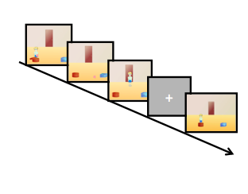

*Figure 1.* A series of still images illustrating the sequence of events in the false belief task.

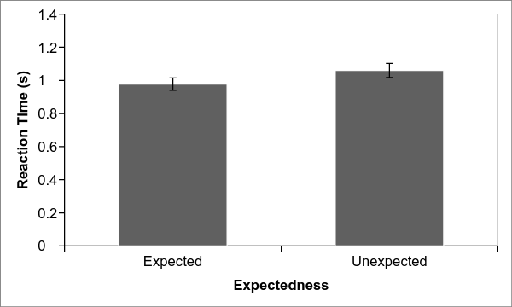

*Figure 3.* Mean response times in the expected and unexpected conditions in Experiment 1.

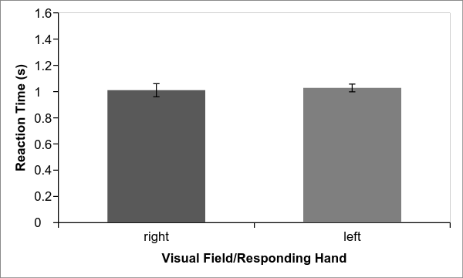

*Figure 2.* Mean response times for images flashed in the right and left visual field in Experiment 1.

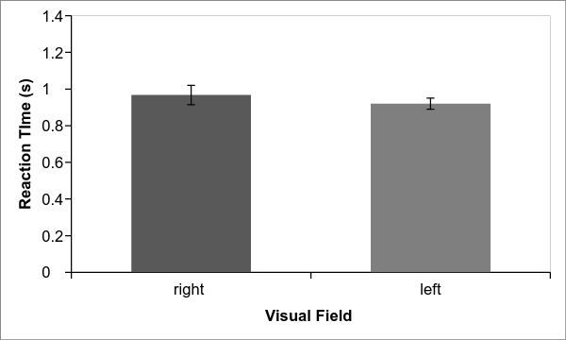

*Figure 4.* Mean response times for images flashed in the right and left visual field in Experiment 2.

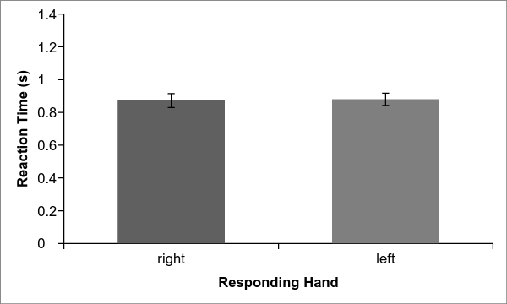

*Figure 5.* Mean response times for right and left hand responses in Experiment 3.

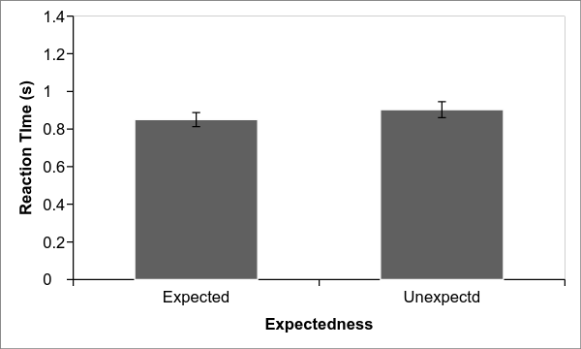

*Figure 6.* Mean response times in the expected and unexpected conditions in Experiment 3.

***ADHD Severity, Peer Victimization, and Intimate Partner Violence in Young Adult Women***

**Cherry Youn**

University of California, Berkeley

Peer victimization (PV) and intimate partner violence (IPV) are ubiquitous public health concerns across ages and cultures, but previous studies indicate that they are more salient in females than males, especially for individuals with psychiatric illnesses, such as Attention-Deficit/Hyperactivity Disorder (ADHD; Blachman & Hinshaw, 2002; Cardoos & Hinshaw, 2001; Guendelman, Ahmad, Meza, Owens, & Hinshaw, 2015). PV describes physical aggression, verbal threats, and relational harassment by other peers (Crick & Grotpeter, 1995; Hawker & Boulton, 2000), and IPV describes physical, verbal, sexual, and/or psychological abuse by a current or former partner or spouse (Centers for Disease Control and Prevention [CDC], 2014). To better understand the risk factors associated with IPV and PV during adulthood, this study will examine (1) the association between childhood ADHD severity and adulthood IPV and PV, (2) the association between adolescent PV and adulthood PV, and (3) adolescent PV as a predictor of IPV. The longitudinal study included three waves of data, gathered every five years, with 228 female participants: Wave 1 consisted of parent reports on ADHD symptoms; Wave 2 included self-reports on PV; and Wave 3 comprised of self-reports on IPV and PV. Linear regressions showed significant associations between ADHD severity and both adolescent IPV(*β* > .009, *p* < 0.001) and PV (*β* > 0.004, *p* <.001) . There was also a significant association between ADHD severity and adult PV when co-varying sociodemographic and cognitive variables (child IQ, mother’s education, household income, and age). We found significant associations between adolescent PV and adulthood PV (*β* = 0.059, *p* < 0.05). However, adolescent PV was not a significant predictor of adulthood IPV (*β* = 0.070, *p* > 0.05). Clinical and research implications of the study are discussed.

P

eer victimization (PV) and intimate partner violence (IPV) are serious public health concerns that affect 50% and 15% of women, respectively (e.g., Thompson et al., 2006); rates of each increase for individuals with psychiatric illnesses, such as Attention-Deficit/Hyperactivity Disorder (ADHD). Furthermore, the rate of PV is significantly higher in children with ADHD than the comparison groups (Cardoos & Hinshaw, 2011; Wiener, 2009; Humphrey, Storch, & Geffken, 2007). These findings are not surprising, as findings show that peer relations is one of the significant impairments in childhood ADHD (Hinshaw & Melnick, 1995), and that girls have a higher prevalence of conduct and internalizing problems associated with ADHD (Pajer, 1998; Lee & Hinshaw, 2006). Previous research suggests that IPV is significantly more prevalent at young adulthood in women with mental illnesses (Capaldi, Knoble, Shortt, & Kim, 2012; Moffitt & Caspi, 1999; Trevillion, Oram, Feder, & Howard, 2012). Less explored, however, are associations between ADHD and IPV. Moreover, previous studies show that ADHD is a potential risk factor for subsequent IPV (Fang, Massetti, Ouyang, Grosse, & Mercy, 2010), specifically when considering the social dysfunction exhibited in adolescents with childhood ADHD (Guendelman et al., 2015). Yet, there is limited research on the peer relationships of young adults with ADHD and even fewer studies that examine romantic relationships of adults with ADHD. The majority of research on ADHD has focused on children and adolescents, resulting in a gap in the literature regarding interpersonal relationships in adulthood. In an attempt to address the gap in the literature, the current study examined (1) the association between childhood ADHD severity and IPV/PV, (2) the persistence of adolescent PV into adulthood PV, and (3) adolescent PV as a predictor of adulthood IPV. The overall aim of this study is to better understand the risk factor(s) that result in the presence of IPV and persistence of PV in females with ADHD.

**PV in Female Adolescents with ADHD**

Children with ADHD experience a high rate of peer rejection even after brief interactions (Erhardt & Hinshaw, 1994). They have fewer friends than their peers without ADHD and are often ostracized by other peer groups (Hinshaw & Melnick, 1995). The associated peer rejection and isolation are explained, in part, by their insensitive reciprocal interpersonal behaviors and discordant interactions (Hubbard & Newcomb, 1991). Such social maladjustment in children with ADHD is highly associated with (1) externalizing behaviors such as disruptive behavior (Hodges, Boivin, Vitaro, & Bukowski, 1999), lack of cooperation (Perren & Alsaker, 2006), and conflict with peers (Perren & Alsaker, 2006); (2) internalizing behaviors, which include difficulties in emotion regulation (Hodges, Boivin, Vitaro, & Bukowski, 1999; Hodges & Perry, 1999); and (3) social skills problems (Fox & Boulton, 2006). A key result is rejection from their peer groups (Hodges & Perry, 1999).

ADHD is one of the most common childhood psychiatric diagnoses that often persists well into adolescence and adulthood (Glass, Flory, & Hankin, 2012; Goldman, Genel, Bezman, & Slanetz, 1998). Hence, social dysfunction often continues into adolescence and young adulthood, as ADHD persists in adolescence with 50% to 80% of children continuing to meet criteria for ADHD (Barkley, Fischer, Edelbrock, & Smallish, 1990). This persistence accounts for the underdevelopment of skills fundamental to maintaining functional relationships, as well as the stability of disharmony in peer relations over time (Coie & Dodge, 1983). Furthermore, clinical research highlights that social difficulties are often treatment-refractory for children with ADHD, especially evident in current psychosocial and pharmacological treatment (Bagwell, Molina, Pelham, & Hoza, 2001). In other words, even though medications and behavioral treatments lead to behavioral improvements in a majority of cases, peer reputation is harder to improve.

**IPV in Young Adult Women**

IPV is a serious public health concern that affects up to 54% of the women in the United States (CDC 2003; Thompson et al., 2006). Max and colleagues highlighted that the United States spent 5.8 billion dollars for women who have experienced IPV (2004). The data continue to reflect the pervasiveness and costly outcomes of the epidemic of IPV. Research reveals that the risk factors for IPV include young age, lower income and education level of women, previous experience and/or witness of violence in family, and developmental psychopathology (e.g., conduct problems or antisocial behaviors; Stith et al, 2004; Thoennes & Tjaden, 1990). Despite findings that reflect symptoms of ADHD are significant risk factors for IPV (Guendelman et al., 2015), there is very little research on how ADHD severity plays a role in predicting IPV.

**The Relation between PV and IPV**

Furthermore, the extent to which PV contributes to increased IPV risk among young women with childhood ADHD has not yet been examined. Much of what is known about PV and IPV includes only the development of violent behaviors and its perpetration (United States Department of Health and Human Services, 2001; Williams et al., 2008). Considering that there is a strong association between ADHD and the continued prevalence of negative peer status as well as the externalizing problems shown to be risk factors of IPV (Bagwell et al., 2001), this study aims to investigate the associations between childhood ADHD severity and IPV/PV in adolescence and early adulthood. I hypothesize a strong association between adolescent PV and adulthood PV. Additionally, I also predict that adolescent PV is a predictor of IPV in young adulthood.

**Method**

**Participants**

This study included 228 female participants from the Berkeley Girls with ADHD Longitudinal Study (BGALS). They initially participated at research summer programs conducted by the Principal Investigator, Stephen P. Hinshaw, Ph.D., and staff. The programs ran from 1997 to 1999, when the participants were 6 to 12 years old (*M* = 9.1 years). The population sample includes 140 participants diagnosed with ADHD and 88 in a matched comparison group. Comparison girls were recruited from fliers that advertised summer programs for girls, and did not meet the diagnostic criteria for ADHD. Participants with (a) Full Scale IQ lower than 70, (b) neurological disorders or psychosis, (c) autism or other developmental disorders, and (d) other medical or physical conditions that prevented them from participating in the study were excluded from the population sample. Both groups were recruited from various sites that range from schools, pediatric practices, and clinics in the San Francisco Bay Area. The participants of this study were diverse both ethnically (53% Caucasian, 27% African American, 11% Hispanic, 9% Asian American) and in terms of socioeconomic status (*M* = $55,000, ranging from $10,000 or below to $75,000 or over).

Participants in the ADHD group were required to meet the *Diagnostic and statistical manual of mental disorders, 4th edition* (DSM-IV) diagnostic criteria for ADHD via the *Diagnostic Interview Schedule for Children* (4th ed, DISC-IV; Shaffer, Fisher, Lucas, Dulcan, & Schwab-Stone, 2000). To promote generalizability of the ADHD sample, participants with common comorbidities of ADHD, such as oppositional defiant disorder (ODD) and conduct disorder (CD), were included in the ADHD group. Out of the girls with ADHD (*n* = 140), 63% (*n* = 88) and 20% (*n* = 29) met criteria for ODD and CD, respectively. Girls with mental disorders, medical issues, or conditions, such as psychosis, overt neurological disorder, mental retardation, pervasive developmental disorder, non-ability to speak English, that hindered them from participating in the research summer programs were excluded from the study.

**Procedure**

Follow-up assessments have been completed and analyzed throughout the ongoing longitudinal investigation. Participants were asked to participate in follow-up assessments every five years, and are currently participating in the fourth wave of follow-up assessments. This study will only examine the first three completed follow-up studies. Wave 1 consists of participants in their childhood whose ages range from 6 to 12 (*M* = 9.1, *SD* = 1.7), Wave 2 consists of participants in adolescence whose ages range from 11.3 to 18.2 years (*M* = 14.2, *SD* = 1.7); these data include 209 of the original 228 participants (92%). Wave 3 consists of participants in young adulthood whose ages range from 17 to 24 years (*M* = 19.6), including 216 of the original 228 participants (95%). Participants who were not included in this study were due to attrition or lack of experience in romantic relationship.

**Measures**

**ADHD Severity.** Along with the DISC structured interview, the Swanson, Nolan, and Pelham IV rating scale (SNAP-IV; Swanson et al., 2001) was administered on both ADHD and control groups to obtain an ADHD diagnosis. This parent scale includes a total of 26-items according to the symptom criteria in the DSM-IV for ADHD and ODD: nine ADHD inattentive, nine ADHD hyperactive/impulsive, and eight ODD symptoms. The SNAP-IV is scored based on a four-point Likert scale which ranged from 0=not at all, 1=just a little, 2=quite a bit, to 3=very much. Previous studies have shown the SNAP-IV to be a reliable questionnaire and valid source for gathering information on ADHD severity in participants (Hinshaw, 2002). For this study, an ADHD severity index was created by summing the 18 ADHD symptoms, weighted by their severity scores.

**PV and IPV.** The *Social Relationships Interview* (SRI; Brugha et al., 1987) was assessed in both Wave 2 and Wave 3 to measure PV and IPV. This project-derived interview includes topics related to peers, friendships, and romantic relationships. Relevant questions were based on conceptual models of friendship attainment and social/dating relationships. PV, in Wave 2 and Wave 3, was calculated using a variable that averaged three questions rated on a Likert scale (1 = never, 2 = less than once per month, 3 = once or twice per month, 4 = once a week, 5 = a few times a week, and 6 = everyday): (1) "have you ever been hit?", (2) "have you ever been teased to your face?", and (3) "have you ever been teased behind your back?". Across these three items, Cronbach's alpha in our sample = .65, revealing adequate internal consistency.

The composite score for IPV at Wave 3 combined the presence of physical abuse and verbal abuse by the romantic partner. The participant asked was to report one of the four conditions: (1) pushing/shoving, (2) slapping, (3) hitting other parts of the body, and (4) pulling hair, in order to meet the criteria for physical abuse. In addition, indicating either (1) swearing or name calling, or (2) threatening physical violence met the criteria for verbal abuse.

This study applied a stringent method through which a participant was considered to be abused by a romantic partner only if both physical and verbal abuse criteria were met.

**Covariates**

Four sociodemographic and cognitive variables –child IQ, mother’s education, household income, and age– were used in this study as covariates. The *Wechsler Intelligence Scale for Children-Third Edition* (WISC-III; Wechsler, 1991) was administered at Wave 1 to determine the full-scale IQ scores for all participants. The full scale IQ score was calculated to assess if its association with poor social life outcome was, in turn, related to PV, because previous studies indicate that low IQ has been linked to poor social functioning (Dunlop & Savulescu, 2015). Socioeconomic status was calculated using the level of education for the parent in the home measured at Wave 1, along with total gross household income (Guendelman et al., 2015), as previous studies have found that low income is a significant risk factor for IPV (Tjaden & Thoennes, 2009). Mother’s education level was measured on a 6-point scale (1 = less than 8th grade; 6 = advanced or professional degree). Finally, age in months at Wave 3 was collected from *the Wechsler Individual Achievement Test, Second Edition* (WIAT-II; Wechsler, 2001), administered during in-person Wave 3 assessments.

**Data Analytic Plan**

All statistical analyses were performed with SPSS, Version 22 (IBM Corp 2014). First, bivariate correlations among ADHD severity at Wave 1, PV at Wave 2, and IPV/ PV at Wave 3 were calculated. A total of six correlations were analyzed in this study: (1) correlation between ADHD severity at Wave 1 and PV at Wave 2, (2) ADHD severity at Wave 1 and IPV at Wave 3, (3) PV at Wave 2 and IPV, (4) ADHD severity at Wave 1 and PV at Wave 3, (5) PV at Wave 2 and Wave 3, and (6) IPV at Wave 3 and PV at Wave 3.

Second, linear regressions among the four aforementioned variables were conducted. Four regressions are featured: (1) ADHD severity at Wave 1 predicting PV at Wave 2, (2) ADHD severity at Wave 1 predicting PV at Wave 3, (3) ADHD severity predicting IPV at Wave 3, and (4) PV at Wave 2 predicting PV at Wave 3. In these regressions, the covariates were placed on step 1 of the equation and ADHD severity (or, for the fourth regression, PV) was placed on step 2.

**Results**

**Intercorrelations and Descriptive Analyses**

A correlation matrix among the four primary variables, Wave 1 ADHD severity, Wave 2 PV, Wave 3 IPV, and Wave 3 PV, examined the relations among predictor and outcome variables investigated in the current study (see Table 1). Several significant associations were found. As expected, Wave 1 ADHD severity, Wave 2 PV, and Wave 3 PV and IPV were significantly associated with one another. Wave 1 ADHD severity was positively associated with Wave 2 PV (*r* = 0.212, *p* = 0.003; see Figure 1). Similarly, Wave 1 ADHD severity was positively associated with Wave 3 PV (*r* = 0.198, *p* = 0.005; see Figure 2), and IPV (*r* = 0.217, *p* = 0.001; see Figure 3). Wave 2 PV was significantly correlated with Wave 3 PV in the expected direction (*r* = 0.193, *p* = 0.009; see Figure 4). Wave 3 PV was positively associated with IPV (*r* = 0.396*, p* = 0.000; see Figure 5). The association between Wave 2 PV and Wave 3 IPV was the sole intercorrelation that showed a lack of statistical significance (*r* = 0.029, *p* = 0.683; see Figure 6).

**Regression Analyses: Predicting IPV from Wave 1 ADHD Severity**

Five linear regression analyses were conducted to test whether ADHD severity and adolescent PV predicted the criterion variables, which include (1) PV at adolescence, (2) IPV at young adulthood, and (3) PV at young adulthood. One of the hypotheses include that Wave 1 ADHD severity would predict Wave 3 IPV (physical and verbal IPV), using linear regressions after mean-centering the predictor (Wave 1 ADHD severity). As noted above, key sociodemographic and cognitive covariates (child IQ at Wave 1, mother’s education at Wave 1, household income at Wave 1, and age at Wave 3) were entered during the first step and Wave 1 ADHD severity during the second step. Results revealed that Wave 1 ADHD severity predicted all three criterion variables with statistical significance over and above child IQ, mother’s education, household income, and age at Wave 3 (see Table 2). The results of the five regressions are as follows: (a) as hypothesized, Wave 1 ADHD severity significantly predicted Wave 2 PV (*β* = 0.011, *p* = 0.004). (b) The hypothesis that Wave 1 ADHD severity would predict Wave 3 IPV was also supported (*β* = 0.009, *p* = 0.003). (c) Wave 1 ADHD severity also predicted Wave 3 PV (*β* = 0.004, *p* = 0.001). (d) The hypothesis that Wave 2 PV would predict Wave 3 PV was supported (*β* = 0.059, *p* = 0.024). (e) Contrary to the hypothesis, Wave 2 PV did not predict Wave 3 IPV (*β* = 0.070, *p* = 0.052).

**Discussion**

The current study examined the relationships among childhood ADHD severity, adolescent and young adulthood PV, and young adulthood IPV victimization in females. ADHD severity in childhood was significantly associated with increased risk for PV by adolescence and IPV by young adulthood. Furthermore, linear regressions revealed that PV in adolescence was predicted increased risk for PV by young adulthood. All of these associations continued to remain significant when controlling for multiple covariates, suggesting that childhood ADHD severity predict significant risk for PV/IPV independently of sociodemographic and cognitive variables (e.g., child IQ, mother’s education, household income, and age). In sum, females with more severe childhood ADHD symptoms are especially at risk for IPV by young adulthood and PV by adolescence that persists into young adulthood.

Our finding on the significant association between childhood ADHD severity and IPV in young adulthood yielded similar results to previous literature on ADHD and IPV (Eakin et al., 2004; Fang et al., 2010; Murphy & Barkley, 1996; Wymbs et al., 2012). However, a number of other studies have found no relation between the two (e.g., Crane, Hawes, Devine, & Easton, 2014; Sacchetti & Lefler, 2014). Though Crane et al. and Sacchetti and Lefler’s studies have limitations on small, selected samples rather than population samples to the conclusions, the heterogeneity of results warrants a need for additional research in IPV victimization with larger, representative samples of young adult populations. Similarly, our findings indicate that there are statistically significant associations between ADHD severity in childhood and PV in adolescence as well as in young adulthood. We also found significant relations between PV across adolescence and into young adulthood. Impairments in peer relations for ADHD adolescents persist in adulthood and are also translated to impairments in romantic relationships, resulting in higher occurrences of physical and verbal victimization.

Contrary to our hypothesis, there was no significant association between Wave 2 PV and Wave 3 IPV. Girls who were victimized in adolescence by their peers were more likely to be involved in romantic relationships where they are physically and/or verbally victimized, but those victimized in romantic relationships were not necessarily victimized in adolescence by peers. This result could be interpreted by the environment that the adolescent females with ADHD are in: significant rates of females with ADHD are single parents and young mothers (Russell, Ford, Rosenberg, & Kelly, 2014), excluding them from social environments such as school and work where most social interactions occur. Another interpretation could be made from the durations of relationships formed by girls with ADHD. Previous literature shows that women with ADHD have serious problems in interpersonal relationships, and are involved in significantly less number of intimate relationships due to poor social functioning abilities (Babinski et al., 2011), and exhibit less satisfying romantic relationships (Biederman et al., 2006; Kessler et al., 2006; Murphy & Barkley, 2006). In other words, girls with higher ADHD severity are unable to commit to long-term relationships, if any at all, resulting in the lack of data in our study to support the presence of IPV. However, out of those who engage in romantic relationships, many are victimized and become involved in IPV.

**Limitations and Conclusions**

A few study limitations should be considered. First, PV and IPV victimization were assessed from a small subsection of the self-report questionnaire. Not using standardized PV and IPV instruments may have led to unreliability of measurement as well as false negatives, where participants underestimate the rate and frequency of the PV/IPV due to a number of factors including recall bias and psychological trauma. Moreover, the self-report questionnaire did not assess for exact time, severity, or frequency of PV/IPV, hindering the study from further analyses on the severity of PV/IPV in girls with more severe symptoms of ADHD. Lastly, the study only focused on the participants’ exposure to both physical and verbal IPV, excluding sexual and psychological victimization. The presence of child abuse and neglect, a significant risk factor for future IPV (Bensley, Van Eenwyk, & Wynkoop Simmons, 2003; Ehrensaft et al., 2003), was also not assessed for this study. Future research on the association between the presence and severity of different victimization and ADHD severity over several developmental periods is recommended.

Taking these limitations into account, this study introduces a conceptually plausible pathway between peer victimization and physical and verbal IPV in females with ADHD. In other words, prior experience of peer victimization has shown to function as a gateway for subsequent victimization of other kinds, including peer victimization in adulthood and IPV. In conclusion, the current study found that childhood ADHD severity is linked to adolescent and young adult PV and young adult IPV. Given the developmental significance of peer relationships, additional research on the causes and treatment of poor social functioning in ADHD severity in adolescence and adulthood is warranted.

**References**

Babinski, D. E., Pelham, W. E., Jr., Molina, B. S., Gnagy, E. M., Waschbusch, D. A., Yu, J., … Karch, K. M. (2011). Late adolescent and young adult outcomes of girls diagnosed with ADHD in childhood: an exploratory investigation. *Journal of Attention Disorders, 15*(3), 204-214.

Bagwell, C. L., Molina, B. S., Pelham, W. E., Jr., & Hoza, B. (2001). Attention-deficit hyperactivity disorder and problems in peer relations: predictions from childhood to adolescence. *Journal of the American Academy of Child and Adolescent Psychiatry, 40*(11), 1285-1292.

Barkley, R. A., Fischer, M., Edelbrock, C. S., & Smallish, L. (1990). The adolescent outcome of hyperactive children diagnosed by research criteria: I. An 8-year prospective follow-up study. *Journal of the American Academy of Child and Adolescent Psychiatry, 29*(4), 546-557.

Bensley, L., Van Eenwyk, J., & Wynkoop

Simmons, K. (2003). Childhood family violence history and women’s risk for intimate partner violence and poor health. *American Journal*  *of Preventive Medicine, 25*(1), 38–44.

Biederman, J., Faraone, S. V., Spencer, T. J., Mick, E., Monuteaux, M. C., & Aleardi, M. (2006). Functional impairments in adults with self-reports of diagnosed ADHD: A controlled study of 1001 adults in the community. *Journal of Clinical Psychiatry, 67*(4), 524-540.

Blachman, D. R., & Hinshaw, S. P. (2002). Patterns of friendship among girls with and without attention-deficit/hyperactivity disorder. *Journal of Abnormal Child Psychology, 30*(6), 625-640.

Brugha, T. S., Sturt, E., MacCarthy, B., Potter, J., Wykes, T., & Bebbington, P. E. (1987). The Interview Measure of Social Relationships: The description and evaluation of a survey instrument for assessing personal social resources. *Social Psychiatry, 22*(2), 123-128.

Capaldi, D. M., Knoble, N. B., Shortt, J. W.,

& Kim, H. K. (2012). A systematic review of risk factors for intimate partner violence. *Partner Abuse, 3,* 231–280.

Cardoos, S. L., & Hinshaw, S. P. (2011). Friendship as protection from peer victimization for girls with and without ADHD. *Journal of Abnormal Child Psychology, 39*(7), 1035-1045.

Centers for Disease Control and Prevention.

(2003). Costs of intimate partner violence against women in the United States. Atlanta: National Center for Injury Prevention and Control.

Centers for Disease Control and Prevention.

(2014). Intimate partner violence. Retrieved from http://www.cdc.gov/ViolencePrevention/intimatepartnerviolence/index.html.

Coie J. D., & Dodge K. A. (1983).

Continuities and changes in children’s social status: a five-year longitudinal study. *Merrill-Palmer Quarterly*, *29*(3)*,* 261-282.

Crane, C. A., Hawes, S. W., Devine, S., &

Easton, C. J. (2014). Axis I psychopathology and the perpetration of intimate partner violence. *Journal of Clinical Psychology, 70*(3), 238-247.

Crick, N. R., & Grotpeter, J. K. (1995).

Relational aggression, gender, and social-psychological adjustment. *Child Development, 66*(3), 710–712.

Dunlop, M., & Savulescu, J. (2015).

Distributive justice and cognitive enhancement in lower, normal intelligence. *Monash Bioethics Review, 32*(3), 189-204.

Eakin, L., Minde, K., Hechtman, L., Ochs, E., Krane, E., Bouffard, R., ... Looper, K. (2004). The marital and family functioning of adults with ADHD and their spouses. *Journal of Attention Disorders, 8*(1), 1-10.

Ehrensaft, M. K., Cohen, P., Brown, J.,

Smailes, E., Chen, H., & Johnson, J. G. (2003). Intergenerational transmission of partner violence: a 20-year prospective study. *Journal*  *of Consulting and Clinical Psychology, 71*(4), 741–753.

Erhardt, D., & Hinshaw, S. P. (1994). Initial

sociometric impressions of attention-deficit hyperactivity disorder and comparison boys: predictions from social behaviors and from   
nonbehavioral variables. *Journal of Consulting and Clinical Psychology, 62*(4), 833-842.

Fang, X., Massetti, G. M., Ouyang, L.,

Grosse, S. D., & Mercy, J. A. (2010). Attention-deficit/hyperactivity disorder, conduct disorder, and young adult intimate partner violence. *Archives of General Psychiatry, 67*(11), 1179-1186.

Faris, R., & Felmlee, D. (2014). Casualties

of social combat: School networks of peer victimization and their consequences. *American Sociological Review,* *79*(2), 228-257.

Fox, C. L., & Boulton, M. J. (2006).

Friendship as a moderator of the relationship between social skills problems and peer victimization. *Aggressive Behavior*, *32*(2), 110–121.

Glass, K., Flory, K., & Hankin, B. L. (2012).

Symptoms of ADHD and close friendships in adolescence. *Journal of Attention Disorders, 16*(5), 406-417.

Goldman, L. S., Genel, M., Bezman, R. J.,

& Slanetz, P. J. (1998). Diagnosis and treatment of attention-deficit/hyperactivity disorder in children and adolescents. Council on Scientific Affairs, American Medical Association. *Journal of the American Medical Association, 279*(14), 1100-1107.

Guendelman, M. D., Ahmad, S., Meza, J. I.,

Owens, E. B., & Hinshaw, S. P. (2015). Childhood attention-deficit/hyperactivity disorder predicts intimate partner victimization in young women. *Journal of Abnormal Child Psychology,* Advance online publication. doi: 10.1007/s10802-015-9984-z

Hawker, D. S. J., & Boulton, M. J. (2000).

Twenty years’ research on peer victimization and psychosocial maladjustment: a meta-analytic review of cross-sectional studies. *Journal of Child Psychology and Psychiatry, 41*(4), 441-455.

Hinshaw, S. P. (2002). Preadolescent girls

with attention-deficit/hyperactivity disorder: I. Background characteristics, comorbidity, cognitive and social functioning, and parenting practices. *Journal of Consulting and Clinical Psychology, 70*(5), 1086-1098.

Hinshaw, S., & Melnick, S. (1995). Peer

relationships in boys with attention-deficit hyperactivity disorder with and without comorbid aggression. *Development and Psychopathology,* *7*(4), 627-647.

Hodges, E. V., Boivin, M., Vitaro, F., &

Bukowski, W. M. (1999). The power of friendship: protection against an escalating cycle of peer victimization. *Developmental Psychology, 35*(1), 94-101.

Hodges, E. V., & Perry, D. G. (1999).

Personal and interpersonal antecedents and consequences of victimization by peers. *Journal of Personality and Social Psychology, 76*(4), 677-685.

Hubbard, J. A., & Newcomb, A. F. (1991).

Initial dyadic peer interaction of attention deficit-hyperactivity disorder and normal boys. *Journal of Abnormal Child Psychology, 19*(2), 179-195.

Humphrey, J. L., Storch, E. A., & Geffken, G. R. (2007). Peer victimization in children with attention-deficit hyperactivity disorder. *Journal of Child Health Care, 11*(3), 248-260.

IBM Corp. (2011). *IBM SPSS statistics for*

*Mac OS, Microsoft windows* (Version 23.0). Armonk: IBM Corp.

Kessler, R. C., Adler, L., Barkley, R., Biederman, J., Conners, C. K., Demler, O., ... Zaslavsky, A. M. (2006). The prevalence and correlates of adult ADHD in the United States: results from the National Comorbidity Survey Replication. *American Journal of Psychiatry, 163*(4), 716-723.

Lee, S. S., & Hinshaw, S. P. (2006). Predictors of adolescent functioning in girls with attention deficit hyperactivity disorder (ADHD): the role of childhood ADHD, conduct problems, and peer status. *Journal of Clinical Child and Adolescent Psychology, 35*(3), 356-368.

Max, W., Rice, D. P., Finkelstein, E., Bardwell, R. A., & Leadbetter, S. (2004). The economic toll of intimate partner violence against women in the United States. *Violence and Victimization, 19*(3), 259-272.

McCauley, H. L., Breslau, J. A., Saito, N., & Miller, E. (2015). Psychiatric disorders prior to dating initiation and physical dating violence before age 21: findings from the National Comorbidity Survey Replication (NCS-R). *Social Psychiatry and Psychiatric Epidemiology, 50*(9), 1357-1365.

Moffitt, T. E., & Caspi, A. (1999). *Findings*

*about partner violence from the Dunedin multidisciplinary health and development study*. Research in Brief. NCJ 170018. Washington: National Institute of Justice.

Murphy, K., & Barkley, R. A. (1996).

Attention deficit hyperactivity disorder adults: comorbidities and adaptive impairments. *Comprehensive Psychiatry, 37*(6), 393-401.

Pajer, K. A. (1998). What happens to "bad"

girls? A review of the adult outcomes of antisocial adolescent girls. *American Journal of Psychiatry, 155*(7), 862-870.

Perren, S., & Alsaker, F. D. (2006). Social

behavior and peer relationships of victims, bully-victims, and bullies in kindergarten. *Journal of Child Psychology and Psychiatry, 47*(1), 45-57.

Russell, G., Ford, T., Rosenberg, R.,

& Kelly, S. (2014). The association of attention deficit hyperactivity disorder with socioeconomic disadvantage: alternative explanations and evidence. *Journal of Child Psychology and Psychiatry, 55*(5), 436-445.

Sacchetti, G. M., & Lefler, E. K.

(2014). ADHD Symptomatology and Social Functioning in College Students. *Journal of Attention Disorders, 1*(11)*,* 1-11.

Stith S. M., Smith, D. B., Penn, C.,

Ward, D., & Tritt, D. (2004). Risk factor analysis for spouse physical maltreatment: a meta-analytic review. *Journal of Aggression and Violent   
Behavior,* *10*(1), 65-98.

Swanson, J. M., Kraemer, H. C., Hinshaw,

S. P., Arnold, L. E., Conners, C. K., Abikoff, H. B., ... Wu, M. (2001). Clinical relevance of the primary findings of the MTA: Success rates   
based on severity of ADHD and ODD symptoms at the end of treatment. *Journal of the American Academy of Child and Adolescent Psychiatry, 40*(2), 168-179.

Thoennes, N., & Tjaden, P. G. (1990). The

extent, nature, and validity of sexual abuse allegations in custody/visitation disputes. *Child Abuse and Neglect, 14*(2), 151-163.

Thompson, R. S., Bonomi, A. E., Anderson,

M., Reid, R. J., Dimer, J. A., Carrell, D., & Rivara, F. P. (2006). Intimate partner violence: prevalence, types, and chronicity in adult women. *American Journal of Preventive Medicine, 30*(6), 447-457.

Trevillion, K., Oram, S., Feder, G.,

& Howard, L. M. (2012). Experiences of domestic violence and mental disorders: A systematic review and meta-analysis. *PloS One, 7.* Advance online publication. doi:10. 1371/journal.pone.0051740.

Wechsler, D. (1991). *Wechsler Intelligence*

*Scales for Children —Third Edition* [Measurement Instrument]. San Antonio, TX: The Psychological Corporation.

Wechsler, D. (2001). *Wechsler Individual*

*Achievement Test (2nd ed.)* [Measurement Instrument]. New York, NY: Psychological Corporation.

Wiener, J., & Mak, M. (2009). Peer

victimization in children with Attention-Deficit/Hyperactivity Disorder. *Psychology in the Schools, 11*(3), 116-131.

Wymbs, B., Molina, B., Pelham, W.,

Cheong, J., Gnagy, E., Belendiuk, K., ... Waschbusch, D. (2012). Risk of intimate partner violence among young adult males with childhood ADHD. *Journal of Attention Disorders, 16*(5), 373-383.

**Appendix**

Table 1*Intercorrelations among the primary variables*

|  |  |  |  |
| --- | --- | --- | --- |
|  | 1. | 2. | 3. |
| 1. Wave 1 ADHD Severity |  |  |  |
| 2. Wave 2 PV | .212** |  |  |
| 3. Wave 3 IPV | .217** | .029 |  |
| 4. Wave 3 PV | .198** | .193** | .396*** |

*Note*: PV = peer victimization, IPV = intimate partner violence  
* Correlation is significant at the .05 level (2-tailed).  
** Correlation is significant at the .01 level (2-tailed).  
*** Correlation is significant at the .001 level (2-tailed).

A correlation matrix among the four primary variables, which include Wave 1 ADHD severity, Wave 2 PV, Wave 3 IPV, and Wave 3 PV, examined the relations among predictor and outcome variables investigated in this study. All but the correlation between Wave 2 PV and Wave 3 IPV showed statistical significance at the .05 level or higher. This data was retrieved from the Berkeley Girls with ADHD Longitudinal Study (BGALS).

Table 2 *Linear regressions among primary variables while accounting for covariates*

|  |  |  |  |
| --- | --- | --- | --- |
|  | β | SE | p-value |
| Wave 1 ADHD Severity | | | |
| Wave 2 PV | .011 | .004 | .001 |
| Wave 3 IPV | .009 | .003 | .001 |
| Wave 3 PV | .004 | .001 | .001 |
| Wave 2 PV | | | |
| Wave 3 IPV | .070 | .052 | .180 |
| Wave 3 PV | .059 | .024 | .014 |

*Note*: PV = peer victimization, IPV = intimate partner violence

Results indicate that Wave 1 ADHD severity predicted all three criterion variables with statistical significance over and above four key socioeconomic and cognitive covariates (child IQ at Wave 1, mother’s education at Wave 1, household income, and age) at Wave 3. All hypotheses other than the one that Wave 2 PV would predict Wave 3 PV were supported with statistical significance. This data was retrieved from the Berkeley Girls with ADHD Longitudinal Study (BGALS).

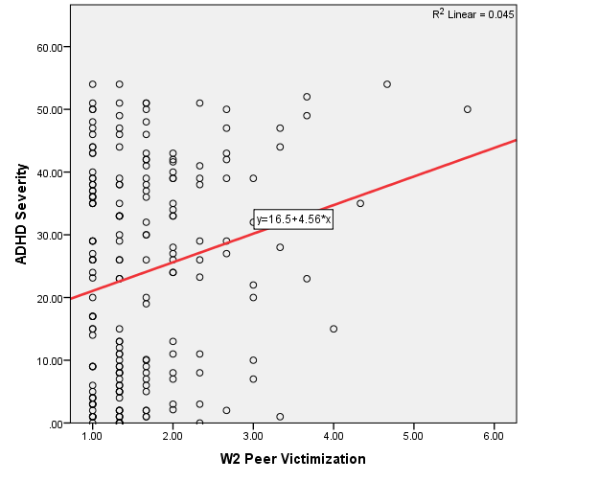

*Figure 1.* Association between Wave 1 ADHD severity and Wave 2 PV. This figure illustrates the statistically significant positive association between Wave 1 ADHD severity and Wave 2 PV. This data was retrieved from the Berkeley Girls with ADHD Longitudinal Study (BGALS).

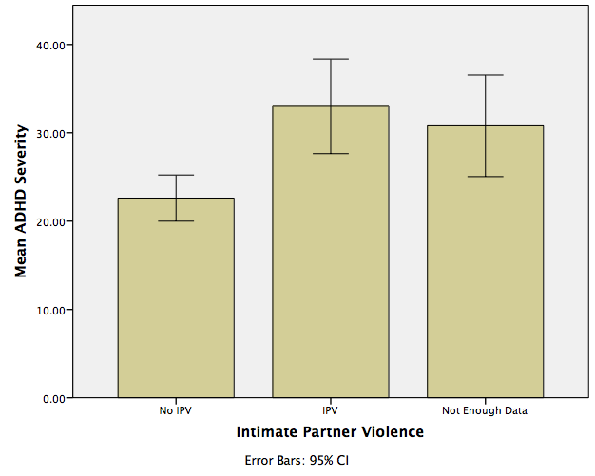

*Figure 3.* Association between Wave 1 ADHD severity and IPV. This figure illustrates the statistically significant positive association between Wave 1 ADHD severity and IPV. This data was retrieved from the Berkeley Girls with ADHD Longitudinal Study (BGALS).

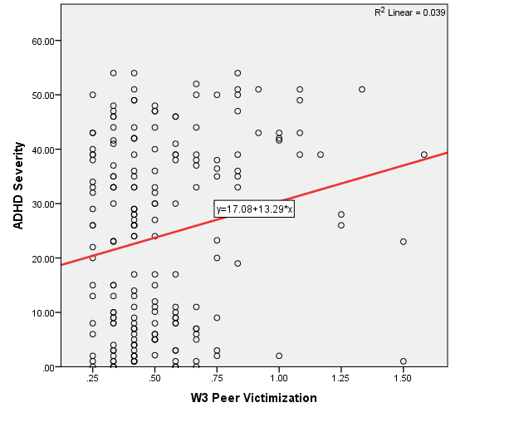

*Figure 2.* Association between Wave 1 ADHD severity and Wave 3 PV. This figure illustrates the statistically significant positive association between Wave 1 ADHD severity and Wave 3 PV. This data was retrieved from the Berkeley Girls with ADHD Longitudinal Study (BGALS).

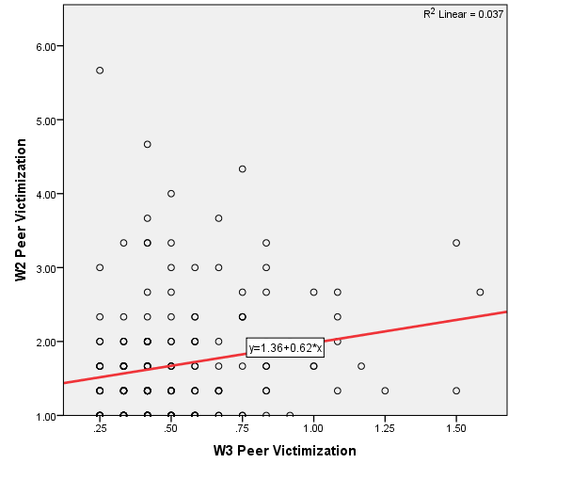

*Figure 4.* Association between Wave 2 PV and Wave 3 PV. This figure illustrates the statistically significant positive association between Wave 2 PV and Wave 3 PV. This data was retrieved from the Berkeley Girls with ADHD Longitudinal Study (BGALS).

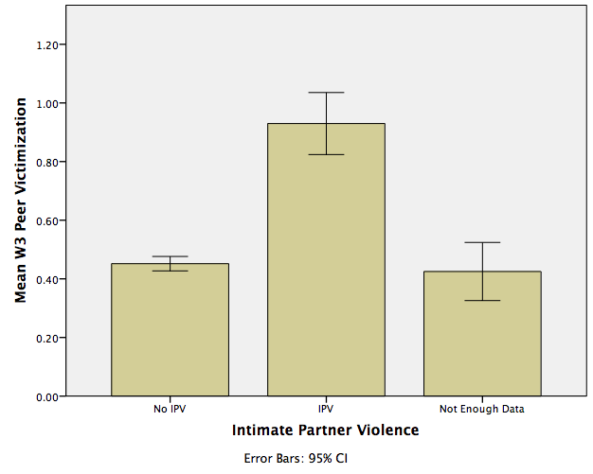

*Figure 5.* Association between Wave 3 PV and IPV. This figure illustrates the statistically significant positive association between Wave 3 PV and IPV. This data was retrieved from the Berkeley Girls with ADHD Longitudinal Study (BGALS).

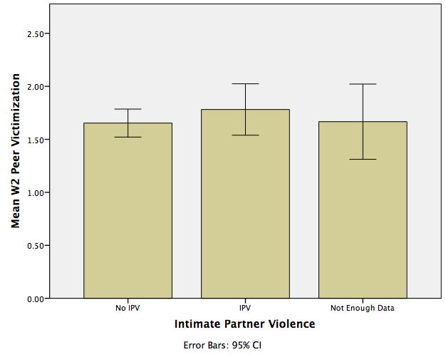

*Figure 6.* Association between Wave 2 PV and IPV. This figure illustrates the association between Wave 2 PV and IPV. This data was retrieved from the Berkeley Girls with ADHD Longitudinal Study (BGALS).

***Music-Shape Associations and the Emotional Mediation Hypothesis***

**Sheila Rajagopalan**

University of California, Berkeley

Previous research has shown that non-synesthetes make systematic associations across a variety of sensory combinations (Spence, 2011). Studies conducted in the Palmer Visual Aesthetics and Perception Lab at UC Berkeley have found that for a variety of visual and musical stimuli, a shared affective response mediates cross-modal associations. This study aims to test whether people make systematic associations between diverse musical genres and line-shapes and additionally whether these associations could be mediated by the perceived emotional, perceptual, and/or musical qualities that are shared by the respective stimuli. Participants listened to music samples from 33 different genres while 48 line-shapes were displayed on a computer screen. They were then asked to select the three most consistent and the three least consistent shapes for each musical selection. Finally, they rated each of the musical and shape stimuli along a series of 13 bipolar dimensions from three categories: emotional (Calm/Agitated, Disharmonious/Harmonious, Dislike/Like, Not Angry/Angry, and Sad/Happy), perceptual (Light/Heavy, Open/Closed, Simple/Complex, and Smooth/Sharp), and musical (Monotonous/Interesting, Slow/Fast, Soft/Loud, and Sparse/Dense). Results support previous research in that participants typically matched line-shapes and music samples that shared emotional, perceptual, and musical features. The dimensions which demonstrated the strongest correlations for musical selections and line-shapes were Calm/Agitated (r=0.95, p<0.001), Light/Heavy (r=0.95, p<0.001), and Soft/Loud (r=0.95, p<0.001). This suggests that emotional, perceptual, and musical features could indeed all be mediating cross-modal associations.

The author would like to thank Dr. Palmer, Dr. Malfatti, and the rest of the team in the UC Berkeley Visual Aesthetics and Perception Lab for their immense help with this project.

W

e experience the world as an integrated combination of information presented through different sensory modalities. As we encounter particular combinations of sensory stimuli more frequently than others, it should follow that we eventually learn to associate certain stimuli of one sensory modality with those of another. Which sensory stimuli do we pair together? What is the nature of the method in which we make these associations?

One phenomenon related to these sentiments is the neurological phenomenon of synesthesia, which affects up to 5% of the population (Simner et al., 2006). Synesthetes experience unusual mixing of the senses, such that stimulation in one sense also triggers perception in a different sense. For synesthetes, everyday activities like reading or listening to music arouse extraordinary sensations of color, smells, tastes, shapes, and other perceptions that non-synesthetes simply do not experience (Simner & Hubbard, 2013). While synesthetes tend to make absolute correspondences with definite cross-modal experiences, non-synesthetes tend to make only relative correspondences without cross-modal experiences (Gallace & Spence, 2006). Non-synesthetic cross-modal matching effects are nevertheless robust in the general population, particularly for children (Bond & Stevens, 1970; Braaten, 1993; Cohen, Henik, & Walsh 2009; Imai, Kita, Nagumo, & Okada, 2008; Lewkowicz & Turkewitz, 1980; Mondloch & Maurer, 2004; Morgan, Goodson, & Jones, 1975).

Of the various sensory combinations that have been studied for non-synesthetes, the most well documented is visual-auditory associations. Research has shown that people use certain low-level visual metaphors to represent low-level auditory features. A study conducted by Walker (1987) found that across cultures, people match high vertical placement with high pitch, large objects with high volume, and long duration with long horizontal length.

Additional work done previously in the Palmer Visual Aesthetics and Perception Lab at UC Berkeley has shown that non-synesthetes also make systematic auditory-visual cross-modal associations for a variety of higher-level musical stimuli (such as musical passages) as well. The results of this research suggest that these associations are mediated by shared emotional content across sensory stimuli, a theory coined the “emotional mediation hypothesis” (Palmer, Schloss, Xu, & Prado-Leon, 2013). Evidence for the emotional mediation hypothesis stems from studies showing that participants match cross-modal stimuli that are rated similarly along emotional dimensions. This effect was first demonstrated for music-to-color associations (Schloss, Lawler, & Palmer, VSS-2008; Palmer, Langlois, Tsang, Schloss, & Levitin, VSS-2011; Griscom & Palmer, VSS-2012; Griscom & Palmer, VSS-2013), but later extended to music-to-texture associations (Langlois, Peterson, & Palmer, VSS-2014; Peterson, Langlois, & Palmer, VSS-2014). Further research done by Malfatti (2014) has shown that emotion also mediates associations between line-shapes and color, while research by Whiteford has shown that emotion mediates associations between color and musical genres (Whiteford, Schloss, & Palmer, VSS-2013). The present study aims to supplement previous research in an attempt to discover whether emotional, perceptual, and/or musical characteristics mediate the formation of associations between musical genres and line-shapes.

Previous research into the correlation between shape and music has found that people match high pitches with sharp shapes and low pitches with round shapes (Kohler, 1929; Marks, 1987). The connection between shape and music is somewhat intuitive for those with musical training (Kussner, 2013). In fact, musicians often make reference to the “shape” of a musical passage, oftentimes making gestures as if shaped movement can communicate some aspect of the music (Kussner, 2013). In an attempt to examine what the “shape” of music refers to, which acoustical parameters relate to shape, and whether musical shapes can be made more accessible by visualizing them, Kussner had musicians and non-musicians alike listen to passages of music and draw a visual representation of that music. He found that musicians made more consistent drawings in line with the overall expressive quality of the music, while non-musicians used more diverse representation strategies and neglected temporal aspects of pitch (Kussner, 2013).

This correlation works inversely from shape to music as well. Graphic design of a composition is a common aid in the creation of an envisioned musical work (Goldberg & Schrak, 1986). The creation of the Unité Polyagogique Informatique CEMAMu (UPIC) system by the composer Iannis Xenakis is perhaps the most famous example. The UPIC system allows composers to use graphic notation to represent musical effects that are too complicated to be specified with the traditional staff notation. For instance, the system represents convoluted orchestral musical features such as glissandi for many instruments with lines in a pitch-versus-time domain. The lines and various other graphical objects have specific functions that a computer recognizes to synthesize sound (Marino, Serra, & Raczinski, 1993). In this way, the composer can draw music and is freed from the limitations of traditional notation which cannot represent a great variety of sound phenomena (Marino, Serra, & Raczinski, 1993).

The relationship between shape and music is also of artistic interest. There have been multiple artistic attempts to create multimedia works in both the visual and sonic domains. The artistic technique of “graphical sound” involves photographing lines and shapes, then arranging those images on an analog optical sound track to produce notes and chords. This technique has been used in art films for decades (Goldberg & Schrak, 1986). Various scenes in Disney’s 1940 film *Fantasia* show lines and shapes that transform to reflect the sound and rhythm of the soundtrack. The connection between music and form is an important aspect of artistic works by Kupka, Kandinsky, and Klee, who use music as a primary source of inspiration and whose work is often discussed using the lexicon for musical composition (Goldberg & Schrak, 1986).

In studying associations made between shape and music, as well as the mechanisms of those associations, we hope to enrich the fields of visual art, music, and psychology by offering a greater understanding of cross-modal correlations in the general population.

**Methods**

#### **Participants**

For this study, 23 participants were recruited through the UC Berkeley Research Participation Program and 9 participants were recruited through the UC Berkeley Research Subject Volunteer Pool, for a total of 32 participants (8 male, 24 female). Participants ranged from 18 to 34 years of age (mean= 22.6), were fluent in English, and self-identified as having either normal or corrected-to-normal vision. Participants included in analysis were non-synesthetic, as determined by a pre-screening questionnaire adapted from the Eagleman Battery. Further online assessments were carried out as needed through the synesthete.org website (see Appendix A) (Eagleman, Kagan, Nelson, Sagaram, & Sarma, 2007). An additional three participants were excluded from the data analysis because their data were incomplete (two participants) or they were identified as shape-sound synesthetic (one participant).

#### **Materials**

The line-shapes used in the experiment varied along four dimensions: number of line segments (4 vs. 8), angularity (angular vs. curved), line thickness (thin vs. thick), and number of intersections (0% vs. 50% of the number of line segments). Lines were produced in Adobe Illustrator using a script for random line generation. Once shapes of 4 and 8 line segments were randomly produced, subsets of the shapes were selected for having no intersections (0 %) or 50% intersections (e.g., 2 intersections for 4-line-segments shapes and 4 intersections for 8-line-segment shapes). These selected shapes were then edited in Adobe Illustrator to create variants with different curvatures (angular vs. curved) and line thickness (thick vs. thin). Three shape variants of each four-factor combination were produced, for a total of 48 lines shapes (see Figure 1). These 48 shapes were then arranged systematically by factors and spatially permuted in eight different sets to counter any bias that may have arisen from specific placements of each shape within the grid. The first four sets were designed to balance placement of the four shape dimensions and variants, so that each row corresponded to a different variant and each column, quadrant, and semi-quadrant corresponded to one of the four shape dimensions. These four sets were then rotated 180° to produce the second four sets (see Appendix B for all sets). The shapes were presented on a neutral gray background (CIE x= 0.312, y=0.318, Y=19.26), at the center of a 21.5-inch Mac desktop monitor that was calibrated using a Minolta CS100 Chroma Meter. Participants were seated approximately 70cm from the monitor.

The 33 musical selections were a subset of the selections used in a previous experiment carried out in the Palmer Visual Perception and Aesthetics Lab at UC Berkeley (Whiteford, Schloss, & Palmer, VSS-2013) (see Figure 2). The stimuli were instrumental selections from 33 different musical genres that were edited using Audacity software to have an appropriate peak amplitude. Each was a sample of 15 seconds and was edited to include a 2-second fade-in and fade-out. The music was played through closed-ear headphones for the experiment.

Participants rated each of the 33 musical selections and 48 line-shapes along a series of 13 bipolar dimensions. Five of these dimensions were chosen as being primarily emotional (Calm/Agitated, Disharmonious/Harmonious, Dislike/Like, Not Angry/ Angry, and Sad/Happy), four as primarily perceptual or geometric (Light/Heavy, Open/Closed, Simple/Complex, and Smooth/Sharp), and four as primarily musical (Monotonous/Interesting, Slow/Fast, Soft/Loud, and Sparse/Dense).

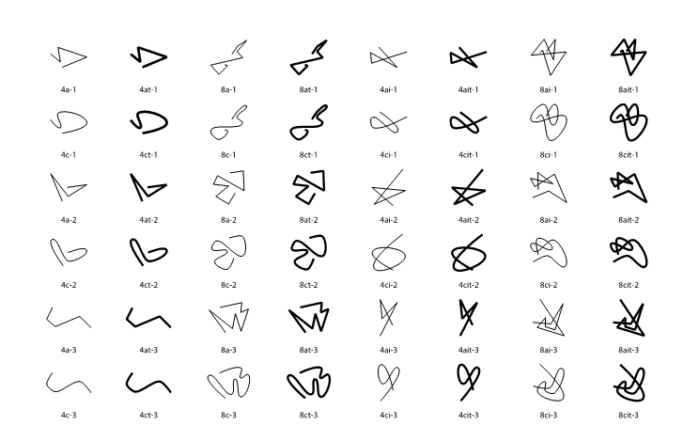

*Figure 1*: The 48 line-shapes used in the study. Line-shapes varied along four dimensions, which are indicated by the labels beneath: number of line segments (“4” vs. “8”), angularity (“a” for angular vs. “c” for curved), line thickness (presence of “t” for thick), and number of intersections (presence of “i” if shape has intersections).



**Table 1:** The titles, of the 33 musical selections used in the study, as well as the performing artists and genres.

#### **Procedure**

Participants initially signed a consent form and completed a demographic questionnaire. The first task involved making associations between the 33 musical stimuli and the 48 shape stimuli. Participants then rated each of the musical selections and each of the line stimuli along a series of 13 bipolar dimensions concerning their emotional, perceptual, and musical features. The order of the ratings tasks was balanced so that half of the participants rated the line stimuli first and the other half rated musical stimuli first. Once these three tasks were completed, participants filled out a synesthesia battery questionnaire. If the pre-screening indicated that the participant might be synesthetic, the participant would then complete a more extensive online synesthesia battery created by Eagleman, Kagan, Nelson, Sagaram, & Sarma (2007). One participant was determined to be both grapheme-color and music-color synesthetic through this process. His/her data were excluded from all analyses. All participants were debriefed after the experiment. The study was designed so that each of the eight line-shape arrangements was used by four participants.

**Task one: Music-to-line associations.**

Participants listened to each of the 33 musical selections one at a time in random order while they viewed one of the eight arrangements of all 48 line-shapes (see Figure 3). They then were asked to select the three line-shapes that they found most consistent (“went best”) with that particular musical selection. They were instructed to first click on the shape which they found most consistent with the musical selection, then the shape they found second-most consistent, and so on. Once selected, the line-shape would disappear from the grid so that it could not be re-selected. The musical selection looped until the participant had made their three line-shape choices. Then, the participant was presented with the same array of 48 shapes and was asked to select the three line-shapes they found most inconsistent (“went worst”) with that musical selection. As before, they were instructed to first click on the shape they found most inconsistent, then second-most inconsistent, and so on. The shapes would again disappear from the array so that they could not be re-selected. This procedure was repeated for each of the 33 musical selections, using the same line-shape arrangement each time.

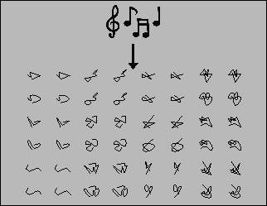

*Figure 3*: The music-line association task. Participants listened to each musical selection one at a time while viewing one of the line-shape arrangements. They were then prompted to select the three line-shapes from the array they found most consistent with that musical selection and the three shapes they found least consistent with that musical selection.

**Tasks 2 and 3: Stimulus ratings.** The order of the second and third tasks was varied so that half of the participants performed the line-dimension rating task first and the other half performed the music-dimension rating task first.

***Line-dimension rating task.*** The participant was presented with each of the 48 line-shapes one at a time in random order and was asked to rate each shape along a series of 13 bipolar dimensions (Calm/Agitated, Disharmonious/Harmonious, Dislike/Like, Light/Heavy, Monotonous/Interesting, Not Angry/Angry, Open/Closed, Sad/Happy, Simple/Complex, Slow/Fast, Smooth/Sharp, Soft/Loud, and Sparse/Dense). Each line-shape appeared at the center of the computer screen, and a slider scale with an adjustable bar was placed below it. Each end of the scale was labeled with a word indicating one extreme pole of the dimension (See Figure 4). The participant was instructed to rate the shape along that bipolar dimension by sliding the bar’s position along the continuous scale and clicking to record their response. The slider bar was one pixel in width, and the scale itself was 400 pixels in width, so that their response correlated to a rating between -200 and 200 for that dimension. The center of the scale indicated neutrality and was marked with a tick for the participant’s reference. The slider was placed in the middle of the scale at the start of each iteration.

***Task 4: Music-dimension rating task.*** In this task, participants were presented with each musical selection one at a time in random order and asked to rate each along the same 13 bipolar dimensions using the same procedure as for the line-dimension task described above.

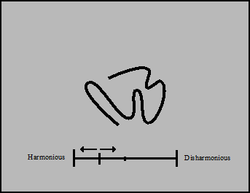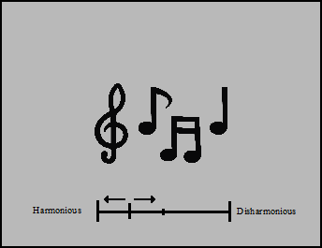

*Figure 4:* The line-dimension and music-dimension rating tasks. Participants were presented with each line-shape and musical stimulus one at a time in random order, then were instructed to move a bar along a continuous scale to rate each stimulus along a series of 13 bipolar dimensions (e.g., Disharmonious/Harmonious). Note that arrows were not displayed in the experiment, but are included here to signify the possible movements of the slider bar. Similarly, the participant did not see musical notes during the music-dimension rating task (just the dimensional scale), but it is included here to represent the fact that the participants heard music during that task.

**Results**

Music-Shape Association scores (*MSA*s) were computed to examine the correlation between each musical selection and line-shapes chosen as consistent with that selection along each of the 13 bipolar dimensions. The calculation is modeled after the Music-Color Association scores used by Palmer et al. (2013) and is computed as follows:

(1) *Cd,m = (3c1,d,m + 2c2,d,m + c3,d,m)/3*

(2) *Id,m = (3i1,d,m + 2i2,d,m + i3,d,m)/3*

(3) *MSAd,m= Cd,m – I­d,m*

where *cj,d,m* is the average rating for the *j*th line chosen as consistent (*c*) with musical selection *m* along dimension *d*, and *ij,d,m* is the average rating for the *j*th line chosen as inconsistent (*i*) with musical selection *m* along dimension *d.* Each shape’s dimensional rating is weighted by the order in which it was picked, so that the values for the most consistent and inconsistent shapes are multiplied by three, second-most consistent and inconsistent multiplied by 2, and so on. The average values for the most inconsistent shapes (*Id,m*) are subtracted from the average values for the most consistent shapes (*Cd,m*) to compute a single Music-Shape Association score for each musical selection along each dimension. Figures 5,6, and 7 show the MSA values (y-axis) plotted against the average ratings for each musical selection (x-axis) in order to observe music-line shape correlation along the emotional, perceptual, and musical dimensions, respectively.

**Correlations Along Emotional Dimensions**

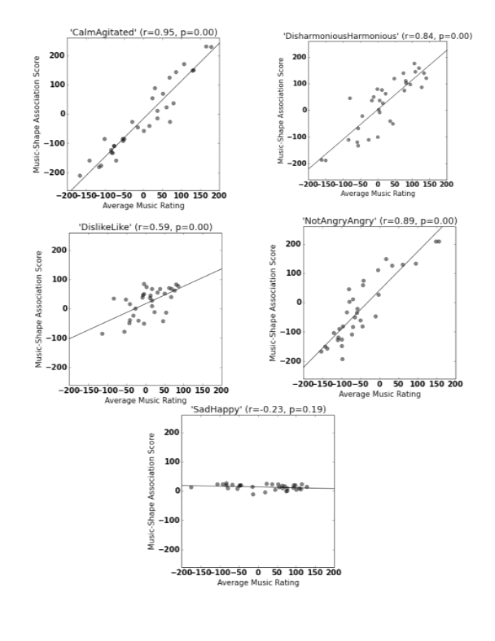

*Figure 5*: Correlations between the emotional ratings of the musical selections and the line-shapes chosen as consistent with those selections. Average music ratings appear along the x-axis and MSA scores appear along the y-axis. Calm/Agitated showed the strongest correlation (r=0.95, p<0.001), while Sad/Happy showed a statistically insignificant correlation (r=0.23, p=0.19), and Dislike/Like showed the weakest statistically significant correlation (r=0.59, p<0.001).

**Correlations Along Perceptual Dimensions**

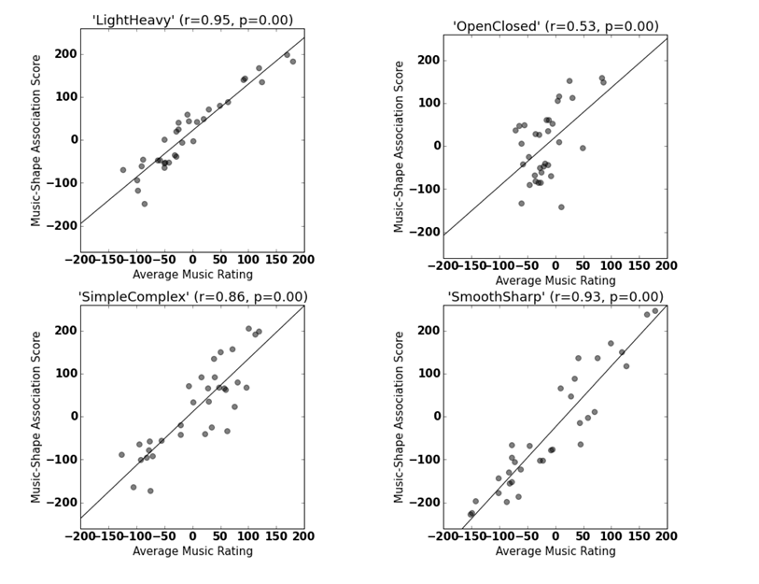

*Figure 6*: Correlations between the perceptual ratings of the musical selections and the line-shapes chosen as consistent with those selections. Average music ratings appear along the x-axis and MSA scores appear along the y-axis. Light/Heavy showed the strongest correlation (r=0.95, p<0.001), while Open/Closed showed the weakest correlation (r= 0.53, p<0.001).

**Correlations Along Musical Dimensions**

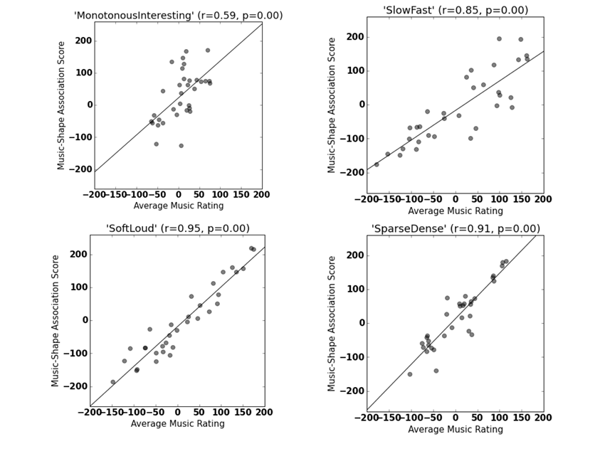

*Figure 5*: Correlations between the musical ratings of the musical selections and the line-shapes chosen as consistent with those selections. Average music ratings appear along the x-axis and MSA scores appear along the y-axis. Soft/Loud showed the highest correlation (r=0.95, p<0.001), while Monotonous/Interesting showed the weakest correlation (r=0.59, p<0.001).

All of the 13 dimensions showed statistically significant correlations (p < 0.001) between the ratings for the musical selections and the corresponding ratings of the line-shapes that were chosen as going best/worst with those selections (see Figures 5-7). The only exception was for Sad/Happy (r = -0.23, p = 0.19).

Among the five emotional dimensions, three showed very strong correlations between the emotional ratings of the music samples and line-shapes paired with each music sample (Calm/Agitated r = 0.95, Disharmonious/Harmonious r = 0.84, Not Angry/Angry r = 0.89). On the other hand, the Dislike/Like domain (r = 0.59) demonstrated the weakest statistically significant correlation. Among the four perceptual dimensions, three showed very strong positive correlations (Light/Heavy r = 0.95, Smooth/Sharp r = 0.93, Simple/Complex r = 0.86), whereas Open/Closed showed a weaker correlation (r = 0.53). Among the four musical dimensions, three showed very strong positive correlations (Soft/Loud r = 0.95, Sparse/Dense r = 0.91, Slow/Fast r = 0.85), while Monotonous/Interesting showed a weaker correlation (r = 0.59).

A principal components analysis on the emotional ratings of the musical genres showed that the five dimensions (Calm/Agitated, Disharmonious/Harmonious, Disklike/Like, Not Angry/Angry, Sad/Happy) could be reduced to two principal components that explained 91.1% of variance in the data. The first principal component (PC1) explained 73.3% of the data, and the second (PC2) explained 17.8% of the data. PC1 corresponded roughly to the agitation level of the music (PC1 loadings: Calm/Agitated = 0.963, Disharmonious/Harmonious = -0.958, Not Angry/Angry = 0.91, Dislike/Like = -0.822, Sad/Happy = 0.561). PC2 roughly represented the happiness of the music (PC2 loadings: Sad/Happy= 0.814, Dislike/Like= 0.346, Disharmonious/Harmonious= 0.196, Calm/Agitated= 0.188, Not Angry/Angry= -0.183).

We performed an analogous principal components analysis for the emotional ratings of the line-shapes. The solution was very similar to that of the emotional ratings of the musical genres. The five emotional dimensions could be reduced to two principal components that explained 79.4% and 17.5% of variance in the data, respectively, for a total of 96.9% of the data explained by the two components. The first principal component corresponded roughly to the harmony of the lines (PC1 loadings: Disharmonious/Harmonious = 0.987, Not Angry/Angry = -0.974, Calm/Agitated = -0.956, Dislike/Like = 0.941, Sad/Happy = 0.498), whereas the second principal component corresponded roughly to the happiness of the lines (PC2 loadings: Sad/Happy = 0.860, Calm/Agitated = 0.251, Not Angry/Angry = 0.188, Dislike/Like = 0.134, Disharmonious/Harmonious = -0.133).

**Discussion**

The current study reveals that participants consistently matched musical selections with line-shapes that affected a shared emotional response. The shared Agitation and Angriness levels of the stimuli were the most significant mediating factors, similar to findings in the Whiteford et al. study on musical genres and color (2013) and the Malfatti study on color and line shape (2014). These results support the emotional mediation hypothesis. The perceptual and musical dimensions tended to have very high correlations as well, indicating that any of these three dimensional categories could play an important role in mediating systematic music-to-line associations.

When analyzing musical stimuli across dimensional categories, it was apparent that certain musical dimensions correlated highly with certain emotional dimensions (p < 0.01 for all correlations; See Appendix C for full correlation table). Most notably, the Calm/Agitated dimension correlated strongly with several musical dimensions (Soft/Loud r = 0.958, Slow/Fast r = 0.909, Sparse/Dense r = 0.908, Monotonous/Interesting r = 0.566), indicating that the agitation of a musical selection corresponds strongly to its loudness, quickness, and density, but not necessarily to its level of interest for the subject. It is unclear whether we have a representative enough sample of musical genres to generalize across all music, but this is certainly an intriguing relation that deserves further exploration.

Similar effects occurred across dimensional categories for the line ratings (See Appendix C for full correlation table). In particular, the Smooth/Sharp dimension correlated highly with various emotional dimensions (Not Angry/Angry r = 0.949, Calm/Agitated r = 0.940, Dislike/Like r = -0.847, Sad/Happy r = -0.357, p < 0.05 in all cases). This result indicates that the sharp lines in our sample are viewed as angry and agitated, and are generally disliked.

The relative Calmness and Harmony of the line-shapes and music tended to be the most important associative factors. The line-shapes that were rated as most calm were curved, non-intersecting, lines with few segments; the most harmonious lines were the lines that shared those same characteristics. This implies that harmonious, calm lines are those that are simple, non-intersecting, and curved. The most agitated lines were the angular, intersecting, thick lines with the most line segments; the most disharmonious were the angular, intersecting lines with the most line segments. Agitated, disharmonious lines can then be interpreted as possessing those qualities. Interestingly, line thickness did not seem to play a vital role in determining the perceived Calmness or Harmony of the line-shapes. For music, the Calmest genres were Piano, Indie, and Soundtrack, whereas the most Agitated were Heavy Metal, Dubstep, and Ska. The most Harmonious musical genres were Mozart, Smooth Jazz, and Indie, whereas the most Disharmonious were Dubstep, Heavy Metal, and Gamelan.

It is important to note that the musical selections used in this study were chosen by Whiteford et al. to be representative of the genre, but the measurements we report here should be interpreted in terms of each particular selection, rather than representative of the entire genre. Furthermore, the evidence presented here is purely correlational, and therefore does not establish a causal relation between emotional, perceptual, or musical feature mediation in shape-music associations. Future research could examine correlations between line-shapes and musical genres on a broader scale and clarify the respective roles of emotional, perceptual, and musical mediating factors in producing the observed pattern of associations. It would also be interesting to study how these associations are affected by various levels of perceptual organization.

The results presented here could be useful in creating multimedia art works that strongly evoke certain emotions by utilizing emotionally complementary shapes and music. Commercially, the associations made between music and form could be utilized to create album covers that accurately represent the emotions of the music. Using an understanding of correlated shapes and music, music educators can reinforce their pupil’s learning by incorporating stimuli for multiple senses, which could help those students who differentially prefer visual or auditory learning. Although it is not clear that the stimuli used in the study actually made the participants feel the emotions they assigned to the stimuli, further research in this area could help predict emotional responses to music and/or shapes, as well as the emotions felt during painting or music composition. Art and music therapists could use that information to develop a more enriched understanding of the emotions experienced by their patients by viewing the musical and perceptual features of that patient’s creations. Furthermore, they could soothe agitated patients with fittingly calm artwork and music as identified through research supplemental to this study. In a psychiatric setting, therapists may be able to better communicate with patients who have trouble interpreting emotions in other people (such as those with Asperger’s Syndrome) by using visual or musical stimuli as identified through this study in conjunction with past and future studies.

**References**

Bond, B., & Stevens, S. S. (1969). Cross-

modality matching of brightness to loudness by 5-year-olds. Perception & Psychophysics, 6, 337–339.

Braaten, R. (1993). Synesthetic

correspondence between visual location and auditory pitch in infants. Paper presented at the 34th Annual Meeting of the Psychonomic Society.

Cohen Kadosh, R., Henik, A., & Walsh, V.

(2009). Synaesthesia: Learned or lost? Developmental Science, 12, 484–491.

Eagleman, D.M., Kagan, A.D., Nelson, S.S.,

Sagaram, D., & Sarma, A.K. (2007). A standardized test battery for the study of synesthesia. *Journal of Neuroscience Methods, 159*(1), 139-145.

Gallace, A., & Spence, C. (2006).

Multisensory synesthetic interactions in the speeded classification of visual size. Perception & Psychophysics, 68, 1191–1203.

Goldberg, T., & Schrack, G. (1986).

Computer-Aided Correlation of Musical and Visual Structures. *Leonardo, 19* (1), 11-17. Retrieved 2015, from JSTOR.

Griscom, W., & Palmer, S. (2012, May).

*The Color of Musical Sounds: Color Associates of Harmony and Timbre in Non-synesthetes*, Poster Presented at the 12th annual meeting of the Vision Sciences Society, FL.

Griscom, W., & Palmer, S. (2013, May).

*Cross-modal Sound to Sight Associations with Musical Timbre in Non-synesthetes*, Poster Presented at the 13th annual meeting of the Vision Sciences Society, FL.

Imai, M., Kita, S., Nagumo, M., & Okada,

H. (2008). Sound symbolism facilitates early verb learning. Cognition, 109, 54–65.

Köhler, W. (1929). *Gestalt psychology*. New

York: Liveright.

Kussner, M. (2013). Music and Shape.

*Literary and Linguistic Computing, 28*(3), 472-479. Retrieved 2015, from Oxford Journals.

Langlois, T., Peterson, J., Palmer, S. (2014,

May). *Visual Texture, Music, and Emotion,* Poster presented at the 14th annual meeting of the Vision Sciences Society, FL.

Lewkowicz, D. J., & Turkewitz, G. (1980).

Cross-modal equivalence in early infancy: Auditory–visual intensity matching. Developmental Psychology, 16, 597–607.

Malfatti, Michela (2014) *Shape-to-color*

*associations in non-synesthetes: perceptual, emotional, and cognitive aspects.* PhD thesis, University of Trento.

Marino, G., Serra, M., & Raczinski, J.

(1993). The UPIC System: Origins and Innovations. *Perspectives of New Music,* *31*(1), 258-269. doi:10.2307/833053

Marks, L. E. (1987). On cross-modal

similarity: Auditory–visual interactions in speeded discrimination. Journal of Experimental Psychology: Human Perception and Performance, 13, 384–394.

Mondloch, C. J., & Maurer, D. (2004). Do

small white balls squeak? Pitch–object correspondences in your children. Cognitive, Affective & Behavioral Neuroscience, 4, 133–136.

Morgan, G. A., Goodson, F. E., & Jones, T.

(1975). Age differences in the associations between felt temperatures and color choices. The American Journal of Psychology, 88, 125–130.

Palmer, S. E., Schloss K. B., Xu, Z., Prado-

León, L. R. (2013). Music-colour associations are mediated by emotion. Proceedings of the National Academy of Sciences, USA, 110, 8836–8841.

Palmer, S., Langlois, T., Tsang, T., Schloss,

K., & Levitin, D. (2011, May). *Color, Music, and Emotion*, Poster presented at the 11th annual meeting of the Vision Sciences Society, FL.

Peterson, J., Langlois, T., & Palmer, S.

(2014, May). *Cross-modal associations from musical timbres and intervals to visual textures,* Poster presented at the 14th annual meeting of the Vision Sciences Society, FL.

Schloss, K., Lawler, P., & Palmer, S. (2008,

May). *The Color of Music,* Poster presented at the 8th annual meeting of the Vision Sciences Society, FL.

Simner, J., Mulvenna, C., Sagiv, N.,

Tsakanikos, E., Witherby, S. A., Fraser, C., et al. (2006). Synaesthesia: The prevalence of atypical cross-modal experiences. Perception, 35, 1024–1033.

Simner, J., & Hubbard, E. (Eds.). (2013).

*The Oxford handbook of synesthesia.* New York, New York: Oxford University Press.

Spence, C. (2011). Crossmodal

correspondences: A tutorial review. *Attention, Perception, & Psychophysics*, 73 (4). 971-995. Retrieved 2015, from JSTOR.

Walker, R. (1987). The effects of culture,

environment, age, and musical training on choices of visual metaphors for sound. *Perception & Psychophysics, 42* (5), 491-502. Retrieved 2015, from Google Scholar.

Whiteford, K., Schloss, K. B., & Palmer, S.

E. (2013). Music-Color Associations from Bach to the Blues: Emotional Mediation in Synesthetes and Non-synesthetes. Poster presented at the 13th Annual Meeting of the Vision Science Society, Naples, Florida,

May 2013.

**Appendix A**

#### Synesthesia Battery Pre-screening Questionnaire

Subject #: _________

1. Does seeing, thinking of, or hearing a number (e.g. Arabic or Chinese) cause a perception of color?

☐ Never ☐ Rarely ☐ Sometimes ☐ Often ☐ All the time

2. Does seeing, thinking of, or hearing a letter cause a perception of color?

☐ Never ☐ Rarely ☐ Sometimes ☐ Often ☐ All the time

3. Does the concept of dates such as days (e.g. Monday, Tuesday), or months (e.g. January, February) trigger a color?

☐ Never ☐ Rarely ☐ Sometimes ☐ Often ☐ All the time

4. Do you visualize numbers, letters or time units like weekdays or months as being spread out in a 3D space around you?

☐ Never ☐ Rarely ☐ Sometimes ☐ Often ☐ All the time

5. Do individual keys on a piano or other instrument cause the perception of different colors?

☐ Never ☐ Rarely ☐ Sometimes ☐ Often ☐ All the time

6. Do different musical chords cause perception of different colors?

☐ Never ☐ Rarely ☐ Sometimes ☐ Often ☐ All the time

7. Do different musical instruments cause perception of different colors?

☐ Never ☐ Rarely ☐ Sometimes ☐ Often ☐ All the time

8. Do individual keys on a piano or other instrument cause the perception of different shapes?

☐ Never ☐ Rarely ☐ Sometimes ☐ Often ☐ All the time

9. Do different musical chords cause perception of different shapes?

☐ Never ☐ Rarely ☐ Sometimes ☐ Often ☐ All the time

10. Do different musical instruments cause perception of different shapes?

☐ Never ☐ Rarely ☐ Sometimes ☐ Often ☐ All the time

11. Do tastes trigger a color for you? For example, does the taste of chocolate, citrus, or banana trigger a color?

☐ Never ☐ Rarely ☐ Sometimes ☐ Often ☐ All the time

12. Do smells trigger a color for you? For example, does the odor of steak or fries cause the perception of a color in you?

☐ Never ☐ Rarely ☐ Sometimes ☐ Often ☐ All the time

13. Does pain trigger a color for you? For example, do different levels of pain you experience at different times, say while having a headache, cause you to perceive color?

☐ Never ☐ Rarely ☐ Sometimes ☐ Often ☐ All the time

14. Does seeing or thinking of a person make you perceive a color?

☐ Never ☐ Rarely ☐ Sometimes ☐ Often ☐ All the time

15. Do tactile sensations trigger a color for you? For example, when you experience touch sensations of different kinds, on different parts of your body, do you also perceive color?

☐ Never ☐ Rarely ☐ Sometimes ☐ Often ☐ All the time

16.Do heat and cold trigger colors in you? For example, does touching cold water or feeling warm water in a shower cause you to perceive different colors?

☐ Never ☐ Rarely ☐ Sometimes ☐ Often ☐ All the time

17. Do you perceive different colors while experiencing a sexual orgasm?

☐ Never ☐ Rarely ☐ Sometimes ☐ Often ☐ All the time

18. Do different emotions like joy, gloom cause perception of color?

☐ Never ☐ Rarely ☐ Sometimes ☐ Often ☐ All the time

19. Does seeing a picture or a scene also cause you to hear a sound?

☐ Never ☐ Rarely ☐ Sometimes ☐ Often ☐ All the time

20. Does hearing a sound cause a distinct odor, like the noise of water gushing arouses the smell of a rose?

☐ Never ☐ Rarely ☐ Sometimes ☐ Often ☐ All the time

21. Does seeing a picture, object or a scene cause you to perceive a distinct smell?

☐ Never ☐ Rarely ☐ Sometimes ☐ Often ☐ All the time

22. Does hearing a sound cause a sensation of touch for you? For example, does hearing an airplane fly past cause a distinct sensation of touch?

☐ Never ☐ Rarely ☐ Sometimes ☐ Often ☐ All the time

23. Does hearing a sound cause a sensation of taste for you? For example, does the ticking of a clock cause a sour taste in your mouth?

☐ Never ☐ Rarely ☐ Sometimes ☐ Often ☐ All the time

24. Does seeing a picture, object, or a scene cause the sensation of a taste for you?

☐ Never ☐ Rarely ☐ Sometimes ☐ Often ☐ All the time

25. Does sign language (e.g. American Sign Language, British Sign Language) cause a perception of color for you?

☐ Never ☐ Rarely ☐ Sometimes ☐ Often ☐ All the time

26. Does the alphabet (e.g. Cyrillic, Greek, Hebrew) cause experiences of color for you?

☐ Never ☐ Rarely ☐ Sometimes ☐ Often ☐ All the time

27. We have described a few types of synesthesia. Many other unusual blendings of the senses have been reported. Do you suspect that you experience an unusual blending that other people do not have (other than the ones listed above)? Those could include automatically hearing a sound when you see movement, or the sense of a shape being triggered by a taste, or experiencing a color when feeling pain.

☐ Yes, I believe I may have other forms of unusual sensory experiences ☐ Not that I know of

28. Please describe any other unusual blending of the senses that you think you might have and that other people do not have. If you would like to add any comments about the experiences that are mentioned in this survey as well, feel free to do so.

29. Do you have any training in music? If so, please describe the extent of your training and address your knowledge of music theory, the instruments you play, and the length of time you have spent studying or playing.

30. Do you have any training in visual art, especially drawing, graphics programming or painting? If so, please describe the extent of your training and address your technical knowledge, the art forms you have studied or practiced, and the length of time you have spent studying or practicing.

**Appendix B**

#### Line-shape Stimuli Arrangements with the Line-shape Labels

*These were not displayed during the experiment, but are included here for ease of reference*

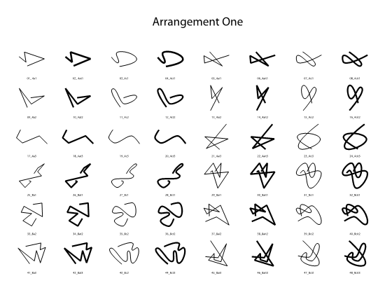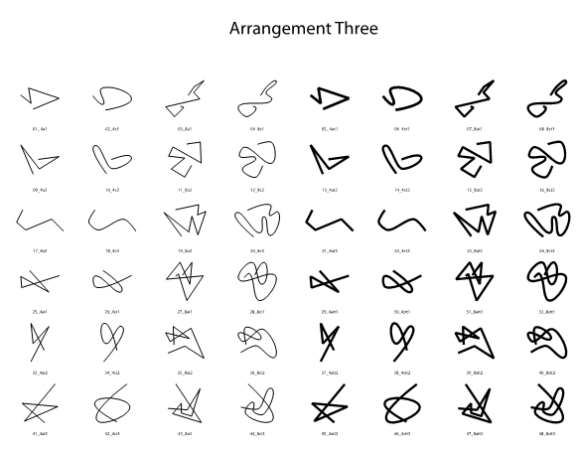

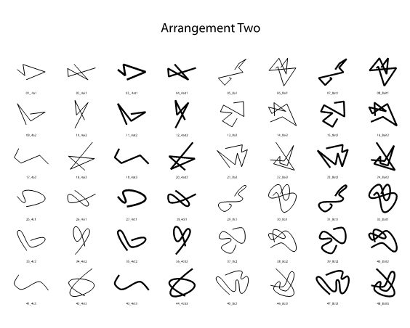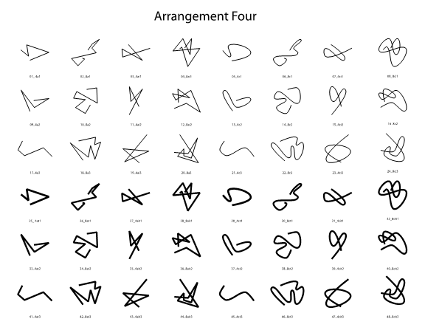

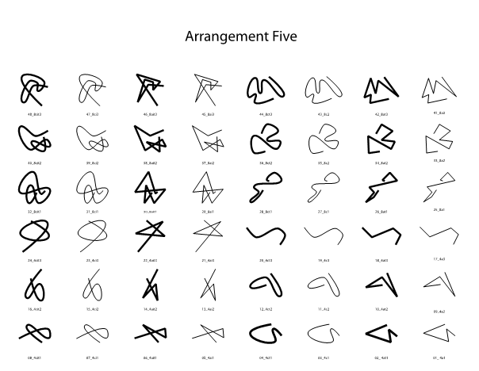

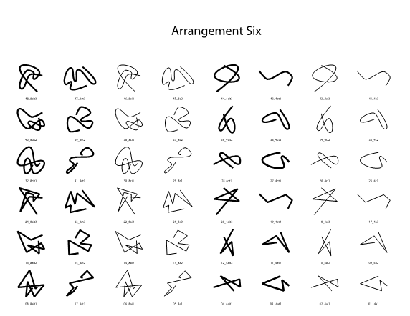

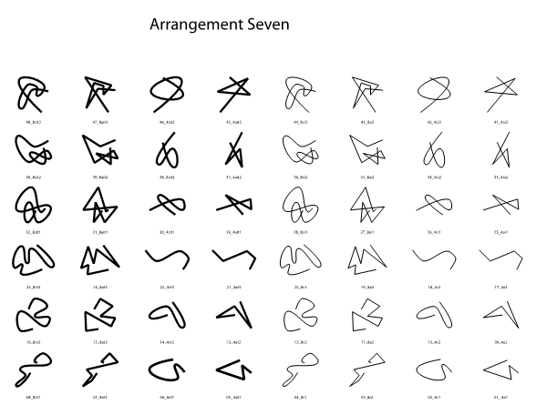

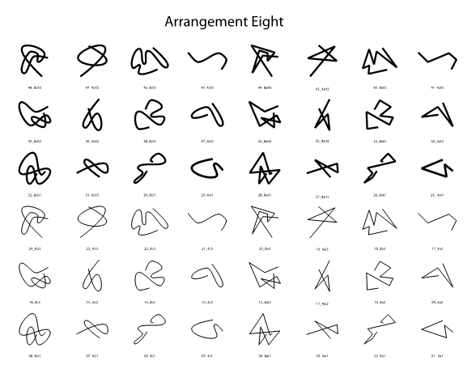

**Appendix C**

#### Line-Shape Dimensional Correlation and Musical Genre Dimensional Correlation Tables

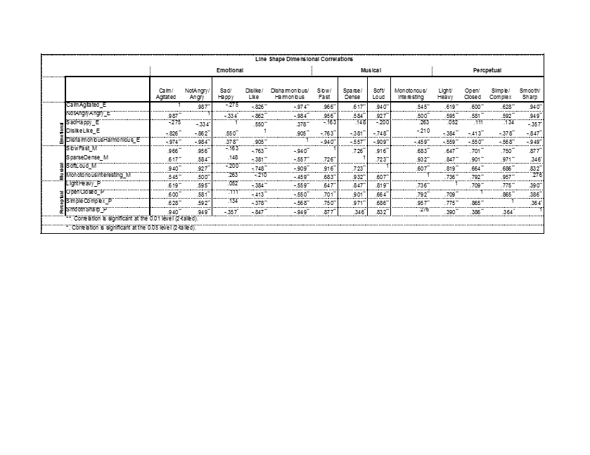

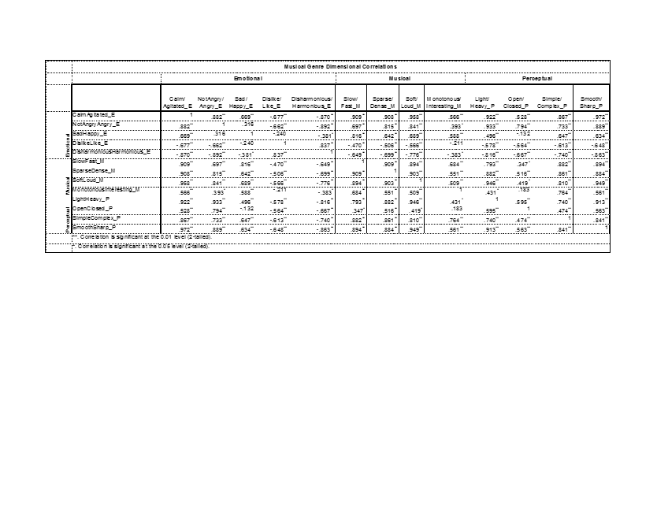

***Deficits in anxiety and social behaviors induced by early-life stress can be attenuated by Cannabinoid Type 1 Receptor Antagonism***

**Patrick M. Einhorn**

Boston College

McLean Hospital and Harvard Medical School

Early life stress (ELS) has been implicated in increasing anxiety and aggression in rats, possibly by means of modulating inhibitory GABA interneurons colocalized with cannabinoid receptors in the prefrontal cortex. We sought to investigate the developmental effects of maternal separation (MS) and cannabinoid type 1 (CB1) receptor antagonism on anxiety and social behaviors in male and female Sprague-Dawley rats. With the use of retrospective analysis, we wished to discover if juvenile social play behaviors could be used to predict those exhibited in adulthood. As adults, rats were exposed to the CB1 antagonist, rimonabant (Rim), or vehicle (Veh) prior to the elevated plus maze, marble burying, and social interaction. With immunohistochemistry, we investigated whether changes in calbindin and calretinin-expressing GABAergic interneurons in the medial prefrontal cortex may mechanistically underlie behavioral deficits. Sex differences in adult social behavior resulted from MS, most notably an increase in aggression and evasion in male adults. Rim treatment uncovered a trend of decreased anxiety in MS, but increased anxiety in controls (CON). Rim reduced social and explorative behaviors in males, but increased the crossovers and stretch-attend postures in females in the elevated plus maze. Juvenile social play behaviors were predictive of some behaviors in adulthood. A moderate trend was observed for the interaction of condition, cell type, region, and cortical layer. This trend, along with prior research, suggests that differences in anxiety and social behavior seen in adults are differentially affected by Rim treatment dependent on changes in GABAergic interneuron subpopulations resulting from early life stress.

**Early Life Stress (ELS)**

E

arly life stress (ELS) and other developmental insults significantly increase one’s susceptibility to long-lasting psychiatric pathologies and substance-abuse disorders later in adulthood (Cadet, 2014). Although exposure to stress, both prior to and during adolescence, can promote the onset of behavioral and cognitive disturbances, early childhood appears to be the most significant sensitive period of development (Leussis, Freund, Brenhouse, Thompson, & Andersen, 2012). Models of ELS, particularly maternal separation (MS), are quite effective in promoting the emergence of these pathologies during late adolescence and early adulthood, just as in the human population (Huot, Lenox, & McNamara, 2002; Andersen & Teicher, 2008).

**Medial Prefrontal Cortex and Behavioral Development**

Leading up to adolescence, many developmental processes, such as cell migration and differentiation, take place along with the development and maturation of the dopaminergic, GABAergic, and endocannabinoid systems, which continue to mature during childhood (Viveros et al., 2011). As a result, childhood stress can induce long-standing behavioral deficits, such as heightened risk of developing problems with drug abuse and psychopathology (Lupien et al., 2009). Of particular interest is the medial prefrontal cortex (mPFC). The mPFC mediates the stress response of the hypothalamic-pituitary-adrenal axis (Seidel, Poeggel, Holetschka, Helmeke, & Braun, 2011; Groenewegen & Uylings, 2000). Recent evidence also indicates that the mPFC is integral to the reinforced learning and acquisition of drug-seeking behaviors and the mediation of its rewarding effects (Tzschentke, 2000). The mPFC acts as an inhibitory brake on emotional neural activity through its projections to the amygdala, and also on reward-driven behaviors through projections to the nucleus accumbens (Seidel et al., 2011; Elzinga & Bremner, 2002). Therefore, the mPFC is crucial to higher-order functions such as planning, decision-making, personality expression, motivation, and social behavior. Lesions to the mPFC disrupt executive function and decrease a subject’s behavioral inhibition, leading to the facilitation of drug-seeking behaviors (Weissenborn et al., 1997), as well as relapse (Kalivas et al., 2005; Kalivas & Volkow, 2005).

**ELS and Drug Use**

Prior preclinical research indicates that ELS, such as MS, is also predictive of later life illicit drug-seeking behaviors and drug usage (Gordon, 2002; Lynch, Mangini, & Taylor, 2005; Lehmann, Stöhr, & Feldon, 2000). Some of these behaviors may be due in part to repeated stress, which has been found in adult rats to increase neuronal atrophy (Liston et al., 2006), as well as decrease both dendritic density and dendritic branching within layers 2 and 3 of the mPFC’s anterior cingulate cortex (ACC) and prelimbic (PL) areas (Radley et al., 2004; Radley et al., 2006). Accordingly, there is a need for further investigation into MS’s role in increasing susceptibility to drug abuse later in development using mPFC modulation.

**ELS and Social Behaviors**

ELS has also been implicated in increasing anxiety and reducing sociality in both rats and humans. Animals exposed to ELS spent more time in the closed arms of the elevated plus maze (EPM), indicating the presence of anxiety (Girardi, Zanta, & Suchecki, 2014). MS also promotes depressive-like behavior (immobility), increases stress hormone response in the forced swim test, and increases aggression between males when compared to controls (Veenema et al., 2006). To date, there has been no investigation into the effects of marble burying (MB) in measuring anxiety. Rather than measuring anxiogenic avoidance behavior, like in the EPM, MB uncovers perseverative anxious behavior; when the animal subject is placed into a novel setting with glass marbles evenly spaced throughout, anxious subjects will bury more marbles when compared to controls, providing an effective means of measuring anxiety-like behavior (Handley, 1991). Resultantly, we predict that MS rats will likely exhibit more anxiety than controls by exhibiting increased MB and decreased time in the open arms of the EPM. Juvenile social play will be used as a predictive model of adult anxiety following ELS.

Juvenile social play behavior is rewarding and offers a multitude of developmental benefits. For example, rough-and-tumble play, consisting of pouncing and pinning play partners, allows juvenile rats to gain motor training (Pellis & Pellis, 2007), as well as experience with unexpected situations and stimuli (Pellis & Pellis, 2005; Baldwin and Baldwin, 1977). As a result, early life socialization may function to foster a rat subject’s ability to interact with one another as they age, thereby establishing stable adult social relations (Panksepp, 1981).

MS increases aggressive play fighting (biting and tail-pulling) in juvenile male rats (Veenema et al., 2009); behaviors which remain into adulthood (Veenema et al., 2006). Consequently, it may be possible to use juvenile social play as a means of predicting adult social behaviors. We expect an increase in aggressive behaviors in MS rats during juvenile social play and adult social interaction (Veenema et al., 2009; Veenema et al., 2006). Little previous research has investigated the effects of MS on anxiety and social behaviors in female rats. This experiment hopes to bridge the gap in the previous literature by investigating juvenile and adult gender differences in these behaviors, as well as the role of the mPFC, particularly GABAergic interneurons, implicated in regulating top-down inhibition on anxiety and social behavior. Given the mPFC’s role in coordinating social and anxious behavior, as well as MS’s ability to disrupt mesocortical development, adult social deficits are expected. As such, the MS subject should continue to exhibit aggressive behaviors.

**GABA**

Recent evidence has shown that many behavioral deficits promoted by MS are highly correlated with GABAergic dysfunction within the PFC (Le Magueresse & Monyer, 2013). GABA neurons can be found throughout the brain’s cortex, with the majority of GABA neurons synapsing locally while functioning as interneurons (Inan, Petros, & Anderson, 2013). GABA neurons and the circuitry they regulate are particularly immature in early life stages. These GABA neurons require a protracted period of development in order to carefully refine cortical circuitry during development (Reynolds, Zhang, & Beasley, 2001; Cotter et al., 2002). Manipulation of infant-mother relationships during neonatal development produces both short and long-lasting effects in the GABAergic system (Giachino et al., 2007; Pryce & Feldon, 2003). Additionally, early GABAergic signaling can affect many aspects of cellular maturation and synaptic plasticity (Heck et al., 2007) that extend into early adulthood (Hashimoto, 2009; Lewis, Hashimoto, & Volk, 2005).

Maintaining healthy cortical function requires a carefully calibrated balance between inhibition and excitation (Okun & Lampl, 2009; Haider et al., 2006). By shaping neural responsiveness, preventing excess excitation, refining cortical receptive fields, and maintaining the synchronization of cortical activity, GABA interneurons allow their circuits to remain malleable in order to react to stressful stimuli in a healthy manner (Rossignol, 2011). Thus, the proper regulation and recalibration of these circuits are vital to their maintenance and continued development in an effort to achieve normal cognitive and behavioral functioning.

**GABA Dysfunction**

Any reduction in the density of GABAergic neurons can create pervasive disturbances within cortical circuits due to their control over the modulation and calibration of activation and inhibition (Rossignol, 2011). Within the PFC, the role of GABAergic interneurons appears to be at least partly to blame for the emergence of psychopathological and drug-related behaviors (Keverne, 1999; Miller & Marshall, 2004;). Through the recruitment of the hypothalamic-pituitary-adrenal (HPA) axis, along with the adrenal-medullary system’s sympathomimetic response, stress rapidly induces central and peripheral nervous system effects (Skilbeck, Johnston, & Hinton, 2010). It has been hypothesized that GABAergic interneuron dysfunction could be due in part to either excitotoxicity induced by excess excitatory transmission (Yizhar et al., 2011; Marin, 2012), or the early maturation of GABAergic interneurons as a result of a sustained increase in transmission within the neural circuitry (Yizhar et al., 2011; Marin, 2012).

With reduced GABAergic interneuron signaling, one could predict excessive excitation within the circuit to be responsible for the neuronal damage seen within the population (Olney & Farber, 1995). In rats, acute and recurrent stress can reduce GABA binding affinity in the PFC (Biggio et al., 1981; Caldji, Diorio, & Meaney, 2000). Likewise, ELS reduces the number of high-affinity GABA binding sites in the mPFC (Caldji et al., 2000; Plotsky et al., 2005), as well as increases anxiety and HPA axis hyperresponsiveness to stress (Giachino et al., 2007). Though the mechanism for GABAergic neuron loss is not yet fully understood, it is evident that ELS does disrupt mesocortical inhibition via changes in GABAergic interneurons (Nemeroff, 2003). Though many MS models have focused on behavioral deficits exhibited in adulthood (Réus et al., 2011; Holland, Ganguly, Potter, Chartoff, & Brenhouse, 2014), there is significant evidence to indicate the emergence of psychopathological and drug-related symptoms as early as adolescence (Andersen & Teicher, 2009).

**Calcium-Binding Protein (CBP) and GABA Interneurons**

CBP-expressing interneurons are of particular interest because these cell types are widely distributed across the nervous system and express proteins that are considered modulators of intracellular calcium (Schwaller, Meyer, & Schiffman, 2002; Mueller et al., 2005; Giachino et al., 2007). Research has shown that these neurons help control synaptic plasticity (Gurden et al., 1998; Schwaller et al., 2002) and the cell’s ability to maintain sustained firing by regulating intracellular calcium (Lin, Arai, Lynch, & Gall, 2003). The CBPs expressed in these neuronal populations reversibly bind calcium, thereby influencing the cells’ likelihood of propagating an action potential (Hendry et al., 1989; Kawaguchi & Kubota, 1997). These interneurons balance GABAergic interneuron excitability, neurotransmitter release, and its resulting GABA-mediated inhibition on its synaptic projections. MS studies investigating the relative density and distribution of these populations have yielded conflicting results, though it appears that overall, MS may reduce CBP-type protein expression in GABAergic interneurons in the mPFC (Helmeke, Ovtscharoff, Poeggel, and Braun, 2008).

Changes in populations of GABAergic interneurons that are immunopositive for CBPs increase an individual’s vulnerability to psychopathological behavior later in life (Lewis et al., 2005). There are far fewer studies documenting the histology of Calbindin (CB) and Calretinin (CR) within the mPFC of those at risk for psychological illness and substance abuse than other classes of CBP-expressing GABA interneurons, such as Parvalbumin (PV). As such, this investigation has been restricted to Calbindin (CB) and Calretinin (CR) expressing GABA interneurons in the mPFC.

Most studies investigating CB regarding anxiety, depression, or maternal stress have found a net reduction in cortical populations as compared to controls (Pascual et al., 2007; Lephart & Watson, 1999; Xu et al., 2011). However, one study has documented no changes in CB (Cotter et al., 2000), while another found a net increase in CB expressing GABAergic interneurons (Daviss & Lewis, 1993). Unfortunately, in the only previous study that has investigated changes in CR following MS, no change in CR expression was found in male Octodon Degus when compared to controls (Helmeke et al., 2008). These conflicting results warrant further investigation into medial prefrontal changes in CR and CB interneuron populations. By representing ELS through repeated neonatal MS for four hours daily from P2-P20, in conjunction with fluorescent immunohistochemistry, we were able to compare the relative distribution and the frequency of CB and CR GABAergic interneurons within the mPFC of male adolescent (P40) Sprague-Dawley rats. This method allowed for the analysis of co-localization of both CB and CR subpopulations throughout layers 2/3 and 5/6 across the ACC, PL, and IL regions of the mPFC. Given previous findings, we expect to see a reduction in CB and CR interneurons in MS subjects during adolescence.

A recent study by Wedzony and Chocyk (2009) reported that CB-expressing GABAergic interneurons were colocalized with cannabinoid type (CB1) receptors within the mPFC of male Wistar rats. Given that adolescent marijuana usage increases the proclivity of users to develop substance abuse and various other psychoses, along with the colocalization of CB1 receptors on GABAergic interneurons immunopositive for CB (but not PV or CR), it is possible that marijuana usage may exacerbate the disturbances already incurred in the prefrontal GABA system as a result of ELS (Wedzony & Chocyk, 2009).

**Endocannabinoids**

The endocannabinoid system modulates many different neural activities in various regions of the brain, particularly the regulation of stress and emotional behavior in the PFC and HPA axis (Herkenham et al., 1990; Katona, 2001; Mackie, 2005). Cannabis and its primary psychoactive component, Δ9-tetrahydrocannabinol (THC), exhibit the ability to alter a subject’s reaction to stimuli, which has implicated the endocannabinoid system’s role in stress management (Patel et al., 2004; Rodriguez et al., 2013). In healthy individuals, endogenous endocannabinoids are synthesized as needed and use retrograde transmission to reduce further presynaptic transmission (Herkenham et al., 1990; Katona 2001). In the brain, the CB1 receptor has been isolated as the most abundant endocannabinoid receptor and is likely responsible for much the endocannabinoid activity in the central nervous system (Mackie, 2005). CB1 and cannabinoid type 2 (CB2) receptors are Gi/G-protein coupled. When activated by an agonist, cyclic adenosine monophosphate, and thus ATP, are reduced by CB1’s G-protein activity inhibiting the secondary messenger, adenylyl cyclase, while also enhancing the activity of mitogen-activated protein kinase (Svíženská, Dubovy, & Sulcova, 2008). Similarly, the activity of cAMP-dependent protein kinase is inhibited by reduced cAMP production (Svíženská et al., 2008). Through G-protein coupling to ion channels, CB1 activation increases the activity of inward rectifying and A-type potassium channels, reduces the activity of outward D-type potassium channels, and inhibits activity at P/Q-type and N-type calcium channels (Howlett & Mukhopadhyay, 2000; Pertwee, 1997). When CB1 is not activated by cannabinoids, PKA phosphorylates protein in potassium channels to reduce the outward movement of potassium, thereby increasing membrane potential. Similarly, cannabinoid activity at CB1 inhibits neurotransmitter release by reducing presynaptic calcium channel activity (Svíženská et al., 2008).

Unfortunately, there is little research documenting the effects of neonatal stress on an endocannabinoid system that has been taken “offline” by a direct CB1 antagonist. Given MS’s ability to induce changes in CBP-expressing GABAergic interneurons, CB1’s role in calcium-driven synaptic reactivity, and the colocalization of CB1 receptors on CBP-expressing GABAergic interneurons, manipulation using MS and CB1 antagonism should uncover how these systems interact to contribute to anxiety and social behavioral deficits.

**Cannabinoid Antagonism and Rimonabant**

Rimonabant (SR141716), is a selective synthetic CB1 antagonist (Padwal & Majumdar, 2007; Zador et al. 2015). As a direct CB1 antagonist, rimonabant binds CB1 and exerts an effect opposite to that of THC. Rimonabant blocks CB1 with high selectivity and efficacy in lower concentrations, while acting on both CB1 and CB2 at increasing levels of concentration (Svíženská et al., 2008; Jagger et al., 1998). Rimonabant may, in fact, exert behavioral effects that reflect receptor activity inhibited below baseline since CB1 receptors are tonically active in the absence of cannabinoid signaling (Ward & Raffa, 2012; Fong & Heymsfield, 2009). Not only does rimonabant mitigate the inhibitory effect of CB1 agonists on Ca2+channels, but it also increases Ca2+ channel currents when acting in the absence of an agonist (Pan, Ikeda, & Lewis, 1998). Given that MS increases susceptibility to adult psychopathology and drug use, the inhibition of the endocannabinoid system by rimonabant should allow for further analysis of the system’s role in modulating risk trajectory by measuring its effects on anxiety and social behaviors. The effect of rimonabant on CB1 receptors should increase presynaptic calcium influx, which increases neuronal excitability, synaptic activity, and neurotransmitter release. With inhibitory dysfunction following MS**,** antagonistic activity at CB1 receptors may mitigate the behavioral deficits (increased anxiety and increased aggressive social behavior) by stimulating activity at dysfunctional GABAergic interneurons previously inhibited by MS. However, recent research findings have proven inconsistent with this prediction.

Measures of anxiety induced by cannabinoid agonism and antagonism in mouse and rat models have yielded conflicting results, indicating that there may be a species difference to account for the incongruity. As for measures of anxiety, lower doses of rimonabant (1-3 mg/kg) increased the exploration of the open arms in the EPM in mice, indicating an anxiolytic effect. Also, the use of another CB1 antagonist, AM-251, was shown to dose-dependently increase anxiety-like EPM behaviors in wild-type mice (Haller, Varga, Ledent, & Fruend, 2004). Conversely, a study by Gomes, Cassarotto, Resstel, and Guimaraes (2011) found that the CB1 agonist WIN, along with endocannabinoid synthesizing protein inhibitors, AM404 and URB597, all reduced marble burying behavior in mice. In male rats, MS and exposure to the cannabinoid agonist CP55,940, increases time in the closed portion of the EPM and perimeter areas in open-field testing, indicating a significant increase in anxiety-like behaviors, which were much more prominent when rats were exposed to both MS and CP55,940 (Klug & van den Buuse, 2012). Furthermore, indirect inhibition of the cannabinoid system of mice through enzyme inhibition reduced MB, which could be prevented by rimonabant (Kinsey, O’Neal. Long, Cravatt, & Lichtman, 2011).

Unfortunately, no studies have investigated the relationship of MB and the endocannabinoid system in rats. It is apparent that the endocannabinoid system plays a sizable role in the maintenance of many social, aggressive, anxious, and depressive behaviors; therefore, when coupled with early life insults, exposure to cannabinoid antagonist/inverse agonist rimonabant may have the capacity for inducing robust changes in behavior. Despite conflicting research, rat subjects treated with rimonabant are expected to exhibit increased anxiety and decreased open arm exploration in the EPM. However, it is important to concede that this prediction is not inconsistent with the hypothesized activity of rimonabant at the receptor and synaptic levels, especially in regard to MS animals.

**CB1 and Social Behavior**

CB1-related changes in social behavior have conflicted across animal models. A preclinical study by Rodriguez-Arias et al. (2013) concluded that the CB1 receptor is critical in mediating the display of aggressive behaviors, due in part to its role in stress regulation. Accordingly, knock-out mice lacking the CB1 receptor were quicker to engage in aggressive behaviors while also exhibiting more aggressive behaviors than wild-type controls (Rodrigues-Arias et al., 2013). The administration of a CB1 agonist to aggressive wild-type/control mice was also effective in mitigating aggressive behavior. As a result, one would likely hypothesize that an antagonist would propagate aggression, given that CB1 knockout mice displayed significantly increased aggression and also that aggressive behavior in wild-type mice was reduced by administration of a CB1 agonist. However, not all studies have found similar results.

Navarro et al. (1997) found that acute intraperitoneal (i.p.) administration of rimonabant (3 mg/kg) increased anxiety-like behavior in rats in the EPM. A similar study by Schneider, Schomig, and Leweke (2008) concluded that chronic and acute treatment with the synthetic CB1 agonist, WIN 55,212-2 (WIN), during puberty (P40-65) produced significant changes in male rats’ social behaviorand play behaviorduring both puberty and adulthood. Rats chronically exposed to WIN during puberty exhibited significantly less exploration of novel conspecifics in social recognition testing, reduced total social interaction with conspecifics, and an increase in social evasion behaviors. However, acute pubertal exposure to WIN induced a net reduction in social behavior, but a significant increase in spontaneous social play behavior. Furthermore, acute WIN administration to adult rats promoted evasive behaviors and playful activities, as well as, significantly reduced social recognition, investigation of unknown social partners, anogenital exploration, and overall social behavior (Schneider et al., 2008). Notably, injection of WIN reduced social interaction in rats, whereas agonists that indirectly raise the endocannabinoid levels by reducing their metabolizing enzymes, such as the fatty acid amide hydrolase inhibitor, URB597, foster social interaction (Trezza & Vanderschuren, 2008). Currently, it is unclear if a CB1 antagonist, such as rimonabant, would propagate aggressive behavior or reduce social interactions in adults, though we expect to uncover these effects. However, such disparate findings raise the possibility that the effects of rimonabant are biphasic by dose, or that such conflicting findings may be related to maturational, species, or gender differences.

**Predictive Social Behaviors**

Social play behavior was assessed after MS during the juvenile stage (P25) to establish a behavioral baseline in MS versus CON subjects. Subjects were retested again in adulthood (social investigation) following exposure to rimonabant or vehicle to evaluate its effects on exhibited social behavior. Particularly, given that marijuana usage induces such robust behavioral and social effects in its users, the use of rimonabant should be effective in detecting inducible behavioral disturbances in social and anxiety-like behavior. In addition to increasing susceptibility to psychological illness, ELS and MS have been known to alter aggression and social interaction. Therefore, the use of anxiety paradigms and social play interaction both with and without rimonabant exposure should allow for analysis of the endocannabinoid system’s control of social and anxious behaviors.

The EPM and marble burying paradigm testing was counterbalanced and always preceded social investigation such that social interaction did not confound innate measures of anxiety. Given that recent findings have implicated both MS and rimonabant as contributing to decreased social behavior, increased anxiety and aggression, as well as, CB1 knock-out mice displaying increased aggression, we expect the administration of rimonabant will enhance these behaviors in control subjects. However, given the reduction of GABAergic inhibition seen in MS subjects, which should be activated by rimonabant, we expect MS subjects to exhibit behaviors more like that of controls receiving vehicle. Moreover, by pairing predictive and retrospective analysis of social behavior with immunohistochemistry, we sought to further investigate whether CB and CR populations in the mPFC may contribute mechanistically to the behavioral changes exhibited in subjects following MS.

**Methods**

**Animal Subjects**

On gestation day 14, pregnant female Sprague-Dawley Rats were obtained from Charles River Laboratories (Wilmington, Mass., USA). Postnatal day 0 (P0) was designated as the pup’s date of birth. Food and water were made available ad libitum to all rats, which were housed constant temperature and humidity on a 12-hr light/dark cycle (light period 0700h-1900h). For Experiment 2, new male subjects (5 MS and 5 controls), were used to control for the effects of behavioral paradigms and RIM treatment. All experiments conducted herein were in accordance with the 1996 guide for the Care and Use of Laboratory Animals (NIH) and approved by the Institutional Animal Care and Use Committee at Mclean Hospital. Experimental apparati were thoroughly cleaned with 30% ethanol solution between all trials; bedding was changed between all trials, when appropriate.

**Maternal Separation**

The MS paradigm used is identical to procedures previously conducted by this laboratory (Leussis et al., 2012), and similar to those used by others (Veenema & Neumann, 2008; Holland et al., 2014). MS was initiated on P2 when all litters were culled to 10 pups: 5 males and 5 females. By means of random assignment, these litters were designated as an MS or an animal facility reared control group (CON). Additionally, pups in Experiment 1 were randomly assigned to treatment with rimonabant or vehicle within a litter.

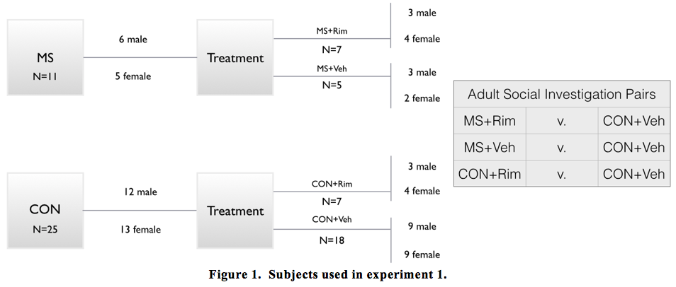

As seen in Figure 1, a total of 36 rats (18 male and 18 female, N=36) were used in Experiment 1. Of which, 6 males and 5 females were assigned to the MS condition, while 3 males and 3 females were randomly assigned to treatment with rimonabant (MS+Rim). The remaining MS subjects were assigned to treatment with Veh (MS+Veh). Of the 22 remaining controls, 3 males and 4 females were designated to treatment with rimonabant (CON+Rim) while the rest received vehicle (CON+Veh). Within Experiment 2, 10 male rats (N=10) were used: 5 MS and 5 CON.

MS animals were isolated at 22 degrees Celsius for 4 hours daily from P2 to P20. The CON rats were not disturbed after P2 except for weekly cage changing and daily weighing. On P21, rats were weaned and assigned to same-sex group housing with 2-4 rats per cage. All subjects remained in group housing until the end of experimentation, (see Figure 2 for the course of subjects and experiments).

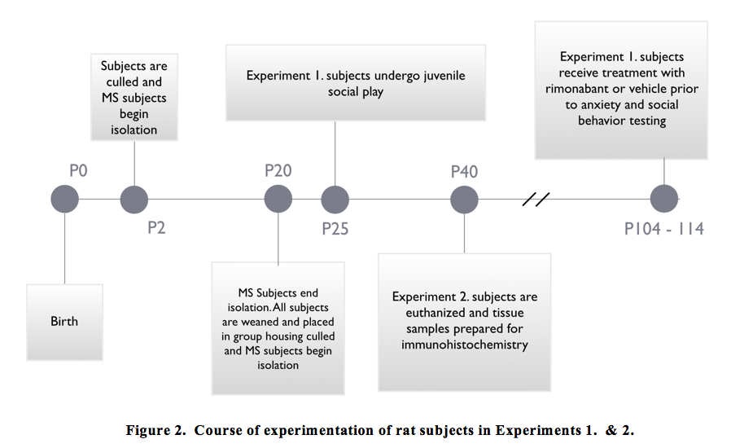

**Experiment 1**

**Drug.** Rimonabant (SR141716A,5-(4-Chlorophenyl)-1-(2,4-dichloro-phenyl)- 4-methyl-N - (piperidin-1-yl) - 1*H*-pyrazole-3-carboxamide) HCl was obtained from Sigma-Aldrich and suspended in dimethyl sulfoxide (DMSO). DMSO was used as the vehicle (Veh). Rimonabant (Rim, 3 mg/kg) or Veh was administered systemically by means of intraperitoneal (i.p) injection with a 15m period of pretreatment before testing. Injection and pretreatment time period is similar to methods used by based on methods of similar previous literature (Ward, Rosenberg, Dykstra, & Walker, 2010; Blasio et al., 2013; Järbe et al., 2011).

**Measures of Anxiety-like**

**Behaviors.**

***Elevated Plus Maze.*** The EPM paradigm used is identical to previous procedures previously by this laboratory (Andersen & Teicher, 1999) and similar to those used by others (Bredeworld, Smith, Dumais, & Veenema, 2014; Lukkes, Engelman, Zelin, Hale, & Lowry, 2012). Rats were placed into the EPM located 50 cm above the ground with two 50 cm long closed arms and two 50 cm long open arms for 5 min. During this testing period, the time spent by the rat in the closed and open arms was recorded. Additionally, the total number of crossovers between open and closed arms, as well as, stretch-attend (SA) postures was recorded.

***Marble Burying.*** To investigate an additional measure of anxiety-like behavior, the marble-burying paradigm used was similar to that used by Skelton et al. (2010) and Kinsey et al. (2011). Rats were placed for 15 min into an opaque cage (41 cm x36 cm x 10 cm) with 5cm of bedding with 24 evenly spaced glass marbles placed on top of the bedding. At the end of the testing period, the number of buried marbles was measured and recorded. A marble is classified as having been buried if 67.7% or more of its surface was covered with bedding.

**Measures for Social Behaviors.**

***Juvenile Social Play.*** All rats were tested for social behaviors at P25, and again in adulthood after treatment with Rim or vehicle. Testing was conducted in a room separate from the housing. Within this protocol, an MS animal was paired with a novel same-sex CON conspecific in a glass-enclosed open field chamber (50 cm x26 cm x32 cm) for 15 min. All animals were isolated for 24 hours on the day prior to testing to promote willingness to socialize. All interactions were videotaped in 720p (HD) using Kodak PIXPRO SPZ1 on a tripod under normal lighting to score the frequency of each exhibited behaviors. As described in Pellis, Pellis, and Bell (2010) and in Veenema et al. (2013), the following behaviors were scored based on their distinct characteristics: pounces, pins, chases, bites, boxing, social sniffing, and nape attacks. Scoring was conducted individually for both the MS and CON subjects within each testing dyad.

***Adult Social Interaction.*** Similar to aforementioned social play testing, social interaction was conducted during adulthood between postnatal days 104 through 114 (P104+). Interactions were assessed in an opaque ovular open field (97 cm x 69 cm x 33 cm) to mitigate the subjects’ propensities to remain in corners. On the day before testing, rats were placed in the novel open field for 5 min of habituation time. On testing day, the rats were isolated for 3.5 hours prior to testing to promote willingness to interact. All interactions were videotaped in 720p (HD) using Kodak PIXPRO SPZ1 on a tripod under normal lighting to score the frequency of each exhibited behaviors. In addition to the behaviors measured in social play testing, additional social behaviors, as well as, evasive and self-grooming behaviors were also assessed. These behaviors include: (1) self-grooming, licking or biting own fur and rubbing forepaws overhead; (2) evasive behaviors, including running, leaping, or swerving away from social partner; (3) additional social behaviors, including (a) contact behaviors, such as grooming (chewing or biting partner’s fur), crawling over/under social partner; (b) social exploration behaviors, including anogenital exploration (sniffing or licking the anogenital area of the social partner), non-anogenital investigation (licking or sniffing any other area of the social partner); and (4) tail manipulations, including grabbing, biting, and pulling the partner’s tail; and (d) approaching and following behaviors, including following, approaching the social partner, or both. (Schneider et al., 2008).

**Euthanasia.** Two days after experimental testing, rats were anesthetized with pentobarbital (60mg/kg, i.p.) 15 min prior to decapitation in accordance with IACUC guidelines.

**Statistical Analysis.** Data were analyzed using a three-way analysis of variance (ANOVA) with repeated measures where appropriate, with factors being sex, MS, and Rim treatment as main factors. In cases where a main effect or interaction was found, separate two-way ANOVAs split by one of the independent factors or pairwise comparisons of appropriate group combinations were used to clarify results. If *p*<0.05, differences were considered statistically significant.

**Experiment 2**

**Euthanasia, Perfusion, and Slicing.** Prior to perfusion, subjects at age P40 were administered 0.5 ml of pentobarbital by IP injection. Approximately 5 min later, when the animals were fully anesthetized, the subjects were transcardially perfused with cold (4°C) phosphate buffered saline (0.1 M PBS, pH 7.4), followed by cold (4°C) 4% paraformaldehyde in 0.1 M sodium phosphate buffer. The animals’ brains were then removed from the skull and post-fixed overnight in 4% paraformaldehyde in 0.1 M sodium phosphate buffer. Afterward, brains were rinsed with 0.1 M PBS, immersed in a solution of 30% sucrose in 0.1 M PBS, and stored at 4°C for two days. The fixed brains were then removed from the sucrose solution and sliced to the level of the mPFC in 40-µm coronal sections using a sliding microtome. Sliced sections were collected in 0.1 M PBS as serial free-floating sections placed into wells containing freezing-solution (10% 0.2 M PBS, 30% dH20, 30% glycerol, 30% ethylene glycol, by volume), such that each well contained every sixth serial section.

**Fluorescent Immunohistochemistry.** Sliced serial sections were washed three times with 0.1 M PBS for 5 m. Following washing, the tissue was transferred to a well contain 10% normal donkey serum (NDS) in PBS with 0.1% Triton X and allowed to block for 1 hour. The blocked tissue was then allowed to incubate overnight at 4°C in primary antibodies: anti-CB (Swant; Mouse; 1:500) and anti-CR (Merck Millipore; Goat; 1:10,000). Upon completion of incubation, the sections were washed with 0.2% PBS with 0.1% Triton X three times for 5m. Washed tissue sections were then incubated for 1 hour at room temperature in secondary antibodies in PBS. The secondary antibodies used to fluorescently label for CB and CR are as follows: Alexa Fluor 488 (1:300; donkey anti-goat) and Alexa Fluor 568 (1:400; goat anti-mouse). Tissue sections were mounted on microscope slides with a fine-tipped brush and cover-slipped with VECTASHIELD (Vector Labs) mounting medium.

**Stereology and Microscopy.** Microscope slides containing immunoreactive, fluorescent-labeled tissue were placed under a high-powered microscope to evaluate the frequency and distribution of neuronal cells in the mPFC (3.20-2.70 Bregma) labeled for CB, CR, or double labeled (DBL) for both markers (see Appendix). Two complete coronal sections containing both left and right hemispheres, one rostral (3.20 Bregma) and one caudal (2.70 Bregma), were analyzed per subject. The ACC, PL, and infralimbic (IL) cortical regions of the mPFC were examined and measured for relative areas through tissue layers 2/3 and 5/6. Approximately 50-70 randomized stereological sections were selected and sequentially examined; single and dual-labeled immunopositive neurons were labeled and recorded.

**Statistical Analysis.** All stereological data was computed using the density (immunoreactive cells/area) of CBP-expressing GABAergic interneurons with the ACC, PL, and IL of the mPFC across layers 2/3 and 5/6. Data were analyzed using a three-way analysis of variance (ANOVA) with repeated measures where appropriate and with factors being MS, type of CBP-expressing GABAergic interneuron, and also an investigation of effects across mPFC regions and cell layers. In cases of where main effects or interactions were found, separate two-way ANOVAs split by one of the independent factors or pairwise comparisons of appropriate group combinations were used to clarify results. If *p*<0.05, differences were considered statistically significant.

**Results**

**Elevated Plus Maze**

Data analysis for time spent in the open arms revealed that females, regardless of condition, spent more time in the open arms of the EPM than males (*F*(1,28)=5.36, *p*=0.028). No other significant effects of time spent in the open arms of the EPM were found. Though nonsignificant, male CON+Veh subjects, on average, spent more time in the open arms of the EPM than MS+Veh subjects (Figure 3). Likewise, male MS+Rim subjects spent more time in the open arms than MS+Veh and CON+RIM, while female MS+Rim subjects spent less time in the open arms when compared to females MS+ VEH. The EPM arm crossovers were significantly affected by sex (*F*(1,28)=5.433, *p*=0.027) and also treatment (*F*(1,28)= 4.827, p=0.036). Similarly, in females, a significant interaction was isolated for the condition in regard to crossovers (*F*(1,14)=6.516, *p*=0.023). Additionally, a significant interaction between treatment and crossovers was documented in females (*F(*1,14)=4.843, *p*=0.045) (Figure 4). Treatment with Rim resulted in a trend of reduced frequency of SA postures (*F*(1,14)=3.278, *p*=0.081). In females, Rim treatment significantly decreased SA postures (*F*(1,14)= 6.728, *p*=0.021). There appeared to be a trend of condition on SA postures (*F*(1,14)=2.912, *p*=0.11) in females; on average, MS subjects displayed fewer SA postures than controls. No significant effects of condition or treatment were observed in SA postures in male.

***Marble Burying***

Data analysis of MB revealed no significant interaction of ELS condition or treatment. In males, a trend of condition and treatment was determined to be responsible for exhibited changes in MB behavior (*F*(1,14)=3.513, *p*=0.082); in general, treatment with Rim reduced MB in MS animals but increased the number of buried marbles in controls. No interactions were discovered in females.

**Juvenile Social Play**

The number social sniffs (*F*(1,18)=9.447, *p*=0.007) were affected by sex (Figure 5 a&b). Specifically, females engaged in fewer social sniffs than males (*p*=0.002). A trend was found for sex and pouncing (*F*(1,18)=3.066, *p*=0.097); juvenile females, on average, pounced more than males. Similarly, a trend of condition was also found for pouncing behaviors (*F*(1,18)=2.798, *p*=0.112), that is, MS subjects engaged in more pounces than controls. A trend of biting behavior appeared to be affected by sex and condition: Sex X Condition (*F*(1,18)=4.189, *p*=0.056), MS males engaged in more bites than controls, but female controls engaged in more bites than MS subjects (Figure 5 a&b).

**Adult Social Interaction**

A Treatment X Condition X Sex interaction was observed in chasing behavior (*F*(1,28)= 6.072, *p*=0.02). A Treatment X Sex interaction indicated significant changes in anogenital explorations (*F*(1,28)= 4.157, *p*=0.051) and social grooming (*F*(1,28)= 6.97, *p*=0.013); post-hoc analysis revealed that males receiving Rim engaged in fewer anogenital explorations and social grooms than Veh males (*p*=0.01 and *p*=0.004, respectively).

Acute Rim treatment in adult rats significantly decreased chases (*F*(1,28)=6.072, *p*=0.02), approaches (*F*(1,28)= 8.58, *p*=0.007), and social grooming (*F*(1,28)=5.706, *p*=0.024); Furthermore, MS produced significant changes in the frequency of pounces (*F*(1,28)= 14.209, *p*=0.001), chases (*F*(1,28)= 6.072, *p*=0.02), genital explorations (*F*(1,28)= 4.517, *p*=0.043), evasive behaviors (*F*(1,28)= 9.713, *p*=0.004), and tail manipulations (F(1,28)= 20.324, *p*<0.001). Sex differences existed in chasing (*F*(1,28)= 6.072, *p*=0.02), approaching (*F*(1,28)= 7.409, *p*=0. 011), self-grooming (*F*(1,28)= 3.035, *p*=0.092) and social grooming (*F*(1,28)= 4.303, *p*=0.047) behaviors. A significant interaction was found between treatment and condition for chases (*F*(1,28)= 6.072, *p*=0.02). Please refer to Appendix A for graphs of all adult social behaviors.

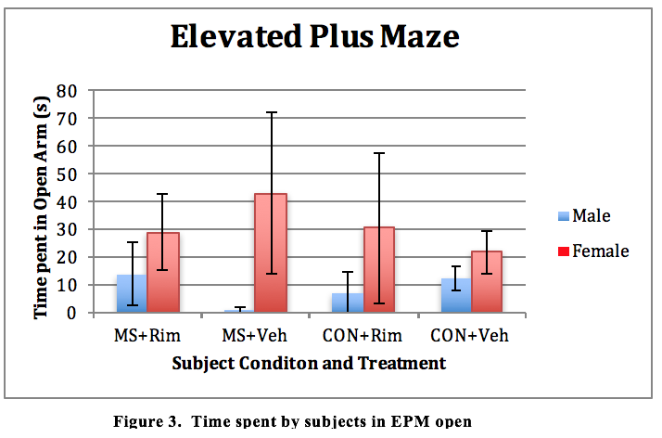

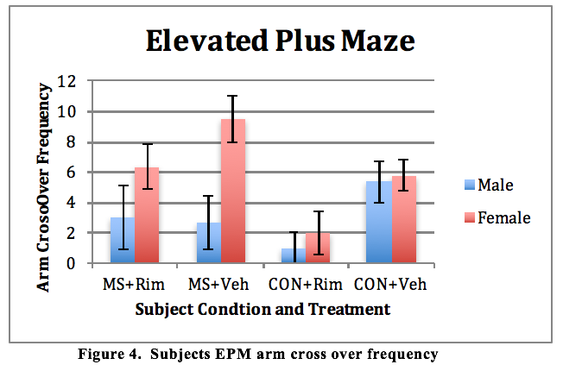

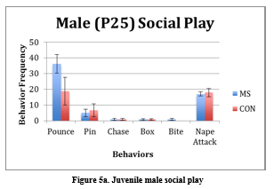

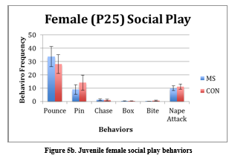

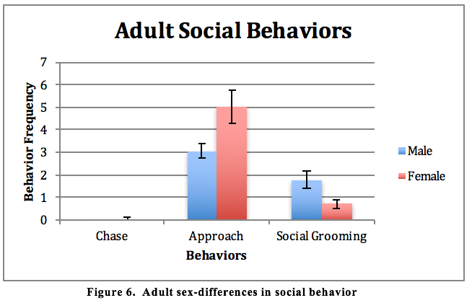

**Predictability of Juvenile Social Play on Adult Anxiety and Social Measures**

In regard to anxiety behaviors displayed during adulthood, a significant and positive correlational relationship (r=0.534, *p*=0.04) was found between juvenile chases and adult MB. Significant, positive correlations were found between the frequency of arm crossovers with time spent in the open arms of the EPM (r=0.598, *p*=0.003) and also with the frequency of SA (r=0.745, *p*<0.001).

Correlational analysis also revealed that juvenile pinning was predictive of adult approaches (r=0.545, *p*=0.029). Juveniles who engaged in more chases exhibited fewer self-grooms during adulthood (r=-0.500, *p*=0.049). A significant, negative correlation was found between juvenile social sniffing and adult approaches (r=-0.623, *p*=0.01). In males only, juvenile pinning was predictive of increased approaches as adults (r=0.598, *p*=0.003). Additionally, juvenile males who engaged in more social sniffing engaged in fewer adult approaches (r=-0.536, *p*=0.01) and boxes (r=-0.444, *p*=0.039). Similarly, juvenile males who engaged in more boxing also crawled over/under their partner more in adult social interaction. In females, juveniles boxing behavior was indicative of increased crawling (r=0.772, *p*=0.042) and anogenital exploration as adults (r=0.849, *p*=0016).

**Experiment 2.**

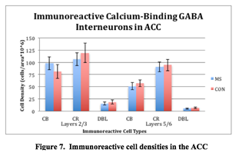

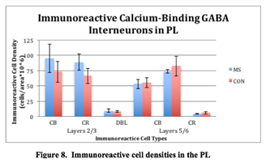

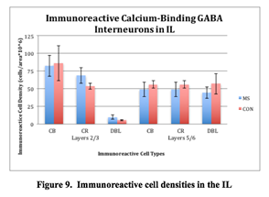

**Stereology/Histology.**

Condition X (Marker X Region X Layer) ANOVA revealed a moderate trend of interaction (*F*(1,8)= 22.865, *p*=0.128) in Condition X (Region X Marker X Layer) (Appendix B). As seen in Figures 7, 8, and 9, significant interactions were also found in Layer (*F*(1,8)= 6.918, p=0.03), Marker (*F*(1,8)=38.413, p=0.001), Region X Layer (*F*(1,8)=21.024, p=0.002), Marker X Layer (*F*(1,8)=35.391, p=0.001), and also Region X Layer X Marker (*F*(1,8)=22.865, p=0.001). Condition X (Marker X Region) ANOVA, revealed a significant difference of immunoreactive cells per region (*F*(1,8)=6.435, p=0.035) and (*F*(1,8)=16.055, p=0.004), respectively. More specifically, less immunoreactive cells were isolated in the ACC and IL regions compared to PL. Additionally, Condition X (Marker X Region X Layer) revealed a significant interaction of marker (*F*(1,8)= 38.413, p=0.001), that is, there were far fewer cells double labeled for CB and CR than those expressing only one marker (Figures 7-9,Appendix B).

**Discussion**

**Experiment 1**

Neonatal maternal separation (MS) and Rimonabant (Rim) treatment in rats produced robust differences in measures of anxiety and social behavior. These results are summarized as follows: **(1)** females exhibited increased time in the open arms of the elevated plus maze (EPM), **(2)** a trend of reduced time spent in closed arms of the EPM in males treated with rimonabant (Rim), when compared to MS+Veh and CON+Rim, **(3)** Rim treatment increased crossovers and reduced stretch-attend (SA) postures in females in the EPM, **(4)** treatment with Rim may have reduced marble burying (MB) in MS, but increased MB in controls, **(5)** a trend of MS increasing aggressive behaviors in juvenile males, but decreasing aggression in juvenile females, **(6)** treatment with Rim reduced social and explorative behaviors in adult males, **(7)** MS subjects exhibited increased aggressive and evasive behaviors in adult social interaction, **(8)** juvenile behaviors were predictive of some adult behaviors.

**Anxiety**

The revealed trend of increased anxiety in MS subjects parallels both significant findings (Huot, Thrivikraman, Meaney, & Plotsky, 2001; Kalinichev, Easterling, Plotsky, & Holtzman, 2002), as well as trends in previous literature (Mathieu et al., 2011; Muhammad & Kolb, 2011). As a result, MS appears to be contributing to increased adult anxiety. This effect may be due to changes in CBP-expressing GABAergic interneuron subpopulations. As seen in previous research, reductions in GABAergic interneurons have been found within the mPFC and also other limbic areas involved in stress response (Pascual et al., 2007; Lephart & Watson, 1999; Leussis et al., 2012; Zadrozna et al., 2011), which may underlie observed behavioral deficits.

**(1)** Overall, females exhibited increased time spent in the open arms of the EPM when compared to males, indicating a significant sex-difference in adult anxiety and confirming results from a previous study using Long-Evans rats by Kalinichev et al., (2002). Furthermore, when isolated to male subjects, a nonsignificant trend in males suggests that MS condition could have contributed to increased anxiety in the EPM and corresponds to significant findings in previous research (Daniels, Pietersen, Carstens, & Stein, 2004; Huot et al., 2001; Kalinichev et al., 2002). Previous research has noted that maternal deprivation (24-hour single isolation) induces sex-dependent and region-dependent changes in endocannabinoid gene expression (Marco et al., 2014) in response to maternal deprivation, genetic expression of proteins responsible for synthesizing and metabolizing endocannabinoids increased in the prefrontal cortex of males, while these genes only increased expression in the hippocampus of female subjects. **(2)** Correspondingly, Rim treatment may have had an anxiolytic effect in open arm exploration in MS males, but an anxiogenic effect in MS females, although this failed to reach significance. As such, it appears that anxiety differences exist between males and females, which are differentially affected by the neonatal environment. Resultantly, gender-specific genetic changes in the endocannabinoid system in response to stress could help clarify why males in the human population appear to be at an increased risk of developing adult-onset psychosis or drug abuse following the use of marijuana (Arendt, Rosenberg, Foldager, Perto, & Munk-Jørgensen, 2005). It is also possible that not only do pre-existing/innate sex differences exist, but also that MS may contribute to long-standing changes in both GABAergic interneurons and colocalized CB1 receptors. Though our study did not yield a significant effect of MS or Rim on time spent in the open arms of the EPM, we must concede that this finding may be statistically driven due to a low sample size. Moreover, the disparity in baseline anxiety behaviors between male and female subjects further highlights the need for an investigation into sex differences in all facets of future research.

**Hesitancy and Risk-Assessment**

**(3)** As a measure of risk-assessment or hesitancy, a strong trend of reduced SA and increased crossovers was observed in subjects treated with Rim. When the analysis was restricted to female subjects, this result was significant, indicating that females may have been less hesitant than males. This finding implicates sex differences as differentially contributing to the effects of Rim. Again, this may be due to sex differences contributing to the differential distribution of CB1 receptors across the brain and to changes in the colocalization of CB1 receptors on GABAergic interneurons. As a result, further investigation into female immunohistochemistry is necessary. **(4)** No significant findings were revealed in MB; however, there is a strong trend of increased MB in MS subjects, but a decrease in MB in CON. This finding indicates that, on average, MS subjects displayed increased perseverative anxiety than controls, despite this effect being nonsignificant. Furthermore, this result appears to be in line with earlier predictions based on GABAergic interneuron activity, which will be discussed later.

**Social Behaviors**

Juvenile social play revealed a number of differences in behaviors as a result of sex and also MS condition. At P25, all females exhibited fewer social sniffs than males, indicating that males were more social and explorative at this time. However, juvenile females engaged in more pounces than males, which is surprising and conflicting with previous findings (Parent & Meaney, 2008). However, our difference was small and may be due to the study’s less-than-ideal sample size. **(5)** A trend in biting behavior suggests that MS increased aggressive biting behavior in males, which parallels significant previous findings (Veenema et al., 2006; Veenema et al., 2009). Interestingly, there was also a trend of reduced biting behavior in juvenile females, revealing the possibility that sex differences due to MS may have reduced aggression in females, likely due to cortical changes in GABAergic interneurons. Therefore, the use of females in future immunohistochemical studies is needed.

**(6)** In adult social behavior, treatment with Rim significantly reduced social grooming in comparison to those receiving vehicle. Also, treatment with Rim reduced anogenital exploration in males. Thus, it appears that treatment with Rim reduced rats’ willingness to engage in nonaggressive social behaviors, as well as, increasing the reluctance of males to explore and interact with conspecifics. **(7)** As expected, MS was responsible for inducing a significant increase in aggressive and evasive behaviors as seen by an increase in adult pouncing, evading, and tail manipulating. This finding indicates that although MS increased male and decreased female aggression in juveniles, both sexes went on to exhibit heightened aggression and social reclusion as adults relative to controls. Our finding of increased male aggression in juveniles and adults supports previous research (Veenema et al., 2009; Veenema et al., 2006). Clarity of this effect in females remains opaque due to the lack of previous research in females. However, Taylor et al. (2000) have argued that stress fosters a “tend-and-befriend,” rather than “fight-or-flight” response in females, likely due to female reproductive hormones promoting attachment and caregiving. Similarly, adult females engaged in significantly more self- and social- grooming behaviors. Though previous findings confirm that adult females engage in an increased number of self-grooming behaviors due to hormonal differences (Moore, 1986), the exhibited increase in social grooming indicates that adult females were more willing to socially engage its conspecific in a nonaggressive manner. This finding appears to be in line with the hierarchal social system seen in rats; it is more advantageous for males to be aggressive to gain social standing just as increased sociality in females would increase reproductive success.

**Predictive Behavioral Measures**

**(8)** Juvenile social play did predict some adult social behaviors. Juvenile pinning behavior was indicative of approaches in adults, that is, juveniles who engaged in more pinning behavior also made more approaches to their social conspecific as adults. This finding indicates that subjects which were more willing to engage in social interaction as juveniles continued to be more social as adults. Juveniles who engaged in more chasing were less likely to exhibit self-grooming and more likely to engage in adult chasing. Taken together, this finding suggests that rats that were actively engaged in socialization as juveniles continued to remain relatively more active as an adult at the expensive of self-grooming. Additionally, juvenile boxing behavior was indicative of increased crawling over and under social partners as adults. In females, juveniles who engage in boxing behavior were more likely to engage in anogenital exploration and crawling over and under as adults. This indicates that juveniles who engaged in co-defensive behaviors were more willing to socialize with adult partners in a nonaggressive manner. To our knowledge, this is one of the first behaviors to proactively predict adult social interactions based on juvenile play behavior. It is our hope that continued emphasis is placed on measures of juvenile behaviors as predictive markers for those exhibited later in adulthood. Such predictive measures, should they prove reliable, could unlock an entirely new way to quantify and understand developmental neurological changes and corresponding behaviors. When applied to translational research, such predictive paradigms would have the potential to expedite both the development of new pharmaceuticals, as well as more quickly uncover long-term detriments resulting from new and experimental treatments.

**Experiment 2**

The results of the present study demonstrate important differences in the effects of neonatal MS on prefrontal GABAergic interneuron subpopulations, which are summarized as follows: **(1)** a trend of difference in immunoreactive cell density by Condition X (Marker X Region X Layer) and **(2)** significant differences of immunoreactive CBP-expressing cells across mPFC regions and layers.

**(1)** The uncovering of a moderate trend in the interaction of Condition X (Marker X Region X Layer) indicates that condition may have contributed to changes in the density and distribution of CBP-expressing GABAergic interneurons in the mPFC, despite being nonsignificant. However, this nonsignificant finding is consistent with previous studies in humans and degus (Cotter et al., 2000; Helmeke et al., 2008, respectively), thereby suggesting that species differences are minimal.

**(2)** Given prior research indicating a decrease in CBP-expressing GABA interneurons, it was expected that deficits resulting from GABAergic hypoinhibition would be mitigated by Rim treatment, given its ability to increase transmission and activity at the presynaptic terminal. Resultantly, if there were no difference in CB and CR in the mPFC following MS, it would appear that conditional changes in parvalbumin only are responsible for ELS-induced hypoinhibition in GABAergic interneurons (Seidel et al., 2011; Holland et al., 2014; Leussis et al., 2012). This result is interesting given that CB, and not CR or PV, is colocalized with CB1 (Wedzony & Chocyk, 2009), and that a trend of decreased anxiety was found in MS subjects treated with Rim. Furthermore, the observed trend of increased anxiety in CON subjects treated with Rim continues to support this idea. Therefore, increasing our subject samples size could potentially reduce margins of error and reveal a significant interaction of the condition in CB, thereby explaining the resulting trend of decreased MS anxiety. Conversely, it is possible that CB and CR, as a result of their relatively low frequency in comparison to PV, may contribute to these conditional effects, albeit being nonsignificant.

Future investigation into ELS-induced changes in GABA interneurons is still necessary. Significant differences were found in CBP-marked cells across mPFC regions and layers, which may or may not be statistically driven due to the low frequency of DBL cells relative to those labeled for CB or CR. It appears that the limited population sizes of these neuron subtypes could be driving conflicting or obscured measurements in this experiment and those prior. Particularly large sample sizes may help isolate significant neuronal change; however, differences in staining and stereological techniques may also be responsible for such varied results, especially if these populations are congregated in clusters, or “hotspots,” throughout particular regions of the mPFC. This result seems likely as the evaluation of CON subjects uncovered significantly varied distributions of CB and CR across layers 2/3 and 5/6 of all regions of interest in the mPFC. By acknowledging the possibility of both layer and regional hotspots, subsequent investigations should be better able to elucidate if such a phenomenon is responsible for so many inconsistent findings.

**References**

Andersen, S. L., & Teicher, M. H. (1999). Serotonin laterality in amygdala predicts performance in the elevated plus maze in rats. *Neuroreport, 10*(17), 3497-3500.

Andersen, S. L., & Teicher, M. H. (2009). Desperately driven and no brakes: Developmental stress exposure and subsequent risk for substance abuse. *Neuroscience & Biobehavioral Reviews, 33*(4), 516-524.

Arendt, M., Rosenberg, R., Foldager, L., Perto, G., & Munk-Jorgensen, P. (2005). Cannabis-induced psychosis and subsequent schizophrenia-spectrum disorders: Follow-up study of 535 incident cases. *The British Journal of Psychiatry : The Journal of Mental Science, 187*, 510-515.

Baldwin, J. D., & Baldwin, J. I. (1977). The role of learning phenomena in the ontogeny of exploration and play. *Primate Bio-Social Development,* , 343-406.

Beasley, C. L., Zhang, Z. J., Patten, I., & Reynolds, G. P. (2002). Selective deficits in prefrontal cortical GABAergic neurons in schizophrenia defined by the presence of calcium-binding proteins. *Biological Psychiatry, 52*(7), 708-715.

Bell, H. C., Pellis, S. M., & Kolb, B. (2010). Juvenile peer play experience and the development of the orbitofrontal and medial prefrontal cortices. *Behavioural Brain Research, 207*(1), 7-13.

Biggio, G., Corda, M., Concas, A., Demontis, G., Rossetti, Z., & Gessa, G. (1981). Rapid changes in GABA binding induced by stress in different areas of the rat brain. *Brain Research, 229*(2), 363-369.

Blasio, A., Iemolo, A., Sabino, V., Petrosino, S., Steardo, L., Rice, K. C., & Zorrilla, E. P. (2013). Rimonabant precipitates anxiety in rats withdrawn from palatable food: Role of the central amygdala. *Neuropsychopharmacology, 38*(12), 2498-2507.

Caldji, C., Diorio, J., & Meaney, M. J. (2000). Variations in maternal care in infancy regulate the development of stress reactivity. *Biological Psychiatry, 48*(12), 1164-1174.

Cotter, D., Stevenson, R., Kerwin, R., Beasley, C., & Everall, I. (2000). No alterations in the density of parvalbumin or calretinin immunoreactive neurons in the anterior cingulate cortex (BA 24b/c) in schizophrenia or bipolar disorder. *Schizophrenia Research, 41*(1), 107-108.

Cotter, D., Landau, S., Beasley, C., Stevenson, R., Chana, G., MacMillan, L., & Everall, I. (2002). The density and spatial distribution of GABAergic neurons, labelled using calcium binding proteins, in the anterior cingulate cortex in major depressive disorder, bipolar disorder, and schizophrenia. *Biological Psychiatry, 51*(5), 377-386.

Daniels, W., Pietersen, C., Carstens, M., & Stein, D. (2004). Maternal separation in rats leads to anxiety-like behavior and a blunted ACTH response and altered neurotransmitter levels in response to a subsequent stressor. *Metabolic Brain Disease, 19*(1-2), 3-14.

Daviss, S., & Lewis, D. (1993). Calbindin-and calretinin-immunoreactive local circuit neurons are increased in density in the prefrontal cortex of schizophrenic subjects. *Soc Neurosci Abstr, , 19* 201.

Elzinga, B. M., & Bremner, J. D. (2002). Are the neural substrates of memory the final common pathway in posttraumatic stress disorder (PTSD)? *Journal of Affective Disorders, 70*(1), 1-17.

Enoch, M. (2011). The role of early life stress as a predictor for alcohol and drug dependence. *Psychopharmacology, 214*(1), 17-31

Fong, T., & Heymsfield, S. (2009). Cannabinoid-1 receptor inverse agonists: Current understanding of mechanism of action and unanswered questions. *International Journal of Obesity, 33*(9), 947-955.

Giachino, C., Canalia, N., Capone, F., Fasolo, A., Alleva, E., Riva, M., & Peretto, P. (2007). Maternal deprivation and early handling affect density of calcium binding protein-containing neurons in selected brain regions and emotional behavior in periadolescent rats. *Neuroscience, 145*(2), 568-578.

Girardi, C. E. N., Zanta, N. C., & Suchecki, D. (2014). Neonatal stress-induced affective changes in adolescent wistar rats: Early signs of schizophrenia-like behavior. *Frontiers in Behavioral Neuroscience, 8*

Gomes, F. V., Casarotto, P. C., Resstel, L. B., & Guimarães, F. S. (2011). Facilitation of CB1 receptor-mediated neurotransmission decreases marble burying behavior in mice. *Progress in Neuro-Psychopharmacology and Biological Psychiatry, 35*(2), 434-438.

Gordon, H. W. (2002). Early environmental stress and biological vulnerability to drug abuse. *Psychoneuroendocrinology, 27*(1), 115-126.

Groenewegen, H. J., & Uylings, H. B. (2000). The prefrontal cortex and the integration of sensory, limbic and autonomic information. *Progress in Brain Research, 126*, 3-28.

Gurden, H., Schiffmann, S. N., Lemaire, M., Böhme, G. A., Parmentier, M., & Schurmans, S. (1998). Calretinin expression as a critical component in the control of dentate gyrus long‐term potentiation induction in mice. *European Journal of Neuroscience, 10*(9), 3029-3033.

Haider, B., Duque, A., Hasenstaub, A. R., & McCormick, D. A. (2006). Neocortical network activity in vivo is generated through a dynamic balance of excitation and inhibition. *The Journal of Neuroscience : The Official Journal of the Society for Neuroscience, 26*(17), 4535-4545.

Haller, J., Varga, B., Ledent, C., Barna, I., & Freund, T. F. (2004). Context‐dependent effects of CB1 cannabinoid gene disruption on anxiety‐like and social behaviour in mice. *European Journal of Neuroscience, 19*(7), 1906-1912.

Handley, S. L. (1991). Evaluation of marble-burying behavior as a model of anxiety. *Pharmacology Biochemistry and Behavior, 38*(1), 63-67.

Heck, N., Kilb, W., Reiprich, P., Kubota, H., Furukawa, T., Fukuda, A., & Luhmann, H. J. (2007). GABA-A receptors regulate neocortical neuronal migration in vitro and in vivo. *Cerebral Cortex (New York, N.Y.: 1991), 17*(1), 138-148. doi:bhj135 [pii]

Heim, C., & Nemeroff, C. B. (2001). The role of childhood trauma in the neurobiology of mood and anxiety disorders: Preclinical and clinical studies. *Biological Psychiatry, 49*(12), 1023-1039.

Helmeke, C., Ovtscharoff, W., Poeggel, G., & Braun, K. (2008). Imbalance of immunohistochemically characterized interneuron populations in the adolescent and adult rodent medial prefrontal cortex after repeated exposure to neonatal separation stress. *Neuroscience, 152*(1), 18-28.

Hendry, S., Jones, E., Emson, P., Lawson, D., Heizmann, C., & Streit, P. (1989). Two classes of cortical GABA neurons defined by differential calcium binding protein immunoreactivities. *Experimental Brain Research, 76*(2), 467-472.

Herkenham, M., Lynn, A. B., Little, M. D., Johnson, M. R., Melvin, L. S., de Costa, B. R., & Rice, K. C. (1990). Cannabinoid receptor localization in brain. *Proceedings of the National Academy of Sciences of the United States of America, 87*(5), 1932-1936.

Holland, F. H., Ganguly, P., Potter, D. N., Chartoff, E. H., & Brenhouse, H. C. (2014). Early life stress disrupts social behavior and prefrontal cortex parvalbumin interneurons at an earlier time-point in females than in males. *Neuroscience Letters, 566*, 131-136.

Howlett, A. C., & Mukhopadhyay, S. (2000). Cellular signal transduction by anandamide and 2-arachidonoylglycerol. *Chemistry and Physics of Lipids, 108*(1), 53-70.

Huot, R. L., Plotsky, P. M., Lenox, R. H., & McNamara, R. K. (2002). Neonatal maternal separation reduces hippocampal mossy fiber density in adult long evans rats. *Brain Research, 950*(1), 52-63.

Huot, R. L., Thrivikraman, K., Meaney, M. J., & Plotsky, P. M. (2001). Development of adult ethanol preference and anxiety as a consequence of neonatal maternal separation in long evans rats and reversal with antidepressant treatment. *Psychopharmacology, 158*(4), 366-373.

Inan, M., Petros, T. J., & Anderson, S. A. (2013). Losing your inhibition: Linking cortical GABAergic interneurons to schizophrenia. *Neurobiology of Disease, 53*, 36-48.

Järbe, T. U., LeMay, B. J., Vemuri, V. K., Vadivel, S. K., Zvonok, A., & Makriyannis, A. (2011). Central mediation and differential blockade by cannabinergics of the discriminative stimulus effects of the cannabinoid CB1 receptor antagonist rimonabant in rats. *Psychopharmacology, 216*(3), 355-365.

Kalivas, P. W., & Volkow, N. D. (2005). The neural basis of addiction: A pathology of motivation and choice. *American Journal of Psychiatry, 162*(8), 1403-1413.

Kalivas, P., Volkow, N., & Seamans, J. (2005). Unmanageable motivation in addiction: A pathology in prefrontal-accumbens glutamate transmission. *Neuron, 45*(5), 647-650.

Katona, I., Rancz, E. A., Acsady, L., Ledent, C., Mackie, K., Hajos, N., & Freund, T. F. (2001). Distribution of CB1 cannabinoid receptors in the amygdala and their role in the control of GABAergic transmission. *The Journal of Neuroscience : The Official Journal of the Society for Neuroscience, 21*(23), 9506-9518. doi:21/23/9506 [pii]

Kawaguchi, Y., & Kubota, Y. (1997). GABAergic cell subtypes and their synaptic connections in rat frontal cortex. *Cerebral Cortex (New York, N.Y.: 1991), 7*(6), 476-486.

Keverne, E. B. (1999). GABA-ergic neurons and the neurobiology of schizophrenia and other psychoses. *Brain Research Bulletin, 48*(5), 467-473.

Kinsey, S. G., O'Neal, S. T., Long, J. Z., Cravatt, B. F., & Lichtman, A. H. (2011). Inhibition of endocannabinoid catabolic enzymes elicits anxiolytic-like effects in the marble burying assay. *Pharmacology Biochemistry and Behavior, 98*(1), 21-27.

Klug, M., & van den Buuse, M. (2012). Chronic cannabinoid treatment during young adulthood induces sex-specific behavioural deficits in maternally separated rats. *Behavioural Brain Research, 233*(2), 305-313.

Le Magueresse, C., & Monyer, H. (2013). GABAergic interneurons shape the functional maturation of the cortex. *Neuron, 77*(3), 388-405.

Lehmann, J., Stöhr, T., & Feldon, J. (2000). Long-term effects of prenatal stress experience and postnatal maternal separation on emotionality and attentional processes. *Behavioural Brain Research, 107*(1), 133-144.

Lephart, E. D., & Watson, M. A. (1999). Maternal separation: Hypothalamic-preoptic area and hippocampal calbindin-D 28K and calretinin in male and female infantile rats. *Neuroscience Letters, 267*(1), 41-44.

Leussis, M. P., Freund, N., Brenhouse, H. C., Thompson, B. S., & Andersen, S. L. (2012). Depressive-like behavior in adolescents after maternal separation: Sex differences, controllability, and GABA. *Developmental Neuroscience, 34*(2), 210.

Lewis, D. A., Hashimoto, T., & Volk, D. W. (2005). Cortical inhibitory neurons and schizophrenia. *Nature Reviews Neuroscience, 6*(4), 312-324.

Lin, B., Arai, A. C., Lynch, G., & Gall, C. M. (2003). Integrins regulate NMDA receptor-mediated synaptic currents. *Journal of Neurophysiology, 89*(5), 2874-2878.

Liston, C., Miller, M. M., Goldwater, D. S., Radley, J. J., Rocher, A. B., Hof, P. R., & McEwen, B. S. (2006). Stress-induced alterations in prefrontal cortical dendritic morphology predict selective impairments in perceptual attentional set-shifting. *The Journal of Neuroscience : The Official Journal of the Society for Neuroscience, 26*(30), 7870-7874.

Lukkes, J. L., Engelman, G. H., Zelin, N. S., Hale, M. W., & Lowry, C. A. (2012). Post-weaning social isolation of female rats, anxiety-related behavior, and serotonergic systems. *Brain Research, 1443*, 1-17.

Lupien, S. J., McEwen, B. S., Gunnar, M. R., & Heim, C. (2009). Effects of stress throughout the lifespan on the brain, behaviour and cognition. *Nature Reviews Neuroscience, 10*(6), 434-445.

Lynch, W. J., Mangini, L. D., & Taylor, J. R. (2005). Neonatal isolation stress potentiates cocaine seeking behavior in adult male and female rats. *Neuropsychopharmacology, 30*(2), 322-329.

Mackie, K. (2005). Distribution of cannabinoid receptors in the central and peripheral nervous system. *Cannabinoids* (pp. 299-325) Springer.

Marco, E. M., Echeverry-Alzate, V., Lopez-Moreno, J. A., Gine, E., Penasco, S., & Viveros, M. P. (2014). Consequences of early life stress on the expression of endocannabinoid-related genes in the rat brain. *Behavioural Pharmacology, 25*(5-6), 547-556.

Marín, O. (2012). Interneuron dysfunction in psychiatric disorders. *Nature Reviews Neuroscience, 13*(2), 107-120.

Mathieu, G., Oualian, C., Denis, I., Lavialle, M., Gisquet-Verrier, P., & Vancassel, S. (2011). Dietary n-3 polyunsaturated fatty acid deprivation together with early maternal separation increases anxiety and vulnerability to stress in adult rats. *Prostaglandins, Leukotrienes and Essential Fatty Acids, 85*(3–4), 129-136.

Micheva, K. D., & Beaulieu, C. (1996). Quantitative aspects of synaptogenesis in the rat barrel field cortex with special reference to GABA circuitry. *Journal of Comparative Neurology, 373*(3), 340-354.

Miller, C. A., & Marshall, J. F. (2004). Altered prelimbic cortex output during cue-elicited drug seeking. *The Journal of Neuroscience : The Official Journal of the Society for Neuroscience, 24*(31), 6889-6897.

Moore, C. L. (1986). A hormonal basis for sex differences in the self-grooming of rats. *Hormones and Behavior, 20*(2), 155-165.

Muhammad, A., & Kolb, B. (2011). Maternal separation altered behavior and neuronal spine density without influencing amphetamine sensitization. *Behavioural Brain Research, 223*(1), 7-16.

Navarro, M., Hernández, E., Muñoz, R. M., del Arco, I., Villanúa, M. A., Carrera, M. R. A., & de Fonseca, F. R. (1997). Acute administration of the CB1 cannabinoid receptor antagonist SR 141716A induces anxiety‐like responses in the rat. *Neuroreport, 8*(2), 491-496.

Nemeroff, C.B. (2003). The role of GABA in the pathophysiology and treatment of anxiety disorders. *Psychopharmacology Bulletin, 37*(4), 133-146.

Okun, M., & Lampl, I. (2009). Balance of excitation and inhibition. *Scholarpedia, 4*(8), 7467.

Olney, J. W., & Farber, N. B. (1995). Glutamate receptor dysfunction and schizophrenia. *Archives of General Psychiatry, 52*(12), 998-1007.

Panksepp, J. (1981). The ontogeny of play in rats. *Developmental Psychobiology, 14*(4), 327-332.

Parent, C. I., & Meaney, M. J. (2008). The influence of natural variations in maternal care on play fighting in the rat. *Developmental Psychobiology, 50*(8), 767-776.

Pascual, R., Zamora-León, P., Catalán-Ahumada, M., & Valero-Cabre, A. (2007). Early social isolation decreases the expression of calbindin D-28k and dendritic branching in the medial prefrontal cortex of the rat. *International Journal of Neuroscience, 117*(4), 465-476.

Patel, S., Roelke, C. T., Rademacher, D. J., Cullinan, W. E., & Hillard, C. J. (2004). Endocannabinoid signaling negatively modulates stress-induced activation of the hypothalamic-pituitary-adrenal axis. *Endocrinology, 145*(12), 5431-5438.

Pellis, S. M., & Pellis, V. C. (2007). Rough-and-tumble play and the development of the social brain. *Current Directions in Psychological Science, 16*(2), 95-98.

Pertwee, R. G. (1997). Pharmacology of cannabinoid CB 1 and CB 2 receptors. *Pharmacology & Therapeutics, 74*(2), 129-180.

Plotsky, P. M., Thrivikraman, K., Nemeroff, C. B., Caldji, C., Sharma, S., & Meaney, M. J. (2005). Long-term consequences of neonatal rearing on central corticotropin-releasing factor systems in adult male rat offspring. *Neuropsychopharmacology, 30*(12), 2192-2204.

Pryce, C. R., & Feldon, J. (2003). Long-term neurobehavioural impact of the postnatal environment in rats: Manipulations, effects and mediating mechanisms. *Neuroscience & Biobehavioral Reviews, 27*(1), 57-71.

Radley, J., Sisti, H., Hao, J., Rocher, A., McCall, T., Hof, P., & Morrison, J. (2004). Chronic behavioral stress induces apical dendritic reorganization in pyramidal neurons of the medial prefrontal cortex. *Neuroscience, 125*(1), 1-6.

Radley, J. J., Rocher, A. B., Miller, M., Janssen, W. G., Liston, C., Hof, P. R., & Morrison, J. H. (2006). Repeated stress induces dendritic spine loss in the rat medial prefrontal cortex. *Cerebral Cortex (New York, N.Y.: 1991), 16*(3), 313-320.

Raffa, R., & Ward, S. (2012). CB1‐independent mechanisms of Δ9‐THCV, AM251 and SR141716 (rimonabant). *Journal of Clinical Pharmacy and Therapeutics, 37*(3), 260-265.

Réus, G. Z., Stringari, R. B., Ribeiro, K. F., Cipriano, A. L., Panizzutti, B. S., Stertz, L., & Quevedo, J. (2011). Maternal deprivation induces depressive-like behaviour and alters neurotrophin levels in the rat brain. *Neurochemical Research, 36*(3), 460-466.

Reynolds, G. P., Zhang, Z. J., & Beasley, C. L. (2001). Neurochemical correlates of cortical GABAergic deficits in schizophrenia: Selective losses of calcium binding protein immunoreactivity. *Brain Research Bulletin, 55*(5), 579-584.

Rodriguez-Arias, M., Navarrete, F., Daza-Losada, M., Navarro, D., Aguilar, M. A., Berbel, P., & Manzanares, J. (2013). CB1 cannabinoid receptor-mediated aggressive behavior. *Neuropharmacology, 75*, 172-180.

Roman, E., & Nylander, I. (2005). The impact of emotional stress early in life on adult voluntary ethanol intake-results of maternal separation in rats: Review. *Stress: The International Journal on the Biology of Stress, 8*(3), 157-174.

Roman, E., Gustafsson, L., Berg, M., & Nylander, I. (2006). Behavioral profiles and stress-induced corticosteroid secretion in male wistar rats subjected to short and prolonged periods of maternal separation. *Hormones and Behavior, 50*(5), 736-747.

Rossignol, E. (2011). Genetics and function of neocortical GABAergic interneurons in neurodevelopmental disorders. *Neural Plasticity, 2011*, 649325.

Sakai, T., Oshima, A., Nozaki, Y., Ida, I., Haga, C., Akiyama, H., & Mikuni, M. (2008). Changes in density of calcium‐binding‐protein‐immunoreactive GABAergic neurons in prefrontal cortex in schizophrenia and bipolar disorder. *Neuropathology, 28*(2), 143-150.

Schneider, M., Schömig, E., & Leweke, F. M. (2008). PRECLINICAL STUDY: Acute and chronic cannabinoid treatment differentially affects recognition memory and social behavior in pubertal and adult rats. *Addiction Biology, 13*(3‐4), 345-357.

Schwaller, B., Meyer, M., & Schiffmann, S. (2002). ‘New’functions for ‘old’proteins: The role of the calcium-binding proteins calbindin D-28k, calretinin and parvalbumin, in cerebellar physiology. studies with knockout mice. *The Cerebellum, 1*(4), 241-258.

Seidel, K., Poeggel, G., Holetschka, R., Helmeke, C., & Braun, K. (2011). Paternal deprivation affects the development of Corticotrophin‐Releasing Factor‐Expressing neurones in prefrontal cortex, amygdala and hippocampus of the biparental octodon degus. *Journal of Neuroendocrinology, 23*(11), 1166-1176.

Skilbeck, K. J., Johnston, G. A., & Hinton, T. (2010). Stress and GABAA receptors. *Journal of Neurochemistry, 112*(5), 1115-1130.

Svíženská, I., Dubový, P., & Šulcová, A. (2008). Cannabinoid receptors 1 and 2 (CB1 and CB2), their distribution, ligands and functional involvement in nervous system structures—a short review. *Pharmacology Biochemistry and Behavior, 90*(4), 501-511.

Taylor, S. E., Klein, L. C., Lewis, B. P., Gruenewald, T. L., Gurung, R. A. R., & Updegraff, J. A. (2000). Biobehavioral responses to stress in females: Tend-and-befriend, not fight-or-flight. *Psychological Review, 107*(3), 411-429.

Trezza, V., & Vanderschuren, L. J. (2008). Bidirectional cannabinoid modulation of social behavior in adolescent rats. *Psychopharmacology, 197*(2), 217-227.

Tzschentke, T. M. (2000). The medial prefrontal cortex as a part of the brain reward system. *Amino acids*, *19*(1), 211-219.

Urakawa, S., Takamoto, K., Hori, E., Sakai, N., Ono, T., & Nishijo, H. (2013). Rearing in enriched environment increases parvalbumin-positive small neurons in the amygdala and decreases anxiety-like behavior of male rats. *BMC Neuroscience, 14*, 13-2202-14-13

Van den Oever, Michel C, Spijker, S., Smit, A. B., & De Vries, T. J. (2010). Prefrontal cortex plasticity mechanisms in drug seeking and relapse. *Neuroscience & Biobehavioral Reviews, 35*(2), 276-284.

Veenema, A. H. (2009). Early life stress, the development of aggression and neuroendocrine and neurobiological correlates: What can we learn from animal models? *Frontiers in Neuroendocrinology, 30*(4), 497-518.

Veenema, A. H., Blume, A., Niederle, D., Buwalda, B., & Neumann, I. D. (2006). Effects of early life stress on adult male aggression and hypothalamic vasopressin and serotonin. *European Journal of Neuroscience, 24*(6), 1711-1720.

Veenema, A. H., Bredewold, R., & De Vries, G. J. (2013). Sex-specific modulation of juvenile social play by vasopressin. *Psychoneuroendocrinology, 38*(11), 2554-2561.

Veenema, A. H., & Neumann, I. D. (2008). Central vasopressin and oxytocin release: Regulation of complex social behaviours. *Progress in Brain Research, 170*, 261-276.

Veenema, A. H., & Neumann, I. D. (2009). Maternal separation enhances offensive play-fighting, basal corticosterone and hypothalamic vasopressin mRNA expression in juvenile male rats. *Psychoneuroendocrinology, 34*(3), 463-467.

Viveros, M. P., Bermúdez-Silva, F. J., Lopez-Rodriguez, A. B., & Wagner, E. J. (2011). The endocannabinoid system as pharmacological target derived from its CNS role in energy homeostasis and reward. Applications in eating disorders and addiction. *Pharmaceuticals*, *4*(8), 1101-1136.

Ward, S. J., Rosenberg, M., Dykstra, L. A., & Walker, E. A. (2009). The CB1 antagonist rimonabant (SR141716) blocks cue-induced reinstatement of cocaine seeking and other context and extinction phenomena predictive of relapse. *Drug and Alcohol Dependence, 105*(3), 248-255.

Wêdzony, K., & Chocyk, A. (2009). Cannabinoid CB1 receptors in rat medial prefrontal cortex are colocalized with calbindin-but not parvalbumin-and calretinin-positive GABA-ergic neurons. *Pharmacological Reports, 61*(6), 1000.

Weiss, F., Ciccocioppo, R., Parsons, L. H., Katner, S., Liu, X., Zorrilla, E. P., & Richter, R. R. (2001). Compulsive Drug‐Seeking behavior and relapse. *Annals of the New York Academy of Sciences, 937*(1), 1-26.

Weissenborn, R., Robbins, T. W., & Everitt, B. J. (1997). Effects of medial prefrontal or anterior cingulate cortex lesions on responding for cocaine under fixed-ratio and second-order schedules of reinforcement in rats. *Psychopharmacology, 134*(3), 242-257.

Wigger, A., & Neumann, I. D. (1999). Periodic maternal deprivation induces gender-dependent alterations in behavioral and neuroendocrine responses to emotional stress in adult rats. *Physiology & Behavior, 66*(2), 293-302.

Woo, T. U., Miller, J. L., & Lewis, D. A. (1997). Schizophrenia and the parvalbumin-containing class of cortical local circuit neurons. *The American Journal of Psychiatry, 154*(7), 1013-1015.

Xu, H., Hu, W., Zhang, X., Gao, W., Liang, M., Chen, T., & Hu, Z. (2011). The effect of different maternal deprivation paradigms on the expression of hippocampal glucocorticoid receptors, calretinin and calbindin-D28k in male and female adolescent rats. *Neurochemistry International, 59*(6), 847-852.

Yizhar, O., Fenno, L. E., Prigge, M., Schneider, F., Davidson, T. J., O’Shea, D. J., & Paz, J. T. (2011). Neocortical excitation/inhibition balance in information processing and social dysfunction. *Nature, 477*(7363), 171-178.

Zádor, F., Lénárt, N., Csibrány, B., Sántha, M., Molnár, M., Tuka, B., & Marton, A. (2015). Low dosage of rimonabant leads to anxiolytic-like behavior via inhibiting expression levels and G-protein activity of kappa opioid receptors in a cannabinoid receptor independent manner. *Neuropharmacology, 89*, 298-307.

Zadrożna, M., Nowak, B., Łasoń-Tyburkiewicz, M., Wolak, M., Sowa-Kućma, M., Papp, M., & Nowak, G. (2011). Different pattern of changes in calcium binding proteins immunoreactivity in the medial prefrontal cortex of rats exposed to stress models of depression. *Pharmacological Reports, 63*(6), 1539-1546.

Zhang, L., Hernández, V. S., Liu, B., Medina, M. P., Nava-Kopp, A. T., Irles, C., & Morales, M. (2012). Hypothalamic vasopressin system regulation by maternal separation: Its impact on anxiety in rats. *Neuroscience, 215*(0), 135-148.

**Appendix A**

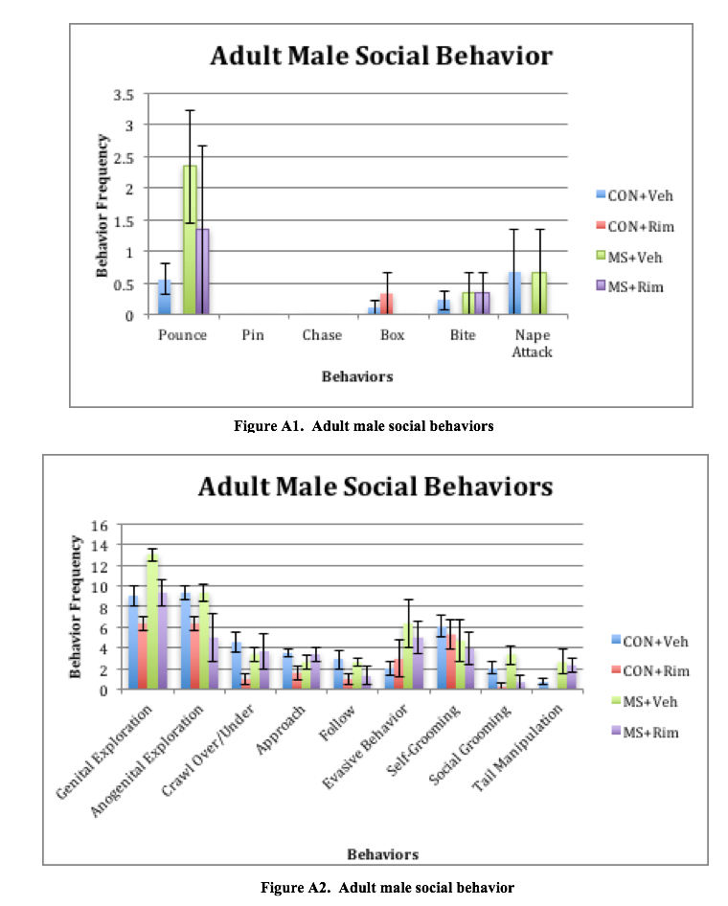

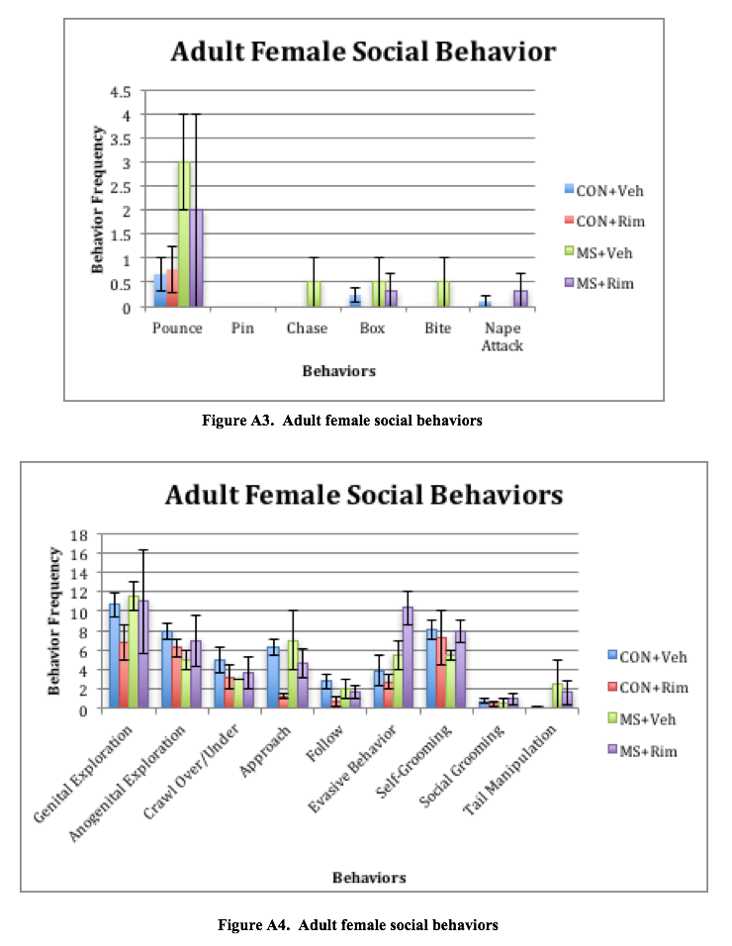

**Appendix B**

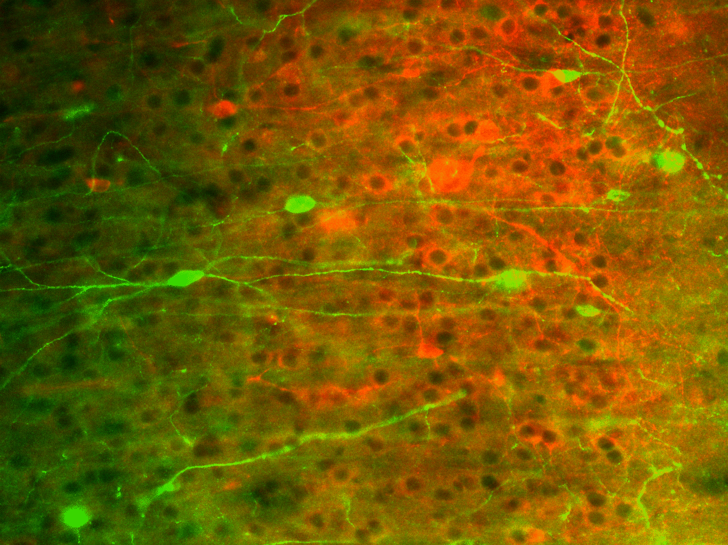

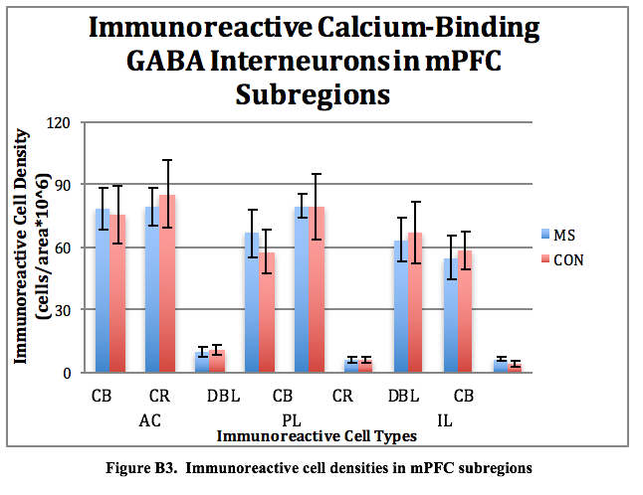

**Figure B1. CB and CR immunoreactive neurons appear in red and green, respective.**

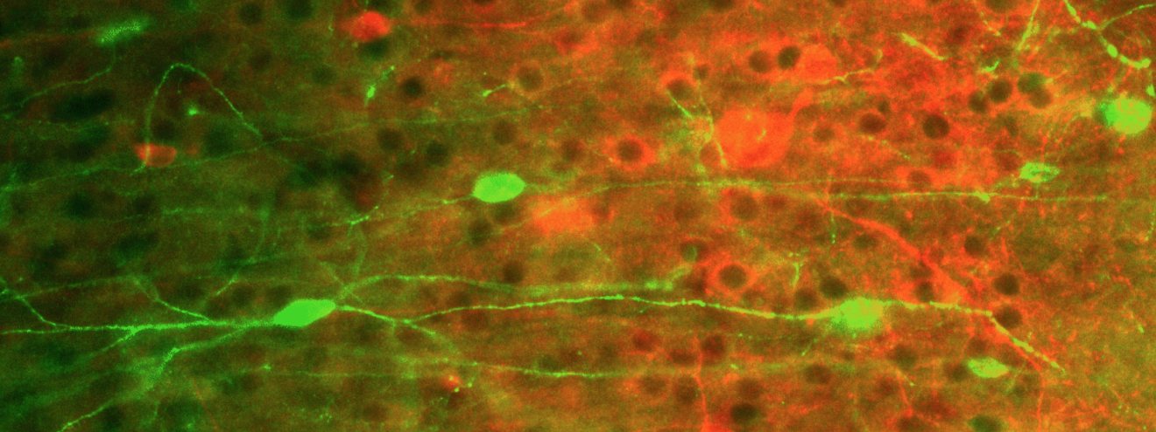

**Figure B2. DBL immunoreactive neurons, marked above by arrows, appear both red and green.**

***Examining Language Processing Under an Embodied Cognition Framework***

**Sumer Vaid**

University of Chicago

Recent advances in cognitive neuroscience have challenged the conventional model of language processing in the brain. Traditional theories maintain that all aspects of language, including pragmatics *and* semantics are processed in amodal or modally non-specific areas of the brain. In these models, the brain areas typically used to process modality-specific sensory information are not employed to somaticize language. However, systematic physiological evidence has indicated that the neural substrates responsible for modality-specific sensory processing and language semantics overlap. How strong is this overlap between language and perceptual systems in the brain? How can traditional theories of language processing be consolidated with this newer evidence? By employing Barsalou’s (2001) framework of embodied cognition, this paper reviews the literature to conclude that there is some connection between the neural underpinnings of semantics and modality-specific perception. However, further research with newer neuroimaging technologies is needed to elucidate the strength of this connection. In particular, action-based language processing in the brain overlaps considerably with the semanticization of literal but not metaphoric action. The paper concludes that current evidence suggests that literal action language is majorly instantiated in the premotor and motor cortices but more metaphorical action language is instantiated in traditional language regions.

This paper is inspired and guided by Professor Daniel Casasanto’s class, The Body in The Mind, offered at The University of Chicago. Professor Anne Henly supervised my writing and assisted me in the articulation of my argument. A special thanks to Benjamin Pitt, who helped me create an understanding of the psychological literature and also offered editorial remarks on this manuscript.

**Language Processing Theories in Psychology**

L

anguage is a defining trait of the human species as it allows us to effortlessly and precisely shape the thoughts of others (Pinker, 1995). Yet, we struggle to answer the question: how do humans understand language? Language can vary widely in form (i.e grammar), structure (i.e syntax) and mode (i.e verbal or written). However, despite these differences, humans are able to use language to take in the thoughts of others and to communicate their own thoughts to others. Of the two utilities, this paper is focused on the former: how are humans able to “make sense” of language? Making sense of language requires several mental and physiological processes. First, one must “perceive” language, based on its medium of transmission (i.e visual, audial, tactile). Second, once one has “perceived” the contents of the language, one must derive meaning from these contents. The mental and neural mechanism engaged in the process of deriving meaning from language is the central topic of this paper.  Hence, for the purposes of this paper, language processing is defined as the processes through which the meaning of language is derived, after it has been “perceived”. Crucially, this definition of language processing will address those processes that occur after language has been “perceived”, which necessarily implies that our discussions will not overtly concern the modality through which the language is communicated.

To examine the mental and neural mechanisms of this process of semanticization, we will survey the fields of cognitive neuroscience and psychology. There are two broad trends in literature – one classical, and the other more recent and controversial.

**Traditional Models of Language Processing**

The traditional model of language processing in the brain asserts that there is a highly specialized brain region, which is solely responsible for the understanding and production of language. This view also claims that this language-specialized brain region is not engaged in neural processes that constitute perception (i.e this brain region is not utilized to see, hear, smell) but only to understand language, regardless of format (Fodor, 1975). In his classic *The Modularity of Mind (1983)*, Fodor lays the criteria for a modular mind, and then supports it with some psychological evidence. The traditional model of language perception is concomitant to a modular mind, the extensive discussion of which lies outside the scope of the paper. Importantly, however, Fodor’s postulates hold that several cognitive substrates rely on highly localized neural-architecture, specialized *only* to sustain that cognitive substrate. Language is one such cognitive substrate, and therefore relies on a specialized brain area to be produced. To adhere to the Fodorian criterion for modularity, this language brain area must necessarily not partake in processes contributing to perception.

This modular model easily accounts for why humans are unique in their ability for language (because other animals lack this highly specialized brain area) and how humans slowly develop ability in language (in-conjunction with the physiological development of this organ) (Tulving, 1972; Smith and Medin, 1981; Pylyshyn, 1984). This model is also able to explain how we can effortlessly understand language across modalities – that is, our understanding of our native language is not reliant on the medium through which it is conveyed.  The traditional view asserts that there are two core areas of language processing: the left inferior fontal cortex and the superior temporal cortex. Based on abundant neuropsychological surveys of lesioned patients, the traditional view postulates that one of these areas “produces” language, whereas the other area is responsible for language comprehension.  (Geschwind, 1970; Lichtheim, 1885).

**Embodied Perspectives on Language Processing**

However, this traditional theory has been recently challenged by embodied cognition scientists, who posit that some language is semanticizedin addition to the processing of language in traditional brain regions, language is also processed in those brain areas that were traditionally thought to be involved only in perception (Barsalou, 2001). These arguments stem from neuro-imaging data that indicates distributed, systematic activations of supplementary brain regions, in addition to the activation of traditional language regions. Some cognitive scientists further argue that the evolutionary time-frame required for the development of this specialized brain organ is far too short to allow for evolutionary changes that span millions of years – language, in its present form, has been estimated to have emerged around 60,000 years ago (Christiansen, 2003; for a detailed review of the evolutionary origins of language, see Bates, 1994).

Hence, the last decade of research in cognitive neuroscience has re-ignited an age-old question concerning the nature of language processing. Traditional theories maintain that language is processed brain areas traditionally not associated with perception (Tulving, 1972; Smith and Medin, 1981; Fodor, 1975; Pylyshyn, 1984) whereas relatively recent embodiment theories assert that there exists some connection between traditional language processing systems and the sensorimotor system in the brain (Pulvermüller, 2005; Barsalou, 2001;  Pulvermüller and Fadiga, 2010). Hence, the automatic, spontaneous activation of sensory-motor systems during language exposure is commonly referred to as a *simulation* in the sensory-motor systems. Weak embodiment theories assert that only perceptually abundant language is simulated in sensory-motor areas of the brain, whereas stronger theories assert that even abstract language make use of sensory-motor simulations (Desai et al., 2011). Perceptually abundant language utilizes verbs to denote physical movement or action (“I threw a ball), as opposed to abstract language, which uses verbs in metaphorical settings (“I threw a fit of rage”. It is also crucial to note that this of language simulation is automatic – the central claim of embodied cognition theories assert that processing language elicits sensory-motor systems for representation automatically rather than consciously.  One other clarification: for the purposes of this paper, perceptually abundant language is that which involves direct action (“I threw a ball”) as opposed to abstract language, which involved the use of action words to denote metaphoric action (“I threw a party”). We will now examine psychological and physiological evidence for the modern model of language processing.

**Behavioral Paradigms**

Several purely behavioral studies have attempted to investigate the link between language and perceptual systems. For instance, a seminal study, participants led by R.A Zwaan attempted to assess if language comprehension shapes the visual representation of actionable events. Participants heard a perceptually loaded sentence (“He threw the ball”) and were then showed two sets of images separated by 175 ms. In the first condition, two sets of pictures displayed visual nuances of the implied movement in the actionable sentence (“He threw the ball” implies the ball moving away from the thrower, hence the second picture displayed a slightly smaller ball as a result of implied further distance). In the second condition, there was no congruence between visual nuances and the aforementioned linguistic input. Subjects in the first condition had a slower reaction time when the implied movement of the ball matched the visual nuances of the pictures. The study concluded that this effect of language comprehension resulted from “dynamic mental representation”, but it did not attempt to provide a neural basis for the observations (Zwaan et al., 2004). The researchers concluded that this was a result of “simulating” the imagery induced by the sentence cue, which provided evidence for a link between the perceptual and language processing mechanisms in the mind.

Another widely cited experiment measured the precise eye-movements of subjects while they were explicitly informed to imagine something (Spivey and Geng, 2001). In the first experiment, the researchers ensured that the participants were unaware that their eye movements were being tracked, while the participants heard a story with spatial elements (“Imagine that you are standing across the street from a 40 story apartment building”). Special care was taken to ensure that the participants did not hear words that implied explicit spatial cues such as “top” or “bottom”. While the participants read this story, their eye movements were discretely analyzed. The results indicated “unconscious” eye-movements of the participants were congruent to supposed eye movements when the story was taking place in real life. that subjects systematically looked at blank regions of space during the process of In the second experiment, participants were presented with four distinct objects at four different corners of a computer screen. In the testing task, they were presented with three of the aforementioned items, and were then asked to remember one particular descriptor of the missing item (i.e color or shape). While the participants performed this task, their eye-movements were discretely analyzed. The results indicated that while “imagining something. The study concluded that this was a result of ” this object, the participants eye movements focused the gaze to the corner in which the missing object had initially been present.  The study concluded that both these results originated from the manipulating and organizing of spatial relationships between virtual or retinal images.

Both these studies were immensely important in establishing a foundation for further, more physiological intellectual venture into embodied cognition theories. However, though these studies establish a link between perceptual and linguistic systems in the mind, they offer no evidence that this mental connection is subserved by a physical link between the perisylvian language regions and modality-specific perceptual brain systems. The behavioral data does not explicitly indicate that the cued language was processed in modality-specific sensory systems; it may originate from varying patterns of brain activation that cannot be accurately inferred from non-neuroimaging experiments. However, Barsalou’s theory of embodiment critically relies on such a functional link as it asserts that even the most basic perceptive mechanisms in the brain play a role in higher-order linguistic processing. Ergo, Barsalou’s theory of embodiment can only be tested by examining the brain directly or by examining other physiological properties of perception and action. Furthermore, the second study (Spivey and Geng, 2010) tests embodied cognition through experimental paradigms that involve conscious “imagining” , which violated Barsalou’s notion of *automaticity.* To test Barsalou’s theory of embodied cognition, one would not only have to examine the brain in real time during language processing, but also take measures to ensure that participants are not told to explicitly “imagine” anything. Any sensorimotor activation should result from an *unconscious* process, which the participants have no control over.

**Brain-Imaging Evidence**

The anatomy of the brain provides some motivation for investigations into the neural underpinnings of embodied cognition. Traditionally, the cortical systems for action control and language were believed to be classic examples of a modular brain (Shalice, 1988). These regions are spatially different and appear to be behaviorally exclusive as revealed by neurological disease - stroke patients are unable to move contralateral body side but have no major disruptions in language ability) (Pulvermüllerr, 2005). However, neuroanatomy has revealed the existence neuronal connections between the dorsal and ventral premotor cortex and the left perisylvian regions of language (Makris et al., 1999; Pandya and Yeterian, 1985), indicating that information can pass in between them. Following the Hebbian learning model, these connections are postulated to exist because of frequent interactions between linguistic brain areas and action perception brain areas.

Neuroimaging experiments further indicate that language and action are linked in the brain. One landmark study found that reading action words describing bodily movements activated brain areas congruent to actually performing those movements physically (Hauk et al,. 2004). Participants were first required to move their feet, arms and tongue on separate trials while their brain metabolism was recorded using functional MRI. The participants were then required to read either leg-related words, arm-related words or face related words while their brain metabolism was recorded. There was a significant intersection between the brain areas used to perform specific actions and the brain areas used to understand words related to that specific action, indicative of a strong relationship between language and action in the brain. It is crucial to note that this overlap in activation maps was not complete – that is, there were substantial differences in the brain-maps for each of the two tasks. This implies that extreme embodied cognition theories, which posit that even the most abstract language is entirely instantiated in modality-specific brain-regions, is lacking evidence.

Functional MRI, like any brain imaging technique, has many weaknesses. One of these is that the hemodynamic metabolism process that this technique measures occurs significantly after the electric potential of neurons has “peaked” (Glover, 2011). In other words, fMRI is not a direct measure of brain-activity, instead it relies on changes in blood-flow to indicate activity. This delay of activity-reporting raises many questions: for instance, it is entirely possible that the motor cortex activations may result from a mental plan of action triggered by the linguistic input (action word). In other words, when the subject “reads” the action word, they are consciously imagining performing that action, instead of unconsciously deriving the meaning of the word. Our topic of interest is the latter, not the former – hence, fMRI data may be providing support an alternative, equally likely hypothesis.  Hence, the observe data would be a result of conscious mental imagery, violating the postulates of Barsalou’s embodied cognition theory, which relies on the unconscious nature of language processing.

Fortunately, other brain imaging techniques can be used to get around the problem caused by activity-reporting delays. In one such study, Event-Related Potentials were measured while participants were asked to read action words (Hauk and Pulvermüller, 2005) using electroencephalography. This technique offers high temporal resolution, as it directly measures the electric activity of the neurons located near the scalp – thereby avoiding delays caused by measuring blood activity. The study reported a category-specific differential activation around 200 ms after exposure to input. In other words, the study found activations for perceptually abundant stimuli at 200 ms but not for control stimuli. Furthermore, this activation was proximate to an inferior frontal region for face-related words and to a superior central source for leg-related words, indicating prompt body-part specific activation following the linguistic input presentation. Previous research in word processing indicates that language understanding elicits brain area-specific activation after 200 ms, on average (Sereno and Rayner, 2013). As the observed brain activations occurred after 200 ms, the results supported the idea that modality-specific activations were instantiating immediate language understanding. Hence, these results support the idea that the brain activation is a result of semantic processing and not because of processing a “plan of action” encompassed by post-semantic processing. Nevertheless, there are a few weaknesses with this mode of brain imaging. While EEG improves temporal resolution, it is not able to offer the high spatial resolution of fMRI. Hence, while we can be sure that the brain activations occurred somewhere in the vicinity of our targeted modality-specific areas, we cannot be sure that they were completely elicited in our areas of interest, which prevents us from using this data to conclusively support Barsalou’s embodiment theories.

To address issues related to temporal and spatial resolution, a new and promising brain-imaging technique was used - magnetoencephalography. While the merits of this technique remain hotly debated, many experts believe that it offers high temporal and spatial resolution. The goal of this study was to investigate the activation of brain regions while participants engaged in a distracting task while listening to action words (Pulvermüller et al., 2005). It was hypothesized that spatiotemporal activations would occur first in the perisylvian language regions of the brain (due to the processing of the form of the action word) followed by immediate activation in the somatotopic specific areas of the premotor and motor cortex (due to the semantic processing of the action word). The purpose of the distractor was to direct the attention of participants away from the target stimulus, as this would allow for the measurement of brain-activations of language processing that is not consciously being attended to. The study found that superior temporal areas (responsible for leg-related movement) activated after an average of 130 ms, and activated more significantly for words relating to leg related movements. Inferior fronto-central areas (responsible for facial movements) activated between 142-146 ms reacted more significantly for words related to facial movement words. This activation occurred shortly after the words were identified as lexical items in the traditional perisylvian language region, as predicted by previous literature. Hence, this study addressed some of the weaknesses of previous neuro-imaging studies, and still found convincing evidence to support the idea that part of language is processed in modality-specific regions of the brains, even when participants were not attending to this word consciously. This lack of directed attention further separated the likelihood of the participants consciously simulating a plan of action following the processing of a perceptually abundant word, which further offered support an embodied cognition hypothesis.

We have evaluated encouraging evidence for embodied cognition theories from three different brain-imaging studies, each of which had its own set of weakness. However, these three techniques have one common, debilitating weakness; brain-imaging evidence, however abundant, only implies a correlational link between activation in primary motor areas of the brain and understanding of action words. We can only conclude that modality-specific brain activity and language comprehension occur in conjunction, but cannot assess (from these studies), if one is *causing* the others. To do this, we need to examine evidence originating from brain-stimulation techniques and language comprehension. Assessing behavioral patterns in relation with non-invasive brain activation cements this link to a certain extent and hints at a functional link between the perceptual and linguistic systems in the brain.

**Brain-Stimulation**

In one such seminal study, Pulvermüller et al. (2005) applied weak magnetic pulses to hand or leg areas in the motor cortex while participants performed to a lexical decision task involving leg-related or hand-related words appearing on a screen. The aim of the study was to determine if creating temporary lesions in the motor cortices had any outcome on how action language was understood. The study found that arm-area stimulation led to a reduction in reaction time of response to arm-related action words (Pick) but did not effect the reaction time of leg-related action words (kick). The reverse was true for leg-area stimulation, suggesting that motor cortex played a functional role in understanding action-related language. This study further cemented the body of evidence supporting embodied cognition theories – not only do activations in the primary motor cortices (traditionally associated only with the production of movements) co-occur with action-based language, but also that disrupting activity in these areas can affect the understanding of action-based language.

This encouraging evidence has motivated other off-spring theories of embodied cognition, the testing of which can offer further support to their parent theory. One such off-spring theory is the body-specificity hypothesis. According to the body-specificity hypothesis (Casasanto, 2009; 2011), if we use our bodily experience to think, then people with different bodies should think differently. For instance, a large body literature indicates that the interaction of people with their environment limits their perceptions and actions (Linkenauger et al., 2009). Hence, one line of research attempted to test this theory using brain imaging and stimulation techniques. Willems et al. (2010, 2011) used this paradigm to investigate the extent of body-specific nature of language processing. The first study (Willems et al., 2010) aimed to discern if brain-activations resulting from the reading of action-words differed across participants with different handedness. As people are more likely to perform manual actions with the dominant hand, brain-imaging evidence should indicate that the processing of manual action-words activates the contra-lateral hemisphere of the dominant hand. Left-handed people and right-handed people were scanned while they read a manual action verb (“throw”) as opposed to a non-manual action verb (“read”). FMRI evidence indicated that when participants read manual action words typically performed by their dominant hand, a contralateral activation is observed in the premotor cortex of the participants (Willems et al., 2010). To establish a functional link between these contralateral activations and language comprehension, Willems, Labruna et al. (2011) activated the left motor cortex (contralateral to dominant right hand) while right-handed participants processed manual action words. This activation led to a reduction in reaction time of response to manual action words typically performed by the dominant hand. Such an interaction was not observed for non-manual action words (e.g “earn”, “learn”). Furthermore, activation to the right motor cortex, responsible for controlling the non-dominant hand, did not produce any interaction with reaction time and type of action (manual/non-manual), implying that the motor basis for language are body-specific. Specifically, these results were ‘body-specific’ because they displayed an interaction between language processing and the dominant hand of subjects, implying that body-specific features may modulate brain activation representing the processing of language. Collectively, support for the body-specificity hypothesis automatically offers support for some versions of the embodied cognition theories. Hence, the literature indicates that there is concrete evidence for at-least some versions of embodied cognition theories.  However, one crucial postulate of embodied cognition theories remains empirically ambiguous – that of abstract language processing.

**Sensorimotor Metaphors**

A pressing question raised by critics of the embodied cognition theory is: if we use perceptual simulations to think then how do we think about things that are not found in the real world? One proposal aims to tackle this question through the mechanisms of metaphors. Metaphors have been shown to be more than just devices of language, they also appear to be ways of thinking (Casasanto and Bottini 2014; Landau et al., 2010). For instance, words that appear closer in space are judged to be closer in meaning (Casasanto, 2008). Similarly, people feel more warmly towards their acquaintances when they are actually experiencing physical warmth (Ijzerman and Semin 2009;). Lakoff describes these metaphors as resulting from links between the source domain (the physical and perceptual real-world experience) and the target domain (the abstract idea not found in the real world) (Lakoff and Johnson, 1999). Hence, it is postulated that abstract thought relies on the metaphorical link between the contents of the thought and perceptual systems in the brain (Desai et al., 2011).

However, not all mental metaphors are necessarily “embodied” (Casasanto and Gijessels, 2015). For a mental metaphor to be embodied (as per Barsalou’s theory of embodiment), it must rely on modality-specific areas in the brain to be processed. Therefore, a key method to verify the embodiment of mental metaphors is by examining brain activations during the processing of metaphoric language.

Experimental evidence for such embodied metaphors remains inconsistent. One study reported somatotopic activation in the premotor cortex for literal action sentences (“I kicked a ball”) but not for phrases with idiomatic elements (“I kicked the habit”) (Aziz-Zadeh et al., 2006). Another group of experimenters reported that somatotopic activation along the motor strip was observed during the presentation of idiomatic and literal sentences alike, and reflected the body-part reference of the words in the stimulus. This activation was greatest after the subjects had finished analyzing the entire sentence suggesting that the context played a crucial role in the neural reflection of the semantics (Boulenger, Hauk and Pulvermüller, 2008). Desai et al. (2011) postulated that this general inconsistency of experimental evidence resulted from the absence of a complexity control across literal and metaphoric sentences. In a series of experiments, they carefully controlled for the complexity of literal and metaphoric sentences and found that metaphoric and literal sentences of comparable complexity elicited a response in the left anterior inferior partial lobule, an area responsible for action planning. They also found that the activation of the primary motor areas was inversely co-related to the familiarity of the metaphor. They hypothesize that this effect results from a gradual abstraction process as detailed simulations are vital to understand unfamiliar metaphors whereas lesser detailed simulations rely more on the secondary motor regions due to the increase in familiarity of the metaphor. However, this evidence is still insufficient as it does not display a robust, causal connection between *primary* modality-specific brain regions and metaphoric action-evoking language. In another experiment, Desai et al. (2013) found that the general abstractness of an action word was inversely correlated with the activation of modality-specific sensorimotor regions.

The interaction between space and musical pitch offers a promising test bed to investigate the physical roots of metaphorical understanding in the brain. Dolscheid et al. (2014) examined brain metabolism while participants judged stimuli across the visual, tactile and auditory modalities (high-pitch vs low-pitch). If the judgments of pitch height involved multimodal simulations, they would show a pattern of activation resulting from the combination of visual *and* tactile activations. If the judgments relied on modality-specific brain area activation, they would show a hemodynamic pattern congruent to either visual *or* tactile patterns. In support of the latter, judgments of pitch height activated unimodal visual areas, offering a one-of-its kind evidence that abstract metaphorical thinking relies on basic perceptual apparatus for processing. Further research in exploring the neural groundings of space-pitch associations are required, in particular, a causal relationship must be defined through the use of brain-stimulation techniques.

**The Big Picture**

Converging evidence from brain-imaging and brain-stimulation techniques indicates that modality-specific brain areas play some role in deriving the meaning of language. Perceptually abundant language (eg: “I threw a ball”) elicits large activations in modality-specific brain areas such as the primary motor cortex, as confirmed by different types of neuro-imaging technologies. Functional MRI, which has high spatial resolution but poor temporal resolution, indicates a significant overlap between modality-specific brain areas when specific actions are performed and perceived. Similar evidence is also reported using EEG – a technique with high temporal resolution but poor spatial resolution. MEG, a technique with reasonably high spatial and temporal resolution, verifies these findings – there is a localized and instantaneous brain activation response in modality-specific areas following the onset of perceptually abundant stimuli. However, all this imaging evidence is not causal – a confounding variable (such as word-structre) systematically varying with the independent variable maybe causing the elicited brain activations.  However, brain-stimulation techniques indicate that temporarily lesioning modality-specific area interacts with the processing of perceptually language, confirming the hypothesis that modality-specific brain areas play a causal role in deriving the meaning of perceptually abundant language. This causal evidence is further strengthened by the evidence for body-specificity hypothesis, which posits that if bodily experience influences our thinking, then people with different bodies should think differently. When contralateral hemisphere of right-handed people is temporarily lesioned, a change in reaction times to perceptually abundant stimuli is noted. This variation in reaction times is lacking when control sites or non-contralateral brain areas of right-handed subjects are lesioned, supporting the body-specificity hypothesis.

However, despite the overwhelming evidence for the embodiment of perceptually abundant language, there is little proof for embodiment regarding abstract language. According to theorists, metaphors are not just devices of language use but also technologies of thinking – in other words, we use metaphors to think about abstract concepts. Nevertheless, this does not necessarily imply that metaphors are *embodied* – because there is little neural evidence to indicate that mental metaphors are instantiated in modality specific brain regions. Neuro-imaging evidence indicates that while perceptually abundant language clearly elicits activation in modality-specific brain areas, metaphoric language does not elicit this type of activation. The sparse evidence for the embodiment of metaphors originates from the neural relationship between musical pitch and space. Judgments of musical pitch activate modality-specific vision areas, implying that metaphors used to describe “high” and “low” pitches are instantiated in the primary visual areas of the human brain.

**Beyond Language: Conceptual Processing**

Existing evidence indicates that there exists a functional link between the traditional linguistic systems in the brain and the perceptual systems of the brain. For literal language, the motor cortex is activated and plays a functional role in its processing. For metaphoric action language, we do not see a robust activation of the motor cortex. However, across other cross-modal paradigms such as space, we see a potential for modality-specific groundings for metaphors.

The reach and scope of embodied cognition stretches far beyond language processing. The theory’s broader implications are tightly linked with philosophical ideas about cognition, the discussion of which was beyond the scope of this review paper. A fundamental driving aim of cognitive science is to gain a better understanding of knowledge is organized, stored and communicated in the mind. Different types of embodied cognition theories make different claims about how each of these knowledge characteristics are entrenched in the brain. This paper examined how the communication of knowledge through language is processed in the brain under the framework of Barsalou’s widely cited embodied cognition theory. Research in this specific area should address the following potential questions:

1. Is the link between pitch metaphors and occipital lobe activation in occipital lobe functional?
2. How does embodied language processing interact with the organization and the storage of knowledge?

**References**

Aziz-Zadeh, L., Wilson, S. M., Rizzolatti, G., & Iacoboni, M. (2006). Congruent Embodied Representations for Visually Presented Actions and Linguistic Phrases Describing Actions. *Current Biology*, *16*(18), 1818–1823. http://doi.org/10.1016/j.cub.2006.07.060

Barsalou, L. W., Simmons, W. K., Barbey, A. K., & Wilson, C. D. (2003). Grounding conceptual knowledge in modality-specific systems. Trends in Cognitive Sciences. <http://doi.org/10.1016/S1364-6613(02)00029-3>

Bates, E. (1994). Modularity, Domain Specificity and the development of language.  *Discussions in Neuroscience, 10, 1/2,*136-149.

Boulenger V, Hauk O, Pulvermuller F (2009) Grasping Ideas with the Motor System: Semantic Somatotopy in Idiom Comprehension. *Cerebral Cortex* 19:1905-1914.

Casasanto, D. (2008). Similarity and proximity: When does close in space mean close in mind? *Memory & Cognition*, *36*(6), 1047-1056.

Casasanto, D. (2011). Different Bodies, Different Minds: The Body Specificity of Language and Thought. *Current Directions in Psychological Science*. <http://doi.org/10.1177/0963721411422058>

Casasanto, D., & Bottini, R. (2014). Mirror-reading can reverse the flow of time. *Journal of Experimental Psychology: General*, *143*(2), 473-9.

Casasanto, D., & Gijssels, T. (2015). What makes a metaphor an embodied metaphor? *Linguistics Vanguard*. doi:10.1515/lingvan-2014-1015

Desai, R. H., Binder, J. R., Conant, L. L., Mano, Q. R., & Seidenberg, M. S. (2011). The neural career of sensory-motor metaphors. *Journal of Cognitive Neuroscience*, *23*(9), 2376–2386. <http://doi.org/10.1162/jocn.2010.21596>

Desai, R., Conant, L., Binder, J.R., Park, H., Seidenberg, M.S. (2013). A piece of the action: Modulation of sensory-motor regions by action idioms and metaphors. *NeuroImage*.

Dolscheid, S., Willems, R. M., Hagoort, P., & Casasanto, D. (2014). The relation of space and musical pitch in the brain. In P. Bello, M. Guarini, M. McShane, & B. Scassellati (Eds.), *Proceedings of the 36th Annual Meeting of the Cognitive Science Society (CogSci 2014*) (pp. 421-426). Austin, Tx: Cognitive Science Society.

Fodor, J.A. (1975) The Language of Thought, Harvard University Press

Hauk, O., & Pulvermüller, F. (2004). Neurophysiological Distinction of Action Words in the Fronto-Central Cortex. *Human Brain Mapping*, *21*(3), 191–201. <http://doi.org/10.1002/hbm.10157>

Hauk, O., Johnsrude, I., & Pulvermüller, F. (2004). Somatotopic Representation of Action Words in Human Motor and Premotor Cortex. *Neuron*, *41*(2), 301–307. <http://doi.org/10.1016/S0896-6273(03)00838-9>

Ijzerman, H., & Semin, G. R. (2009). The thermometer of social relations: Mapping social proximity on temperature: Research article. *Psychological Science*, *20*(10), 1214–1220. <http://doi.org/10.1111/j.1467-9280.2009.02434.x>

Landau, M. J., Meier, B. P., & Keefer, L. A. (2010). A metaphor-enriched social cognition. *Psychological Bulletin*, *136*(6), 1045–1067. <http://doi.org/10.1037/a0020970>

Makris, N., Meyer, J. W., Bates, J. F., Yeterian, E. H., Kennedy, D. N., & Caviness, V. S. (1999). MRI-Based topographic parcellation of human cerebral white matter and nuclei II. Rationale and applications with systematics of cerebral connectivity. *NeuroImage*, *9*(1), 18–45. <http://doi.org/10.1006/nimg.1998.0384>

Pandya, D. N. & Yeterian, E. Architecture and Connections of Cortical Association Areas, in Cerebral Cortex. Vol. 4 (eds Peters, A. & Jones, E. G.) 3–61 (Plenum, London)

Pulvermüller, F. (2005). Brain mechanisms linking language and action. *Nature Reviews Neuroscience*, *6*(7), 576–582. <http://doi.org/10.1038/nrn1706>

Pulvermüller, F., & Fadiga, L. (2010). Active perception: sensorimotor circuits as a cortical basis for language. *Nature Reviews Neuroscience*, *11*(5), 351–360. <http://doi.org/10.1038/nrn2811>

Pulvermüller, F., Hauk, O., Nikulin, V. V., & Ilmoniemi, R. J. (2005). Functional links between motor and language systems*. European Journal of Neuroscience*, *21*(3), 793–797. <http://doi.org/10.1111/j.1460-9568.2005.03900.x>

Pulvermüller, F., Shtyrov, Y., & Ilmoniemi, R. (2005). Brain signatures of meaning access in action word recognition. *Journal of Cognitive Neuroscience*, *17*.

Pylyshyn, Z.W. (1984) Computation and Cognition, MIT Press

Sereno, S.C. & Rayner, K. (2003) Measuring word recognition in reading: eye movements and event-related potentials. *Trends in Cognitive Science. 7*, 489-493

Shallice, T. (1988 ) From Neuropsychology to Mental Structure, Cambridge Univ. Press

Simmons, W. K., Pecher, D., Hamann, S. B., Zeelenberg, R., & Barsalou, L. W. (2003). fMRI evidence for modality-specific processing of conceptual knowledge on six modalities, 1–16. <http://doi.org/10.1016/S1364-6613(02)00029-3>

Smith, E.E. and Medin, D.L. (1981) Categories and Concepts, Harvard University Press

Spivey, M. J., & Geng, J. J. (2001). Oculomotor mechanisms activated by imagery and memory: Eye movements to absent objects. *Psychological Research*, *65*(4), 235–241. <http://doi.org/10.1007/s004260100059>

Tulving, E. (1972) Episodic and semantic memory. In Organization and Memory (Tulving, E. and Donaldson, W., eds) pp. 381–403, Academic Press.

Willems, R. M., Labruna, L., D’Esposito, M., Ivry, R., & Casasanto, D. (2011). A functional role for the motor system in language understanding: evidence from theta-burst transcranial magnetic stimulation. *Psychological Science*, *22*(7), 849–54. <http://doi.org/10.1177/0956797611412387>

Wilson, B. (2001). Philosophy in the Flesh: The Embodied Mind and Its Challenge to Western Thought. English Linguistics.  *Journal of the English Linguistic Society of Japan*. <http://doi.org/10.1590/S0102-44502001000100008>

Zwaan, R. A., Madden, C. J., Yaxley, R. H., & Aveyard, M. E. (2004).

Moving words: Dynamic representations in language comprehension*. Cognitive Science*, *28*(4), 611–619. <http://doi.org/10.1016/j.cogsci.2004.03.004>